Virtual Intelligence Service (VIS) TTP

**Purpose:**

The intention with this document is to provide volunteers in the 132nd VIS role the necessary background and information about the way VIS works in a 132nd context. In addition, the document will help campaign designers/mission makers understand how VIS can be used, and what products are needed from campaign designers/mission makers if they want to use a player staffed by VIS for the campaign.

**Disclaimer:**

The terms and processes described in this document is drawn from real world references but are simplified and adjusted to meet the need for conducting a campaign in DCS.

**How to read:**

Chapter 1 is the same as in JFACC TTP and the documents mirror each other.

Chapter 2 contains a broad and theoretical explanation to provide context and understanding for air campaign planning (how to plan a campaign) and the execution of the air campaign (through the air tasking cycle).

Chapter 3 contains a condensed step by step procedure for JFACC adjusted for planning and executing 132nd hosted campaigns (in line with chapter 2).

Chapter 4: contains best practice for how to organize and work together as VIS volunteers.

VIS for 132nd hosted events can be conducted in 3 (or 2) amibition levels. See section X for ambitions. Theory chapter and terms are describing for the full ambition,and provides the best understanding, but is not needed for ambition 2 or 3.

# Chapter 1: Terms

### End State

An end state is the set of required conditions that defines achievement of all objectives. The end state should account for a wide variety of task the force may need to accomplish. The end state describes the set of conditions to meet the conflict termination criteria (war is over).

### Objective:

The objective is why the mission is being conducted and should be determined first. Objectives may be broad or defined by the end state.

An objective is clearly defined, decisive and attainable. Objectives and their supporting effects provide the basis for identifying tasks to be accomplished.

There are four primary considerations for an objective:

* An objective establishes a single result
* An objective (and associated conditions/effects) should link directly or indirectly to higher-level objectives or to the end state. JFACC participants need to know the higher-level objective (CJTF objectives, found in the CJTF operations order) and should be able to identify how their objective support the higher level objective
* An objective is specific and unambiguous
* An objective does not imply ways and/or mean - it is not written as a task

Objectives describe what must be achieved to attain the desired end state.

### Effects

An effect is a physical and/or behavioral state of a system that results from an action, a set of actions, or another effect. A desired effect can be thought of as a condition that can support achieving an associated objective and an undesired effect is a condition that can inhibit progress toward an objective.

Effects describes the conditions related to the objectives:

* Desired effects describe conditions needed to achieve objectives
* Undesired effects describe conditions that will impede achievement of objectives.

### Actions

An action is performance of activity to create desired effects.

### Centre of Gravity (COG)

Center of Gravity: That characteristic, capability, or locality from which a military force, nation, or alliance derives its freedom of action, physical strength, or will to fight.

### Critical Capability (CC)

A means that is considered a crucial enable for a center of gravity to function as such, and is essential to the accomplishment of the specified or assumed objective(s).

### Critical Requirement (CR)

An essential condition, resource and means for a critical capability to be fully operational.

### Critical Vulnerability (CV)

An aspect of a critical requirement (CR), which is deficient or vulnerable to direct or indirect attack that will create decisive or significant effects.

### Tasks

Tasks describe friendly actions to create desired effects or preclude undesired effects.

### Mission

Mission describes the organization’s essential task or task(s) and purpose.

### Target set

A ‘target set’ is a group of interrelated target categories within the enemy system, such as transportation/lines of communication, electric power and adversary media.

### Target category

A ‘target category’ is a group of targets serving the same function, such as bridges, roads, radio broadcasts and newspapers.

### Joint Task Force (JTF)

A force consisting of units from more than one service. For example, air, sea and land. All 132nd operations are considered joint operations since they use both air force aviation and naval aviation.

### Combined Joint Task Force (CJTF)

A joint force that includes more than one nation. All 132nd operations are considered combined, since members of the 132nd are from various nations.

### Time Sensitive Target (TST)

Time-sensitive targets (TSTs) are those targets requiring an immediate response because they pose (or will soon pose) a danger to friendly forces or are highly lucrative, fleeting targets of opportunity whose successful engagement is of high priority to achieve campaign objectives. A TST is of such importance that JFC and JFACC is willing to divert assets away from other targets and other missions in order to engage it.

### Apportionment

Air apportionment is Joint Force Commanders way of providing the priority that is to be given to any specific mission type or geographical area at any given time. JFCs normally apportion the air effort by priority or percentage of effort into geographic areas, against mission-type orders, and/or by categories significant for the campaign. These categories can include, but are not limited to, strategic attack, interdiction, counter air, maritime support, and close air support.

### Master Air Attack Plan (MAAP)

A plan that contains key information that forms the foundation of the joint air tasking order. Sometimes referred to as the air employment plan or joint air tasking order shell. Information that may be found in the plan includes joint force commander guidance, joint force air component commander guidance, support plans, component requests, target update requests, availability of capabilities and forces, target information from target lists, aircraft allocation, etc

### Air superiority

Local air superiority

### Air supremacy

Fire Support Coordination Measures (FSCM)

## TERMS for VIS

Operational Environment (OE)

Intelligence Preparation of the Battlefield (IPB)

Area of Responsibility (AOR)

Area of Intelligence Interest (AII)

Center of Gravity (COG)

Critical Capability (CC)

Critical Requirment (CR)

Critical Vulnerability (CV)

Course of Action (COA)

Most Likely

Most Dangerous

## Roles

### Joint Force Commander (JFC) (Mission Designer)

JFC is the commander of a JTF or a CJTF. JFC will provide the overall guidance and mission to all components (land, sea, air and special operations).

### Joint Force Air Component Command (JFACC) (Player volunteers)

Joint Force Air Component Command (JFACC) is the headquarter of the Joint Air Forces in the operation (Both Navy and Air Force, so for us in the 132nd, all air forces)

JFACC plans and executes air campaigns. JFACC have a role both in campaign planning for a campaign, but also for the planning for each ATO day (each event)

The JFACC role is about giving the direction and guidance for air operations. JFACC will publish its guidance before each event in the Air Operations Directive (AOD), and this direction and guidance will be used by everyone involved, especially AWACS controllers and mission commanders/flight leads for planning packages or flights.

JFACC also holds responsibility as Airspace Controlling Authority (ACA) and Area Air Defense Commander (AADC) for any 132nd campaign.

If needed JFACC may also request support from other component commands (Land, Sea and Special Operations,

### Virtual Intelligence Directorate (VID) (Mission Designer)

VID provides intelligence injects into the campaign. This can be considered a broader intelligence agency than VIS. VID is the way the mission designer can inject relevant or irrelevant information into the campaign, that can be picked up by VIS and JFACC and used for the execution of subsequent events based on the new information.

### Virtual Intelligence Service (VIS) (Player volunteers)

The VIS role is about providing intelligence for the rest of the organization. The individuals functioning as VIS will try to make sense of the battlefield based on the reports from pilots after events, in addition to intelligence from VID.

VIS has a dual purpose:

1. Support the event planning on a higher level (support to JFACC)
2. Support the event planning on a tactical execution level (support to pilots)

VIS may have intelligence gaps, and can request submit a IR (Information Requirement) to JFACC. JFACC may task specific flight with providing the information asked about in the information requirement.

### Land Component Command (LCC) (Mission Designer)

This is the land component of the Joint Force and controls the fight taking place on the ground. The land forces are slow to maneuver but are often the decisive factor. MCC and JFACC will often have a supporting role to help LCC reach their objectives.

### Maritime Component Command (MCC) (Mission Designer)

This is the maritime component of the Joint Force, consisting of surface ships, submarines. Naval aviation is for the 132nd purposes controlled by JFACC. Surface ships operating together may form a Surface Action Group (SAG) with mutual support. MCC may have several SAG`s. Maritime units are fewer in number than land units, and can easily be task organized in various SAG formations based on the need for the specific mission.

### Special Operations Component Command (SOCC) (Mission Designer)

This is the special operations component of the Joint Task Force. Special operations can be used for sensitive missions, or demanding missions that LCC is not suited for. Typical insertions deep behind the enemy line to provide intelligence, or to support attacks by JTACs.

## Products

### Air Campaign Planning Products:

Air campaign planning products are provided or created prior to the first event in a campaign:

#### Operation Order (Created by mission designer)

The operation order is the overall order from the Joint Force Commander (JFC). It will contain an overall situation, an overview of friendly and enemy forces. It will also contain the mission and the commander’s intent with the operation. Furthermore the operation order contains a broad concept of operation and objectives to be met. The operation order will also list specific tasks to the component commands (Land, Air, Sea, Special operations).

Target audience for the operation order is: JFACC.

#### Joint Target List (JTL) (Created by mission designer)

The Joint Target List is a master list of available targets to be attacked during the air campaign. The effects of attaking the various targets vary, but all targets on the Joint Target List is a valid and approved target that have an effect on the progress in the campaign. The Joint Target List is created by VID and provided to JFACC when JFACC starts planning the air campaign.

Target audience for the JTL is: JFACC.

#### Special Instructions (SPINS) (Created by mission designer and JFACC)

This is a document used for mission designer and JFACC to provide important information for the campaign and its execution. SPINS are to be read by all pilots and controllers participating on an event.

Target audience for the SPINS is: Everyone involved in the campaign.

#### Joint Air Operations Plan (JAOP) (Created by JFACC)

The JAOP is JFACC`s overall plan on how to conduct the campaign. The JAOP will have the mission for JFACC together with JFACC’s intent and the objectives for JFACC. It will contain on the concept of operation through information of what is planned to be conducted during the various phases in the operations. The phases may be given in the Operations Order, but JFACC can add new phases or break down the phases in various sub phases. The JAOP will also include a timeline over the various phases and sub phases. The JAOP is created prior to the first event and will be the guiding document for further events.

Target audience for the JAOP is: Mission designer + all pilots and controllers (to get the big picture)

#### Airspace Control Plan (ACP) ( Created by JFACC)

As part of the air campaign planning, JFACC with its responsibility as Airspace Control Authority (ACA) create an Airspace Control Plan that contain all necessary regulations for the use of the airspace during the campaign. The ACP includes transit corridors, routes, navigation points, contact points, initial points, kill boxes, minimum risk routes, fighther areas of responsibility, missile engagement zones. Points/areas in the ACP are used as basis for the creation of the Airspace Control Order (ACO) that supports each Air Tasking Order (ATO).

Target audience for the ACP is: Mission designer + JFACC during execution.

### Air Tasking Cycle Products:

Air tasking cycle products are provided or created for each ATO day or event in a campaign:

#### Joint Force Commander Direction & Guidance (JFC D&G) (Created by mission designer)

When necessary (before an event or a new phase), JFC may see it necessary to provide additional direction and guidance for the overall campaign. This will be published in the JFC D&G document.

Target audience for the JFC D&G is: JFACC.

#### Air Directions Directive (AOD) (Created by JFACC)

During the execution of the air campaign JFACC uses the AOD to guide and influence operations and taskings. The AOD is JFACC’s plan broad plan and guidance for the execution of an ATO day. The AOD is an important document as it contains the necessary directions and guidance for AWACS controllers to act in accordance with JFACC intent.

Target audience for the AOD is: Mission designer , AWACS controllers,JFACC(for breaking it down into the ATO) and all pilots flying on that ATO day to get the situational awareness of the situation for that ATO day.

#### Air Tasking Order (ATO) (Created by JFACC)

During the execution of the air campaign, the ATO is used daily by JFACC to give detailed taskings to flights and squadrons. The ATO gives information about the mission for each flight that are to be flown that ATO day.

Target audience for the ATO is: Pilots and controllers that are participating on the event for that ATO.

#### Airspace Control Order (ACO) (Created by JFACC)

The ATO is supported by the ACO which provide the detailed information regarding the planned use of the airspace for the specific ATO day. The ACO activates already planned points/areas on the Airspace Control Plan (ACP).

Target audience for the ACO is AWACS controllers and pilots (for flight planning and preparation)

#### Joint Prioritized Target List (JPTL) (Created by JFACC)

The Joint Prioritized Target List (JPTL) is a list of planned targets to be attacked for a specific ATO day. JPTL are added as a annex to the AOD.

Target audience for the JPTL is: AWACS controllers + pilots flying that event to get a better situational awareness.

### Other products

In addition to the products mentioned in the previous section, other products may also be encountered during a campaign:

#### Intelligence reports (Created by mission designer or VIS)

VID and VIS (if participating in the campaign) will publish intelligence reports which gives updates to the enemy situation. This is something JFACC need to bring into its planning and decide if they need to change their plans or change their priorities.

#### Concept of operations (CONOP) (Created by mission designer)

From time to time the other components (Ground, Sea, SOF) may provide a concept of their operations. This is provided so JFACC gets a better understanding of the other friendly operations are planned. JFACC can then better figure out they can support the other components. A Concept of operation can also be provided for a specific sensitive operation as ordered by Joint Force Commander (JFC).

# Chapter 2: Theory

## Intelligence

Intelligence strives to provide accurate, timely, and relevant knowledge about the enemy (or potential enemy) and the surrounding environment. In other words, the primary objective of intelligence is to support decision-making by reducing uncertainty about the hostile situation to a reasonable level—recognizing, of course, that the fog of war renders anything close to absolute certainty impossible. In achieving its primary objective, intelligence performs three related tasks:

* First, it identifies and evaluates existing conditions and enemy capabilities.
* Second, based upon those existing conditions and capabilities, it estimates possible enemy courses of action, providing insight into possible future actions.
* Finally, intelligence assists in the development and evaluation of friendly courses of action based on the results of the first two tasks.

### Information

**Information as a Resource.** Information is one of the most precious resources available to any decision maker (JFACC, aircrew or controller). By nature, humans are information processors who seek knowledge of the past, present, and prospects for the future. Without valid information, decision makers have no logical basis for choosing one course of action over another. Increasing information generally decreases uncertainty in decision making, up to a point of diminishing returns, where too much information can confuse a situation. In a sense, information is like fire insurance. It has little value until it is needed, but then it is invaluable.

**Sources of Information.** Information can take many forms and be derived from many sources. Information can result from observing or reporting an event. ~~It can be derived from the manipulation of facts through computation~~. It can also result from professional opinions, judgments, and interpretations by participants. Information may be objective or subjective. ~~Usually, it comes from a combination of sources and is a presentation of both fact and insight.~~

**Characteristics of Information.** Information has many characteristics and does not come without cost. Acquiring sufficient, accurate, and timely information can be very expensive. It can be perishable and is generally imperfect. Consequently, information from one source should be verified with another source whenever possible. Frequently, information derived from one source can be used as a cue in researching other sources or in collecting additional or different information. ~~Information can be acquired through various methods. Each has advantages, and all have inherent and environmental limitations and constraints~~. ~~The observer, as a source of information, is often biased~~. ~~Observers are limited by what can be seen. Since it is difficult to observe an elaborate and dynamic system, the tendency is to “freeze” the situation and examine individual system parts in a static state. In doing so, essential ingredients are frequently lost. There is often the danger of attributing a great degree of precision to imperfect assessments or measurements. Because of these many limitations, information varies in validity and reliability.~~

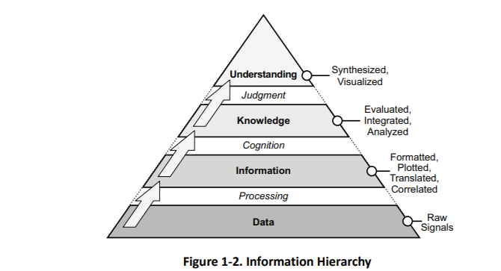

### Intelligence

The overall objective of intelligence is to enable commanders and combat forces to “know the enemy” and operate smarter. It helps commanders ~~across the range of military operations~~ by collecting, analyzing, fusing, tailoring, and disseminating intelligence to the right place at the right time for key decision making. Intelligence provides indications of enemy intentions and guides decisions on how, when, and where to engage enemy forces to achieve the commander’s objectives. It assists in combat assessment through battle-damage assessment

**Intelligence Processing**. Since information does not present itself for exploitation, it must be sought, gathered, assembled, and processed into usable form. The outcome is the transformation of raw information into intelligence suitable for making valid decisions and conducting missions. Intelligence is required for both planning campaigns (JFACC) and for planning and conducting tactical operations (JFACC, aircrew and controllers).

Intelligence sources are the means or systems used to observe, sense and record, or convey information. There are seven primary intelligence source types: imagery, human, signals, measurement and signature, open source, technical.

Intelligence organizations integrate technical and quantitative assessments with analytical judgments based on detailed knowledge of the way the enemy thinks and operates. Intelligence personnel should maintain an independent perspective. Commanders anticipate that even the best intelligence may not provide a complete picture, especially when the enemy is practicing deception or when the intelligence is derived from a single source. Still, intelligence gives commanders the best available estimate of enemy capabilities, Centers Of Gravity’s (COGs), and Courses Of Action (COA).

### Intelligence Cycle Overview

Intelligence provides clear, brief, relevant, and timely analysis on enemy capabilities and intentions for planning and conducting military operations. The intelligence community uses the intelligence cycle which is broken down into five separate categories or steps.

The intelligence cycle is defined as: “*the steps by which information is converted into intelligence and made available to users*”. The five steps in the cycle are:

* **Planning and direction**: determination of intelligence requirements, preparation of a collection plan, issuance of orders and requests to information collection agencies.
* **Collection:** acquisition of information and the provision of this information to processing and/or production elements.
* **Processing:** conversion of collected information into a form suitable to the production of intelligence.
* **Production**: conversion of information into intelligence through the integration, analysis, evaluation, and interpretation of all source data and the preparation of intelligence products in support of known or anticipated user requirements.
* **Dissemination**: conveyance of intelligence to users in a suitable form.

#### Planning and direction

The first phase in the intelligence cycle is planning and direction. This phase consists of the identification of intelligence requirements and the planning of intelligence operations and activities to satisfy those requirements. JFACC directs the intelligence effort; VIS manages this effort for JFACC. In so doing, VIS is guided by the JFACC's intent, the established priority intelligence requirements, and specific guidance provided by JFACC for the conduct of the intelligence effort. ~~Planning and direction encompass the supervision of collection, processing, production, and dissemination operations as well as developing the intelligence structure necessary to support planned or ongoing operations.~~

#### Collection

Collection is the second phase of the intelligence cycle. During collection, organic, attached, and supporting intelligence sources collect and deliver information to the appropriate processing or production unit—or, in some instances, directly to the appropriate commander for immediate action. Effective collection depends upon the use of a variety of mutually reinforcing sources (For example satellite imagery, ground force observation post, intelligence collection flights (using TGP, RWR or ELINT pods). Necessary, planned redundancy and overlap of sources increase the reliability of information and can reduce the effectiveness of enemy deception or denial efforts.

#### Processing and exploitation

Processing and exploitation are the third phase of the intelligence cycle, the conversion of raw data into a form suitable to produce intelligence. Largely a technical function, processing and exploitation converts the data into an understandable form and enhances its presentation (For example taking coordinates of observations and making it available on a map).

For VIS this mean to take observations or information from reports and register it in an intelligence log, so the information is readily available for intelligence production. In addition observations or information also need to be plotted on a map to be able to be used in a meaningful way during the production of intelligence.

~~Examples of processing and exploitation include developing and interpreting a piece of film, translating a foreign-language text, or decoding an encrypted radio report. Not all information requires processing; some is collected in a form already suitable for production. Sometimes processing and exploitation occurs automatically during collection.~~

#### Production

The fourth phase of the intelligence cycle is production, the activities by which processed data (in the intelligence log and received intelligence reports) is converted into intelligence. Production involves evaluating ~~the pertinence~~, reliability, and accuracy of information. It involves analyzing information to isolate significant elements. It includes integrating all relevant information to combine and compare those elements of information with other known information.

Finally, production involves interpreting the information to form logical conclusions that bear on the situation and that support the commander's plan to engage the enemy.

Production is a process of synthesis—the most important action in developing usable intelligence for the commander. Production arranges the intelligence pieces to form coherent images. It is this step which adds meaning to these pieces, creating knowledge. Synthesis does not generally create a complete image—totally filling in the gaps and eliminating uncertainty— but it should provide an image from which the commander can reach an acceptable level of understanding. In the end, synthesis answers the all-important question: "*What effect does all of this have on our ability to accomplish the mission?"*

#### Dissemination

The fifth phase of the intelligence cycle is dissemination, the timely conveyance of intelligence in an appropriate form and by a suitable means to those who need it (JFACC, pilots and controllers). Depending on its importance and time-sensitivity, intelligence may be disseminated—" pushed"——directly to users, or it can be sent to a web page from which users can "pull" that intelligence which they need. Intelligence flows by any number of channels or methods.

~~The form intelligence takes can influence dissemination. Some intelligence can be transmitted almost instantaneously to multiple users via a digital communications link, while other intelligence must be physically delivered by courier. The channel or means of dissemination is less important than the arrival of the intelligence at the proper destination on time and in a form readily usable to the commander. Depending on the urgency and time-sensitivity of the intelligence, it may follow established communications channels, or it may be broadcast to the entire force simultaneously as an alert or alarm.~~

~~The final phase in the intelligence cycle is utilization. The commander may provide direction, information may be collected and converted into intelligence, and the intelligence may be disseminated, but unless that intelligence is exploited through decision and action, it has served no purpose. Utilization is not a function of intelligence per Se, but rather of command and control—making the decision and then carrying it out. This reinforces two important points made earlier: first, intelligence has no value for its own sake but assumes value only when acted upon; and secondly, intelligence is inextricably linked to command and control~~.

No one phase of the intelligence cycle is more important than the others—they are interdependent. Without proper direction, the other phases will be uncoordinated and ineffective. Without effective collection, there may be too much or too little information, and the information obtained may prove irrelevant. Without processing and production, the resulting mass of information may appear meaningless. Lengthening production time will delay dissemination. The first four phases of the intelligence cycle offer marginal value unless the intelligence arrives to the right person in time and in a useful form to support decision-making. Finally, intelligence operations are wasted if JFACC/pilots/controllers fail to understand and act upon the knowledge intelligence offers. For simplicity, the intelligence cycle is described as a sequential method; however, in practice, it is a dynamic process responsive to changes in the situation and the JFACC/pilots/controllers evolving intelligence needs.

### ~~VIS “How To” Intelligence Cycle~~

#### ~~Planning and direction~~

~~VIS intelligence effort begins with receipt of the mission and the CJTF/JFACC's guidance. On-hand intelligence is rarely sufficient to support comprehensive planning and decision-making needs and gaps will remain. Such intelligence gaps are known as intelligence requirements (IR).~~

~~An intelligence requirement is any subject, general, or specific, upon which there is a need for the collection of information, or the production of intelligence. Intelligence requirements (IR) are questions about the enemy and the environment, the answers to which JFACC, aircrew or controllers requires to make sound decisions. The breadth of potential intelligence gaps, however, will generally far exceed intelligence capabilities available. Thus, it is important to focus intelligence operations on those intelligence requirements crucial to mission success. We call these requirements priority intelligence requirements (PIR) (This does not mean that only PIR can be collected on. Both PIR and IRs can be collected on and used for production of intelligence).~~

~~Generally, the difference between a PIR and an IR is that JFACC must have the answer to the PIR to make a decision. At any one time there are not many PIRs in effect. PIRs are prioritized among themselves and may change in priority over the course of an evolution. It is JFACC who designates the priority intelligence requirements (based on recommendations or nominations from VIS) and therefore provides direction to the intelligence effort.~~

~~The lowest priority PIR takes precedence over the highest priority IR. IRs are questions typically generated by VIS, aircrew or controllers but not ones that JFACC feels they needs answered before making decisions. While there are ideally a few PIRs, there may be many IRs. Like PIRs, IRs should be prioritized against each other to support effective intelligence planning and operations. PIRs and IRs have the following characteristics.~~

~~Each PIR or IR:~~

* ~~Asks only one question.~~
* ~~Focuses on specific facts, events or activities concerning the enemy or the battlespace.~~
* ~~Is tied to mission planning, decision-making, or execution.~~
* ~~Provides a clear, concise statement of what intelligence is required.~~
* ~~Contains geographic and time elements to limit the scope of the requirement.~~

~~Example PIR~~

* ~~Will Russian military forces intervene in Syria on D5?~~
* ~~How will Russian military forces intervene in Syria in phase 2?~~
* ~~What are Syrian air defense posture ivo Damascus in phase 3?~~
* ~~Where are Syrian SCUDs located on D4?~~
* ~~Where are Syrian rocket artillery located at the start of phase 1?~~

~~Example IR~~

* ~~Are Syrian SA-11 still operational IVO Tabqua on D3?~~
* ~~Are Russian SU-34 based on Bassel Al Assad in phase 2?~~
* ~~What are Syrian air defense posture ivo Jirah in phase 3?~~
* ~~What is the status of Syrian QRA on D3?~~

~~For VIS, any RFI from JFACC, aircrew or controllers are an IR (or should be converted into an IR).~~

~~VIS may create Named Areas of Interest (NAI) that will aid in the collection of information~~

~~Named Areas of Interest are the geographical area where information that will satisfy a specific information requirement can be collected. Named areas of interest are usually selected to capture indications of adversary courses of action but also may be related to conditions of the enemy or the battlespace.~~

~~MAKE A SYSTEM FOR RFI HANDLING UP AND DOWN + IR HANDLING + CR + CM~~

#### ~~Collection~~

~~The first thing VIS will do with their prioritized list of IR/PIRs are to develop indicators that may aid in answering the question. Some IR/PIRs only have one or a few indicators, while other IR/PIRs are very complex and have many indicators. The indicators and answer to these will aid in the production of intelligence while answering the IR/PIR. See example of indicators below.~~

~~Example IR with indicators~~

* ~~Are Syrian SA-11 still operational IVO Tabqua on D3?~~
  + ~~Are SA-11 vehicles seen IVO Tabqua?~~
  + ~~Are SA-11 radar transmission reported ivo Tabqua~~
  + ~~Are SA-11 vehicles seen or reported leaving Tabqua?~~
* ~~Are Russian SU-34 based on Bassel Al Assad in phase 2?~~
  + ~~Are there air tracks that have terminated at Bassel Al Assad?~~
  + ~~Are SU-34 reported ivo Syria?~~
  + ~~Where are SU-34 aircraft originating?~~
  + ~~What is the current composition of aircraft on Bassel Al Assad?~~
  + ~~Is there Russian presence on Bassel Al Assad?~~
  + ~~What kind of Russian activity are reported on Bassel Al Assad in phase 1?~~
* ~~What are Syrian air defense posture ivo Jirah in phase 3?~~
  + ~~What SAM units are located ivo Jirah?~~
  + ~~What AAA units are located ivo Jirah?~~
  + ~~What radar activity are reported ivo Jirah?~~
  + ~~What aircrafts are currently based at Jirah?~~
* ~~What is the status of Syrian QRA on D3?~~
  + ~~What are the times from detection to launch for Syrian QRA at Tabqa?~~
  + ~~What are the times from detection to launch for Syrian QRA at Jirah?~~
  + ~~What aircrafts are used as QRA aircrafts?~~
  + ~~What kind of weapons are the QRA aircrafts using?~~
  + ~~Do the QRA aircraft have external fuel tanks?~~
  + ~~What are the QRA aircraft tactics once airborne?~~

~~When VIS have a prioritized list of IRs and PIR’s with indicators, VIS will make a decision for each IR/PIR if they belong in one of the following three categories:~~

* ~~Production~~
  + ~~This means that VIS have enough information about this IR/PIR to start producing intelligence to answer the IR/PIR.~~
* ~~Collection~~
  + ~~VIS do not have sufficient information about this IR/PIR to start producing intelligence, but by using JFACC assets (aircrew or controllers) they can collect more information in subsequent ATO days to get information to answer the IR/PIR later.~~
* ~~RFI~~
  + ~~VIS do not have sufficient information about this IR/PIR to start producing intelligence and JFACC assets are likely not able to collect relevant information to answer til IR/PIR. VIS will then submit an RFI to VID for additional information that may help contribute to answering the IR/PIR later.~~

**~~Collection~~**

~~For IR/PIRs that are categorized as for collection VIS will ensure they have indicators that are observable/reportable so that aircrew and controllers are able to answer them during the flight. Indicators are given a number tied to the IR/PIR so that pilots can answer the correct indicator, and that it will make it easier for VIS to collect the information and make sense of it during intelligence collection. For example, if IRs are labelled with numbers 1-10, then indicators can be given as X.1, X.2 etc. Example:~~

* ~~IR 1: What is the status of Syrian QRA on D3?~~
  + ~~1.1: What are the times from detection to launch for Syrian QRA at Tabqa?~~
  + ~~1.2: What are the times from detection to launch for Syrian QRA at Jirah?~~
  + ~~1.3: What aircrafts are used as QRA aircrafts?~~
  + ~~1.4: What kind of weapons are the QRA aircrafts using?~~
  + ~~1.5: Do the QRA aircraft have external fuel tanks?~~
  + ~~1.6: What are the QRA aircraft tactics once airborne?~~

~~Having multiple assets answer the same IR/PIR (either the same indicators or different indicators) provides VIS with the best possible information to be able to answer the IR/PIR during production of intelligence as this will give different perspectives.~~

~~VIS will inform JFACC about the IRs they have listed for collection as an input to the~~ ~~targeting meeting~~~~. After the targeting meeting, JFACC will use the inputs and give order in the ATO for relevant flights to collect on the indicators listed. If required JFACC may also task flights with intelligence collection as the mission for the flight.~~

~~It is important for VIS and JFACC to not overload aircrew and controllers with IR/PIRs with many indicators if the flight is tasked with doing something else. As a rule of thumb, all flights should have at least a few indicators that they should answer after the flight. If a flight is dedicated for collecting intelligence, the aircrew/controllers may have a longer list of IR/PIR and indicators for that specific flight.~~

~~The various indicators do not necessarily work for everyone, and VIS and JFACC should ensure that they give the task to collect on the right indicator to an asset that is suited for answering the questions. See example below:~~

* ~~IR 1: What is the status of Syrian QRA on D3?~~
  + ~~1.1: What are the times from detection to launch for Syrian QRA at Tabqa?~~
    - ~~AWACS Controller~~
  + ~~1.2: What are the times from detection to launch for Syrian QRA at Jirah?~~
    - ~~AWACS Controller~~
  + ~~1.3: What aircrafts are used as QRA aircrafts?~~
    - ~~Aircrew~~
  + ~~1.4: What kind of weapons are the QRA aircrafts using?~~
    - ~~Aircrew~~
  + ~~1.5: Do the QRA aircraft have external fuel tanks?~~
    - ~~Aircrew~~
  + ~~1.6: What are the QRA aircraft tactics once airborne?~~
    - ~~AWACS controller and aircrew~~

#### ~~Processing and exploitation~~

~~VIS should establish a master log of all intelligence: VIS Intelligence log. All reports, observations and information should be registered in this VIS Intelligence log. HOPEFULLY TECHNICAL TOOLS FOR AUTOMATION.~~

#### ~~Production~~

~~Production converts data into intelligence and creates the knowledge needed for the~~

~~planning and execution of operations. The intelligence must deliver knowledge, in context, in~~

~~time, and in a form usable in the decision-making process. Intelligence production involves filtering, recording, evaluating, analyzing, synthesizing, and assessing all information relevant to a particular IR. During the production phase, information is:~~

* ~~Evaluated to determine the reliability of the source and the credibility of the information.~~
* ~~Analyzed to isolate significant elements.~~
* ~~Integrated with other relevant information and previously developed intelligence.~~
* ~~Interpreted to form logical conclusions and predictions that clarify the situation and support the commander’s decision-making process.~~
* ~~Produced in the format most suitable to the user (JFACC, aircrew or controllers).~~

~~Analytical Process~~

~~VIS personnel use a framework described as screening, analysis, synthesis, and estimation. This framework calls for a disciplined approach to gathering and understanding information. The~~

~~analyst must place information in context and relate it to the current situation, planned or ongoing operations.~~

**~~Step 1: SCREEN COLLECTED INFORMATION~~**

~~During this step the execution of single-source intelligence or all-source analysis, analysts continuously filter the volume of information or intelligence received through the continuous push and pull of information. It is during the screen phase that analysts sort information based on relevancy and how it ties to the analytical questions or hypotheses they developed in earlier steps in the intelligence cycle to fill information gaps. They do this by conducting research and accessing only the information that is relevant to their PIRs/IRs, mission, or time. Analysts also screen the volume of information based on the information source’s reliability and the information accuracy, as explained below.~~

|  |  |
| --- | --- |
| **~~Reliability~~** | |
|  |  |
| ~~A~~ | **~~Completely reliable~~**~~: Clearly a known source or reliable information~~ |
| ~~B~~ | **~~Usually reliable:~~** ~~A known source that provides reliable information~~ |
| ~~C~~ | **~~Fairly reliable:~~** ~~A source that has reported information with a degree of reliability~~ |
| ~~D~~ | **~~Not usually reliable:~~** ~~Typically, a source who provide information with a heavy bias, or past data was no validated~~ |
| ~~E~~ | **~~Unreliable:~~** ~~Information provided is not reliable; typically, information cannot be confirmed by any means possible with any degree of certainty~~ |
| ~~F~~ | **~~Reliability cannot be judged~~**~~: There is no basis for estimating the reliability~~ |
| **~~Accuracy~~** | |
| ~~1~~ | **~~Confirmed by other sources:~~** ~~One can state with certainty there is corroborating information~~ |
| ~~2~~ | **~~Probably true:~~** ~~There is no actual proof, but no reason exists to assess, the source of the information is already available~~ |
| ~~3~~ | **~~Possibly true:~~** ~~Information may not at present be available to refute the accuracy~~ |
| ~~4~~ | **~~Doubtfully true:~~** ~~There is information that contradicts the accuracy~~ |
| ~~5~~ | **~~Improbable:~~** ~~No confirmation, and the information contradicts other reliable/accurate sources~~ |
| ~~6~~ | **~~Truth cannot be judged:~~** ~~Information does not meet the criteria above~~ |

~~Table 1 Evaluation ratings for source reliability and information accuracy~~

~~Time permitting, analysts research by accessing information and intelligence from VIS master intelligence log, earlier intelligence reports, intelligence summaries. AAR’s.~~

~~databases, the internet (attributed to open-source information), collaborative tools, broadcast services, and other sources such as automated systems. This screening enables analysts to focus their analytical efforts on only the information that is pertinent to their specific analytic problem. (See ATP 2-22.9 for more information on open-source information; see appendix A for more information on automated systems.)~~

~~Analysts may decide to retain or exclude information based on results from the screen phase. While the excluded information may not be relevant to the current analytical question, the information is maintained in the VIS intelligence log as it may answer a follow-on question from a new analytical question.~~

**~~Step 2: Analysis.~~** ~~Analysts must possess a thorough knowledge of military operations, the operational~~

~~environment, the friendly situation, IRs, and the threat situation.~~

~~VIS personnel will:~~

* ~~View collected information in the context of the mission, commander’s intent, and IRs.~~
* ~~Identify key elements of the situation to formulate hypotheses, make deductions from those hypotheses, and reach conclusions.~~
* ~~Divide the battlespace into component parts to isolate and define the elements of significant information (physical dimension, time, threat force structure, battlespace activities, and other characteristics) to facilitate understanding and satisfy the user’s needs.~~
* ~~Compare the existing situation to new information to determine whether it relates to identified IRs and to assess its impact on the current intelligence estimate.~~

~~Analysts examine relevant information or intelligence using reasoning and analytic techniques, which enable them to see information in different ways and to reveal something new or unexpected. It may be necessary to gain more information or apply a different technique, time permitting, until a conclusion is reached, or a determination is made.~~

~~Reliable and accurate information is integrated into the analytical production. Data that is less reliable or accurate is not discarded; it is retained for possible additional screening with other established information or if new requirements arise that are relevant to existing data.~~

**~~Step 3: Synthesis.~~** ~~Synthesis determines relationships that exist among information and pieces the information together into a coherent, meaningful picture. VIS personnel will:~~

* ~~Identify and integrate relationships between individually significant pieces of information with the existing operational environment to provide a new picture of the situation.~~
* ~~Discern emerging patterns in environmental conditions or enemy activity.~~

~~As analysts reach new conclusions about the threat activities during the analyze phase, they should corroborate and correlate this information with prior intelligence holdings using reasoning and analytic techniques. Analysts determine how new information relates to previous analytical conclusions. New information may require analysts to alter or validate initial conclusions. Analysts must continue to evaluate and integrate reliable and accurate information relevant to their mission.~~

~~Analysts resume the analysis based on questions (hypotheses) they established during the screen and analyze phases. At this point, analysts begin to draw conclusions that translate into an initial determination that is likely to require additional analysis and, in certain instances, additional collection. They employ the analytic tradecraft standards to assess probabilities and confidence levels; they employ the action-metrics associated with analytical rigor to draw accurate conclusions. However, some of these conclusions may present alternative COAs not previously considered during IPB. These COAs must be presented to the commander and staff because they might have operational implications. (Appendix C discusses the analytic tradecraft standards and the action-metrics associated with analytical rigor.)~~

~~An analyst’s ultimate goal is finding threat vulnerabilities and assisting the commander and staff in exploiting those vulnerabilities—despite having answered the commander’s PIR. If the intelligence analysis does not answer the commander’s PIR, the analyst should reexamine the guidance, consider recommending different collection strategies, and review information previously discarded as nonessential. Sometimes, the cause for not answering the requirement is the analyst’s misunderstanding of the commander’s PIR or guidance, thus the analyst must return to the original question posed by the commander and reevaluate the initial hypothesis~~

**~~Step 4: Estimation.~~** ~~Estimation, the bottom line of the analytical process, is based on detailed studies of the tactical situation, experience, intelligence successes, the application of specific tools and methods, and the supported commander’s intelligence needs. Estimation must describe the current conditions and present an image of future possibilities. Analysts then determine the enemy’s:~~

* ~~Capabilities.~~
* ~~Intent.~~
* ~~Probable COAs.~~
* ~~Likely reactions to friendly operations.~~

~~Well-founded estimates help manage uncertainty about the situation and facilitate planning and~~

~~executing successful operations.~~

~~Analysts must properly express and explain uncertainties associated with any major analytical judgment. When briefing their analytical results, VIS personnel, should be able to assess the likelihood of an event happening, expressed by using estimative language. Phrases (such as we judge, we assess, and we estimate) commonly used to convey analytical assessments and judgments, are not facts, proofs, or knowledge. Intelligence analysts use estimative language, shown in figure C-1, to convey their assessment of the probability or likelihood of an event and the level of confidence ascribed to the judgment.~~

~~Then, they must express their confidence level—high, moderate, or low—in that assessment. For intelligence analysts to reach a high level of confidence in the accuracy of their analytical assessment, they must apply the actions of high analytical rigor found in table C-1 on page C-5.~~

|  |  |  |  |  |  |  |  |
| --- | --- | --- | --- | --- | --- | --- | --- |
| ~~Expressions of likelihood~~ | ~~Almost no chance~~ | ~~Highly unlikely~~ | ~~Unlikely~~ | ~~Even chance~~ | ~~Likely~~ | ~~Highly likely~~ | ~~Almost certain~~ |
| ~~Probability~~ | ~~01-05%~~ | ~~05-20%~~ | ~~20-45%~~ | ~~45-55%~~ | ~~55-80%~~ | ~~80-95%~~ | ~~95-99%~~ |

~~Table 2: Estimative language expression of likelihood~~

~~Expressing Confidence in Assessments~~

~~VIS may also add their confidence level on their assessments. Confidence levels express the strength of the assessment given the reasoning, methodologies, gaps, and assumptions; the number, quality, and diversity of sources; and the potential for deception. To avoid confusion, assessment language and confidence levels are not combined in the same sentence.~~

~~Confidence in a judgement is based on three factors: The number of key assumptions required, the credibility and diversity of sources, and the strength of the argumentation. Each factor should be assessed independently and then in concert with the other factors to determine the confidence level. Confidence levels are ascribed using high, moderate, and low levels of confidence in analytical assessments:~~

* **~~High confidence level.~~** ~~High confidence generally indicates that sound reasoning and/or methodologies have been applied; no linchpin assumptions have been made; no critical gaps relevant to the issue are evident; consistent evidence from a variety of independent sources supports the judgment; the potential for deception is low; the body of reporting is not consistent with a plausible alternative; and/or the nature of the issue allows one to render a solid judgment. A high confidence judgment, however, is not a fact or a certainty, and such judgments still carry a risk of being inaccurate.~~
* **~~Moderate confidence level~~**~~. Moderate confidence generally indicates that potentially critical assumptions are used to fill gaps; some inconsistencies exist, but the preponderance of evidence supports the judgment; the information is credibly sourced and plausible but is not of sufficient quality or is not sufficiently corroborated to warrant high confidence; moderate potential for deception exists; and/or the body of reporting leaves open the possibility of a plausible alternative explanation of events.~~
* **~~Low confidence level~~**~~. Low confidence generally indicates that key assumptions have been used to fill critical gaps; significant inconsistencies or questions exist regarding the evidence; the information is fragmented or uncorroborated or is of questionable credibility and/or plausibility; high potential for deception exists; and/or the body of reporting supports an alternative explanation of events.~~

## Targeting

Targeting is the process of selecting and prioritizing targets and matching the appropriate response while taking account of JFC/JFACC objectives, and capabilities. T~~his process is systematic, comprehensive, and continuous~~. ~~Combined with a clear understanding of operational requirements, capabilities, and limitations,~~ the targeting process identifies, selects, and exploits critical vulnerabilities within targeted systems to achieve the JFC/JFACC’ desired end state. ~~Targeting is a command function requiring commander oversight and involvement to ensure proper execution~~. It is not the exclusive province of one specialty or division, such as intelligence (VIS) or operations (JFACC), but blends the expertise of both JFACC and VIS.

A target is an entity or object considered for possible engagement or other actions. ~~Joint doctrine describes~~ An entity can be defined as facilities, individuals, virtual (nontangible) things, equipment, or organizations. It is a fundamental tenet of targeting that no potential target derives its importance merely because it exists, or even that it is a crucial element within a target system. Any potential target derives its importance only by the extent to which it enables enemy capabilities and actions that must be affected to achieve objectives. Multiple actions may be taken against a single target, and actions may often be taken against multiple targets to achieve a single effect.

Targeting is focused on achieving objectives. During planning, objectives are translated into detailed actions against adversary targets that produce desired effects. Every target nominated should contribute to attaining JFC/JFACC objectives and the end state.

~~Targeting is effects-based, interdisciplinary, anticipatory, systematic, and integrated with other processes. These principles are fundamental to targeting.~~ ~~Targeting is in part accomplished by targeteers who have specialized training in analyzing targets and developing solutions. It is more than the selection of targets for physical destruction. Destruction may be the best means to the end, but it is only one effect within a spectrum of possible options within joint multi-domain operations. Other options include influence operations, electronic warfare operations, and cyberspace operations. The underlying premise of an effects-based approach is that it is possible to direct the instruments of power—diplomatic, information, military, economic (DIME)—against targets in ways that create effects beyond mere destruction. These effects will influence the adversary’s political, military, economic, social, infrastructure, and information systems, physical environment, and time. Targeting should consider all possible means to achieve desired effects, drawing from all available forces, weapons, and platforms.~~ Target selection must also consider second- and third-order effects that may either positively or negatively contribute to campaign success.

In supporting the JFC/JFACC’s objectives, the targeting process is designed to achieve effects in a systematic manner. Targeting, like other planning processes, is rational and iterative. It methodically analyzes, prioritizes, and assigns forces and capabilities against enemy targets. Targeting is not mechanical and does not assume that the same actions always produce the same effects. If the desired effects are not achieved, targets may be re-planned for subsequent engagement, or different targets may be selected.

Targeting should not be separated from JFC/JFACC objectives. Otherwise, it becomes an inputs-based exercise in target servicing—simply matching available resources to those targets. Integrating targeting within the overarching planning processes (air campaign planning and air tasking cycle) enables an effects-based approach to operations (EBAO).

### The Targeting Process

The targeting process is a conceptual construct used to explain how targeting is performed. ~~The process is performed at various levels of command and execution~~. Though driven by intelligence (VIS), it is not the purview of any one community. Community boundaries are beginning to blur between operations (JFACC) and intelligence (VIS). This should help consolidate targeting functions. The targeting process includes actions that produce target intelligence and target materials ~~(through analysis and fusion of multi-source intelligence)~~ and applied in support of operational decision making and force employment.

This process includes the steps by which targets are recommended and is comprised of six phases:

• Objectives and guidance derivation

• Target development

• Weaponeering

• Force application

• Execution planning

• Combat assessment

These phases are bi-directional and iterative. Often, they overlap and VIS/JFACC may perform several of them simultaneously.

#### Objectives and Guidance Derivation

Objectives and guidance derivation comprise the foundation of the targeting process, ~~originating at the national level and becoming more specific and dynamic at progressively lower echelons of command~~. ~~Unified command~~ JFC/JFACC objectives establish priorities for targeting, damage criteria, and restrictions on force employment. Guidance includes principles of war, the international Law of Armed Conflict (LOAC), and established rules of engagement. Objective and guidance should be clear and unambiguous ~~so as to be interpretable at the lowest level of command~~. The necessary first step as an individual working with targeting is to understand objectives and guidance to provide correct targeting advice to JFACC. JFC objectives will need to be broken down to targeting objectives. Targeting objectives must have the following characteristics:

Observable.

The targeting objective must strive for some visible change in an enemy’s behavior. For example, “*Destroy the (XXX Corps) if it moves out of its assembly area to eliminate its exploitation potential*.” From this objective, it is clear the JFC intends to contain the enemy unit to a particular location for a period of time.

Quantifiable.

The change in enemy behavior must be related to some quantifiable end. Specific levels of expected results must be identified (i.e., the percentage of destruction [the effect] created by strikes on a target). For example, “*Destroy coastal mine storage sites capable of being employed in the ocean outside Turkey*.” It is very easy to quantify the relative success of this targeting objective through various collection assets available once the strikes are completed.

Achievable.

The assets and time available must be sufficient to accomplish the targeting objective—there must be room for a solution. Further, a targeting objective should not be defined in such a way it requires the attack of a specific target system or creation of a tactical effect that also prohibits fulfilling the objective. For example, “*Reduce enemy capacity to refine crude petroleum by 50 percent, for a period of one year, without endangering civilian industrial facilities.”* Obviously, oil refineries are considered to be part of the civilian infrastructure, and it is not possible to significantly affect oil-refining capacity without attacking refineries, unless an indirect node and link can be identified.

#### Target Development

This phase of the joint targeting cycle consists of target development, ~~target vetting, target validation~~, and target list management.

During target development, VIS analyzes a potential target system and its components to estimate the JFACC’s best course of action to achieve a given objective. Intelligence is reviewed and potential target systems and targets are selected for consideration. A subset of target development is target analysis, which examines potential targets to determine military importance, priority of attack, and weapon feasibility to obtain a desired level of damage, casualties or to achieve the desired effect. The selected target systems are then further analyzed to determine their components and critical elements. A priority listing of these critical elements is used for weaponeering assessment. ~~Target development includes validation of the target and nomination to the appropriate authority~~. Once a target is sufficiently developed, it will be added to the Joint Target List (JTL) which is a list of all available targets. During execution of the air campaign, targets are prioritized as part of the air tasking cycle and added onto the Joint Prioritized Target List (JPTL) for each ATO day for prosecution.

#### Weaponeering

The output of weaponeering is a recommendation of the quantity, type, ~~and mix of lethal and non lethal~~ weapons needed to achieve a probable level of target damage or effects while avoiding unacceptable collateral damage. It is important to note weaponeering results are probabilistic and not predictive. Considerations are:

* Target vulnerability
* Weapon effects
* Munitions delivery errors
* Delivery tactics
* Damage criteria
* Probability of kill
* Weapon reliability

#### Force Application

Force application planning is the fusion of target nominations with the optimum available lethal force. In this phase, forces are analyzed to determine likely results to be achieved against target systems and their activities. For lethal force, this is based on probabilities of damage and arrival for a weapon system. ~~For non lethal force this is based on the expected outcome (consequences).~~ The result of force application is a strike package nomination for the commander's approval that has coordinated recommendations from operations, and intelligence. This includes actions in preparation for attack once force selection recommendations are approved. ~~Targeteers prepare the target intelligence portion of plans and assist in air tasking order (ATO) preparation~~.

During force selection, targeting analysts work closely with operators and planners to match targets with available weapon systems, munitions~~, and possible non lethal force options.~~

Force sizing is then optimized in light of available resources and other constraints.

~~Targeteers also assist in attrition analysis or calculations for potential friendly force losses to enemy defenses. Attrition analysis bears on both delivery tactics and optimal force sizing.~~

#### Execution Planning

Execution planning is the more detailed planning required to actually fly the mission and employ weapons. It is both a JFACC and aircrew function. For JFACC, preparation for the execution of the ATO entails review of plans, weather, logistics, and current situation. At the aircrew level, it involves mission planning. ~~Unit functions for targeteers have evolved with the automation of mission planning tools, and the laborious work of hand drawn radar predictions, old mensuration tools, and slide rule weaponeering is approaching an end. With a single Air Force-wide intelligence tool (Combat Intelligence System) and a single mission planning tool (Air Force Mission Support System), we have begun to standardize targeting tasks and ease training problems.~~

Volunteers working with targeting may provide the approved targets list, weaponeering, and target materials, such as maps, charts, mensurated coordinates, and imagery. They may assist aircrew in selecting mission routing, axis of attack, aimpoints, and fuze settings.

Targeting planners may also prepare battle damage assessment (BDA) reporting guidelines.

~~mission folders containing charts (annotated with ingress and egress routing, and aimpoints), strip charts, threat data, and battle damage assessment (BDA) reporting guidelines.~~

#### Combat Assessment

Effective campaign planning and execution require a continuing evaluation of the impact of ~~joint force~~ combat operations on the overall campaign. Combat assessment (CA) evaluates combat operations effectiveness in achieving JFC/JFACC objectives and recommends changes to tactics, strategies, objectives, and guidance. It has several sub assessments including mission assessment (MA), battle damage assessment (BDA), and munitions effectiveness assessment (MEA). The military end state, as written in the campaign estimate and modified during an operation, is directly linked with CA. CA compares the results of the operation to the objectives to determine mission success or failure within the guidance parameters. More important than a review, it looks forward to determine if additional missions are needed and/or if modification to the objectives is necessary. ~~Combat assessment is one concept with many implementations.~~

# VIS Air Campaign Planning

## Intelligence Preparation of the Battlefield (IPB)

~~Intelligence preparation of the battlespace (IPB) is a four-step systematic process of analyzing the threat and environment to help the JFACC better understand the many variables that can influence the mission and operations.~~

~~Specifically, IPB focuses on the relationship between the threat and environment, along with the effect of that interaction on both friendly and enemy courses of action. IPB results in the production of enemy courses of action, named areas of interest, and high-value targets, which are inputs to the JFACC campaign planning, intelligence collection, and targeting processes. When done properly, IPB facilitates getting “inside” the enemy’s decision-making cycle~~

IPB is a systematic, four step analytical methodology employed to reduce uncertainties concerning the adversary and to exploit or minimize environmental factors. It is a ~~continuous~~ process, which enables JFACC to visualize the full spectrum of adversary capabilities, potential centers of gravity (COG), and possible courses of action (COA) across all dimensions of the battlespace. IPB assists VIS personnel to identify facts and assumptions about the battlespace environment and the enemy. This facilitates planning and the development of JFACCs Concept of Operation. ~~During execution, IPB provides the basis for intelligence direction and synchronization that supports JFACCs Concept of operation (formulated through the JAOP) by tying ISR collection and analysis efforts to key decision points.~~

A key difference between air and surface warfare is that air forces can strike directly at key target sets that have strategic results, without having to go through the process of drawn-out attrition at the tactical level of war. ~~Air Force platforms deploy globally and will often pursue strategic, operational, and tactical objectives with very little time separation. Within the Air Force context, intelligence personnel will probably not have the luxury of focusing their IPB on only one level of warfare. Finally, aerospace power is the dominant force employed by the United States against an adversary’s war making potential. To do this effectively, the~~ The VIS IPB process must focus on carefully identifying and analyzing adversary COGs, as well as identifying adversary COAs traditionally associated with the IPB process. Air Force doctrine defines COGs as "Those characteristics, capabilities, or localities from which a military force, nation, or alliance derives its freedom of action, physical strength, or will to fight. ~~They exist at the strategic, operational and tactical levels of war."7~~ VIS and JFACC must understand the adversary’s COGs, his potential and probable COAs, the interrelationships between them, and the enemy’s overall ability to conduct military operations, in order to facilitate effective planning and execution ~~at the strategic and operational levels of warfare. Thus, while the processes will be very similar, there will be some significant differences in emphasis and approach.~~

The VIS IPB process consists of four basic steps:

1. Define the Battlespace Environment

2. Describe the Battlespace’s Effects

3. Evaluate the Adversary

4. Determine Adversary COAs

While the IPB process is sequential, it is also continuous and cyclical. It must be conducted before, during, and after an operation, and while planning for and executing other contingencies as they arise. With the acquisition of new information, intelligence staffs modify their assessments of the battlespace, the adversary, and all potential COGs and COAs.

### Step One: Define the Operational Environment (OE):

The first step of the IPB process focuses on defining the limits of the battlespace. This is done by determining and evaluating JFACC's assigned Area of Responsibility (AOR), Area of Intelligence Interest (AII), and mission. The AOR is that portion of the battlespace in which military operations are conducted to accomplish a mission. The AII is that area of concern to the participants in the military operations, including the area of influence, areas adjacent thereto, and extending into enemy territory to the objectives of current or planned operations. This area also includes areas occupied by enemy forces who could jeopardize the accomplishment of the mission. The AII is usually larger than the AOR.

The purpose of step one is to bound the intelligence problem and identify for further analysis specific features in the environment, activities within it, and the space where they exist that may influence available COAs or JFACC’s decisions. Once the AOR and AII are defined, and mission objectives and desired end states are determined, the JFACC/VIS determines the time available for planning. Time available determines the level of IPB detail possible. Concurrently, VIS personnel analyze existing information to highlight gaps for future intelligence collection and analysis to acquire the enemy and environmental data needed to complete the remaining steps of the IPB process at a level of detail sufficient to support the JFACC’s decision-making process.

#### Step One Final Results:

~~1. Preliminary priority intelligence requirements (PIR) delineating the scope and detail required for the mission being planned, which evolve as the IPB process develops.~~

2. The identification of significant battlespace characteristics affecting JFACC`s mission.

3. The identification of intelligence gaps and priorities, which also evolve as the IPB process develops.

~~4. An initial set of intelligence collection and production requirements that support further IPB analysis and the JFACC’s mission.~~

### Step Two: Describe the Operational Environment’s Effects.

The battlespace imposes constraints and provides opportunities to enemy and friendly forces that are crucial in predicting possible enemy Courses Of Action (COAs) and developing friendly COAs. Step two’s purpose is to determine how the battlespace affects both enemy and friendly operations. ~~Step two is not solely an intelligence function. In some cases other functional areas provide the majority of this information. For example, Air Force Weather is responsible for collecting, analyzing, predicting, tailoring, and disseminating weather and space environmental data to command staffs and operators required to plan and execute the mission.~~

#### Enemy

DESCRIBE HOW THE enemy CAN AFFECT FRIENDLY OPERATIONS

The enemy are part of the battlespace; therefore, JFACC and VIS need to understand all enemies and threats that can potentially affect operations within the Area of Responsibility (AOR) and Area of Intelligence Interest (AII). They may face one unified threat force or several disparate threat forces that must be engaged to accomplish the mission. Although detailed analysis of enemy forces occurs during steps 3 and 4 of the IPB process, the type of enemy force and its general capabilities must be defined during step 2. This places the enemy force in context with other variables in order to understand its relative importance as a characteristic of the operational environment. ~~For example:~~

~~When facing a regular threat in combat operations, regardless of where the engagement occurs,that threat is likely the most important characteristic in that OE.~~

~~When facing an irregular threat conducting operations as part of an insurgency in a failing nation-state, the state of governance and other civil considerations may be more significant than the threatposed by the irregular threat.~~

~~When facing a hybrid threat in combat operations, the hybrid threat will likely be equipped withcapabilities that can be used to exploit perceived friendly vulnerabilities. The mixture of regularand irregular threat capabilities expands threat COA possibilities and can create significantimpacts outside friendly force decision cycles.~~

The threat overlay and the threat description table focus the analysis of the threat and assist in communicating that analysis to JFACC. ~~(See chapter 5 for descriptions of regular, irregular, and hybrid threats.)~~

**Enemy overlay**

The threat overlay depicts the current physical location of all potential threats in the AOR and the AII. The overlay includes the identity, size, location, strength, and AO for each known threat/enemy location. Maintaining an enemy overlay provides a reference to past enemy activity and assists in determining patterns of enemy movement and dispositions. During step 4 of the IPB process, this reference assists in determining enemy COAs.

The enemy overlay can be used for the entire AOR and will then focus on large size enemy units (Corps/divisions) and large SAMs (SA-2, SA-5, SA-10 and EWRs), or the enemy overlay can be scaled down to focus on a specific area, for example a Corps area of operations, and focus is the more detailed, down to the brigade or even battalion level if the information exists. For SAMs in the scaled down version, all SAMs are visualized. Ideally a big picture overlay is used and one or several zoomed in enemy overlays for the anticipated area of operations are presented. The goal is for VIS to understand the enemy and its disposition, and be able to communicate that to JFACC, aircrew and controllers.

**Enemy description table**

The threat description table supports the threat overlay by classifying the types of threats identified on the overlay and describing the broad capabilities of each threat. Table 3 exemplifies a threat description table.

|  |  |  |  |
| --- | --- | --- | --- |
| **Identity** | **Location** | **Disposition** | **Description** |
| 2nd Corps HQ | Minahk AB | 80% strength | Air defense of SA-6 and SA-11 |
| 21st Armored Division | Minhak AB | 100% strength | Top tier unit (armor)  Air defense regiment with SA-19, SA-8 and SA-15  Likely 2nd Corps Reserve |
| 22nd Mechanized Division | Birecik Dam (Occupied area in Turkey | 75% strength | Air defense regiment with SA-13, SA-8 and SA-15 |
| 234th Fighter Squadron | Bassel Al Assad | 11 of 12 aircraft (MiG-29A) | Day and night capable  Primary role A-A  Are reported to be used for QRA at Bassel Al Assad |
| 634th SA 2 Regiment | SA-2 site at  N34 32 321 E032 43 211 | Fully operational | SA-3 BN and EWR currently unlocated.  Air Defense Battery likely protecting SA-2 site |

Table 3 Enemy description table

**NOTE:** For ground, lowest should be Brigade levels for VIS. If focusing on a special operation or area, then focusing further down can be used.

**NOTE:** Threat overlay and threat description table can be used throughout the campaign to keep track of the enemy status.

#### Terrain analysis

Terrain analysis for the area of responsibility (AOR) and area of intelligence interest (AII) are completed, in particular:

* Ground and air avenues of approach (AAs).
* Key terrain.
* Potential objectives, Named Areas of Interest (NAIs), and Target Areas of Interest (TAIs) are identified.
* ~~The effects of weather and light data are integrated.~~
* Any request for information on requests for collection are refined and updated.

Terrain analysis is the evaluation of geographic information on the natural and manmade features of the terrain, combined with other relevant factors, to predict the effect of the terrain on friendly and enemy operations. It involves the study and interpretation of natural and manmade features of an area, their effects on military operations, ~~and the effects of weather and climate on these features~~. ~~Terrain analysis is a continuous process as changes in the operational environment may alter the analysis of its effect on operations.~~

~~There are two types of terrain in which a command may operate—natural and urban. Both of these terrain types are analyzed based on military aspects using the OAKOC/KOCOA considerations. Analysis of natural terrain focuses on surface area, airspace, and subsurface areas. Analysis of urban terrain also focuses on surface area and airspace, but must also consider subsurface as well as internal and external supersurface areas.~~

ANALYZE THE MILITARY ASPECTS OF TERRAIN

~~Generally in the Army, detailed terrain analysis is conducted by geospatial intelligence cells assigned~~

~~to brigade combat teams, division headquarters, corps headquarters, and theater headquarters based on~~

~~priorities established by the intelligence officer. These cells have state-of-the-art digital mapping tools and~~

~~access to national-level support from agencies like the National Geospatial Intelligence Agency. Generally~~

~~in the Marine Corps, geospatial intelligence capability resides within the intelligence battalion and the~~

~~Marine aircraft wing (MAW). During the conduct of operations, this capability can be deployed down to~~

~~the regimental combat team or Marine aircraft group level. The result of terrain analysis is the evaluation~~

~~of the military aspects of terrain on operations.~~

Analyzing the military aspects of terrain involves the collection, processing, evaluation, and

interpretation of geographic information on natural and manmade features of the terrain, combined with other relevant factors, to determine potential effects of the terrain on military operations. It involves the study and interpretation of natural and manmade features of an area, effects on military operations, ~~and the effects of weather and climate on these features~~. ~~Terrain analysis is a continuous process as changes in the operational environment may change the analysis of its effect on the operation or threat/adversary COAs~~.

##### Obstacles

An obstacle is any natural or man-made obstruction designed or employed to disrupt, fix, turn, or block the movement of an opposing force, and to impose additional losses in personnel, time, and equipment on the opposing force. Some examples of obstacles to ground mobility are:

* Buildings.
* Mountains.
* Steep slopes.
* Dense forests.
* Rivers.
* Lakes.
* Urban areas.
* Minefields.
* Trenches.
* Certain religious and cultural sites.
* Wire obstacles

Obstacles affect certain types of movement differently. Obstacles such as rivers, lakes, swamps, dense forested areas, road craters, rubble in the street, or densely populated urban areas may have a greater effect on mounted movement than on dismounted movement. Minefields, concertina wire, or steep slopes may be more effective against dismounted movement.

Obstacles to air mobility include terrain features that exceed the aircraft’s service ceiling; affect nap of-the-earth flight; impact aircraft lift capabilities; or that force the aircraft to employ a particular flight profile. Examples are tall buildings, cellular telephone towers, power lines, rapidly rising terrain features, mountains, smoke, geologic features, high mountains, and other obscurants. High mountainous regions can impact rotary- and fixed-wing aircraft lift capabilities.

~~Obstacles may also decrease the effectiveness of information-related capabilities to influence~~

~~adversary or enemy operations and activities, friendly populations, and neutral populations. For example,~~

~~mountains may block terrestrial-based signals used to broadcast surrender appeals and morale-lowering~~

~~messages to enemy-held territory or messages to populations explaining the intent of U.S. operations. Use~~

~~of other message delivery platforms may be necessary to compensate for the effects of local terrain.~~

##### Avenues of Approach (AA)

AAs are air or ground routes used by an attacking force leading to its objective or to key terrain in its path. The identification of AAs is important because all COAs that involve maneuver depend on available AAs.

During offensive tasks, the evaluation of AAs leads to a recommendation on the best AAs to a command’s objective and identification of avenues available to the enemy for counterattack, withdrawal, or the movement of reinforcements or reserves. In a defense operation, it is important to identify AAs that support enemy offensive capabilities and avenues that support the movement and commitment of friendly reserves. AAs are developed by identifying mobility corridors.

Mobility corridors are areas that are relatively free of obstacles where a force will be canalized due to terrain restrictions allowing military forces to capitalize on the principles of mass and speed.

Identifying mobility corridors requires some knowledge of friendly and enemy forces and their preferred tactics. The best mobility corridors use unrestricted terrain that provided enough space for a force to move in its preferred doctrinal formations (combat formations) while avoiding major obstacles. Mobility corridors can follow, for example, the direction of roads, trails, rivers, streams, ridgelines, subway lines, foot paths, tunnels, and human-sized drainage ditches. Factors other than obstacles and mobility may have to be evaluated when identifying mobility corridors.

Mobility corridors, like obstacles, are a function of the type and mobility of the force being

evaluated. Military forces, such as mechanized infantry or armored units, require large open areas in which to move and maneuver. Irregular forces are less impacted by the presence of obstacles and terrain that would hinder movement of a large formation. The size of a mobility corridor can be determined based on terrain constrictions.

Mobility corridors are categorized by the size or type of force they can accommodate. Mobility corridors can also be categorized by likely use. For example, a mechanized force requires logistical sustainment; a mobility corridor through unrestricted terrain supported by a road network is generally more desirable. ~~A dismounted force might be able to use more restrictive corridors associated with the arctic tundra, swamps or marshes, jungles, or mountains that may or may not have a road network. Due to their rate of march and lack of fire power, dismounted forces require a more covered and concealed route for survivability to reach their objective.~~

AAs consist of a series of mobility corridors through which a maneuvering force must pass to reach its objective. An AA must provide ease of movement and enough width for dispersion of a force large enough to significantly affect the outcome of the operation. Mobility corridors are classed based on the distance between the terrain features that form the corridor. Mobility corridor ranges are not absolute but reflect the relative and approximate distance between terrain features.

Evaluating AAs is a combined effort of the entire staff. Evaluating AAs identifies those that best support enemy or friendly capabilities. The AAs should be prioritized based on how well each supports the ability to meet the desired result in a timely and efficient manner. AAs are evaluated for suitability in terms of:

* Access to key terrain and adjacent avenues.
* Degree of canalization and ease of movement.
* Sustainability (line of communications [LOC] support).
* Access to the objective.

~~Once evaluated, AAs are prioritized on how well each supports maneuver. Figure 4-5 is an example of the identification of AAs with mobility corridors.~~

##### Key terrain

Key terrain is any locality, or area, the seizure or retention of which affords a marked advantage to either combatant. In natural terrain dominated by restrictive terrain features, high ground can be key terrain because it dominates an area with good observation and fields of fire. In an open or arid environment, a draw or wadi can be key terrain because it offers good cover and concealment.

Key terrain may often be identified as objectives (Cities, airfields, bases, bridges).

In urban environments, infrastructure (such as bridges, medical facilities, choke points, intersections, industrial complexes, and ~~economic, social, and government institutions~~) can be considered key terrain. ~~For the Marine Corps, this includes the local population and certain local groups or individuals~~. For example, control of a bridge may equate to control over an Avenue of Approach (AA). ~~However, the command needs to consider the operational and strategic impact on the civil dimension when deciding to control a bridge.~~

~~Key terrain is evaluated by assessing the impact of its control by either force. A technique that aids this assessment is to use the evaluation of the other four aspects of military terrain to assist in determining key terrain.~~

In the offense, key terrain features are usually forward of friendly dispositions and are often assigned as objectives. Adjacent terrain features may be key terrain if their control is necessary for the continuation of the attack or the accomplishment of the mission.

In the defense, key terrain is usually within and/or behind the defensive area, such as terrain that gives good observation over AAs to and through the defensive position; terrain that permits the defender to cover an obstacle by fire; or areas along an Line Of Communication (LOC) that affect the use of reserves or sustainment operations.

~~In counterinsurgency operations, key terrain may include portions of the population, such as political,~~

~~tribal, and religious groups or leaders; a localized population; infrastructure; or governmental~~

~~organizations.~~

~~4-33. Decisive terrain is key terrain whose seizure and retention is mandatory for successful mission~~

~~accomplishment. Key terrain is not necessarily decisive terrain. Decisive terrain has an extraordinary~~

~~impact on the mission. The successful accomplishment of the mission depends on seizing, retaining, or~~

~~denying the use of the terrain to an enemy force.~~

~~Commanders designate decisive terrain to communicate to the staff and subordinate commanders~~

~~how important the terrain is to the concept of operations~~

~~Observation is the condition of weather and terrain that permits a force to see friendly, enemy, and~~

~~neutral personnel, systems, and key aspects of the operational environment. Commanders evaluate their~~

~~observation capabilities for electronic and optical line-of-sight surveillance systems, as well as for unaided~~

~~visual observation. The highest terrain normally provides the best observation.~~

~~In natural terrain, there are limitations on observation caused by relative, localized, and often subtle~~

~~variations in terrain elevations. These limitations are known as intervisibility lines (IVLs). Intervisibility is~~

~~the condition of being able to see one point from the other. Figure 4-9 illustrates IVLs.~~

~~Observation can also be limited by adverse weather, dusk, and smoke. In urban terrain, observation is~~

~~primarily limited by manmade structures, as well as the activity and debris associated with human activity.~~

~~Analyzing observation and fields of fire in urban terrain is more complicated than it is for natural terrain.~~

~~4-40. When evaluating observation and fields of fire for urban terrain, analysts must consider surface,~~

~~supersurface, subsurface, external, and internal surface areas.~~

##### Fields of fire

Fields of fire is observation limited to a specific linear distance based on weapons systems

capabilities. A unit’s field of fire is directly related to its ability to observe. Evaluation of observation and fields of fire identifies:

* Potential engagement areas.
* Defensible terrain.
* Specific equipment or equipment positions.
* Areas where forces are most vulnerable to observation and fires.
* Identification of visual dead space.

~~Analysis of fields of fire includes an evaluation of all direct and indirect fire weapons systems in a command’s inventory.~~ An ideal field of fire for a direct fire weapon is an open area in which the threat/adversary can be seen and on which the threat/adversary has no protection out to the maximum effective range of that weapon. An ideal field of fire for an indirect fire weapons system is a target area that has no protection from the system’s munitions. ~~Terrain that offers good observation and fields of fire generally favors defensive COAs.~~

Both observation and fields of fire are based on lines of sight. Line of sight is the unobstructed path from one point to another. In other words, a line of sight is a straight

line from one point to another. ~~There are two types of lines of sight normally evaluated during terrain analysis—horizontal and oblique.~~

* ~~Horizontal line of sight is an unobstructed path from a weapon system, weapon sight, laser designator, and electronic sending and receiving antennas.~~
* ~~Vertical lines of sight aid in planning air defense artillery systems locations, selecting landing zones and drop zones, and selecting forward arming and refueling points.~~

~~Identifying areas vulnerable to threat/adversary aerial intelligence collection systems aids in~~

~~selecting friendly battle positions. Establishing lines of sight and identifying IVLs are critical parts of analyzing observation and fields of fires because they have a bearing on line-of-sight direct fire weapons, antennas, reconnaissance, and some electro-optical systems.~~

~~An effective technique for analyzing observation and fields of fire is to produce a graphic that displays observation and fields of fire. The use of computer-generated terrain applications can assist in producing observation and fields of fire graphics. An ideal field of fire for direct fire weapons is an open field in which the threat/adversary can be seen and has no protection from fires. Analysts identify features of terrain that allow good observation for indirect fire weapons and determine if the terrain has any effect on fire support missions.~~

~~In intelligence usage, cover pertains to those measures necessary to give protection to a person, plan,~~

~~operation, formation, or installation from the enemy intelligence effort and leakage of information~~

~~(JP 2-01.2). Cover is the physical protection from bullets, fragments of exploding rounds, flame, nuclear~~

~~effects, and biological and chemical agents. Cover and concealment can be provided by but are not limited~~

~~to ditches, caves, riverbanks, folds in the ground, shell craters, buildings, walls, and embankments. Cover~~

~~does not necessarily provide concealment. An example of cover without concealment is a bunker in plain~~

~~sight that is intended for the protection of personnel.~~

~~4-49. Concealment is protection from observation or surveillance (ADRP 1-02). It degrades the threat’s/~~

~~adversary’s ability to observe forces, equipment, or position. Concealment can be provided by trees,~~

~~underbrush, tall grass, cultivated vegetation, weather conditions (such as snow, fog, or rain), as well as~~

~~manmade camouflage. Concealment does not necessarily provide cover.~~

Line-of-sight analysis determines the observation, fields of fire, and cover and concealment that the terrain provides to both the friendly and enemy/adversary forces. ~~The following example and figure 4-12 illustrate the concept of cover and concealment in natural terrain and line-of-sight analysis.~~

##### Modified Combined Obstacle Overlay (MCOO)

After determining terrain characteristics, VIS must determine the effect that the terrain will have on friendly and enemy operations. The primary analytic tools used to aid in determining this effect are the Modified Combined Obstacle Overlay (MCOO). ~~and the terrain effects matrix~~.

The MCOO is a graphic product that portrays the effects of natural and urban terrain on military operations. The MCOO normally depicts military significant aspects of the terrain and other aspects of the terrain that can affect mobility. Though not all inclusive, some of these aspects are:

* AAs.
* Mobility corridors.
* Natural and manmade obstacles.
* Terrain mobility classifications.
* Key terrain.

The combined obstacle overlay provides a basis for identifying ground Avenues of Approach (AAs) and mobility corridors. ~~Unlike the cross-country mobility~~, The combined obstacle overlay integrates all obstacles to vehicular movement, such as built-up areas, slope, vegetation, and rivers into one overlay. The overlay depicts areas that impede movement (restricted areas) and areas where friendly and enemy forces can move unimpeded (unrestricted areas).

~~The MCOO is tailored to the mission and is a collaborative effort involving input from the entire staff.~~ The MCOO depicts the terrain according to mobility classification. These classifications are restricted, and unrestricted:

* Restricted terrain severely hinders or slows movement in combat formations unless some effort is made to enhance mobility. This could take the form of committing engineer assets to improving mobility or deviating from doctrinal tactics, such as moving in columns instead of line formations, or at speeds much lower than those preferred. For example, severely restricted terrain for armored and mechanized forces is typically characterized by steep slopes and large or densely spaced obstacles with little or no supporting roads (Can be identified using CombatFlite using slope tool). A common technique is to depict this type of restricted terrain on CombatFlite overlays and maps by marking the areas with crosshatched diagonal lines. Another technique is to color code the areas in red.
* ~~Restricted terrain hinders movement to some degree. Little effort is needed to enhance mobility, but units may have difficulty maintaining preferred speeds, moving in combat formations, or transitioning from one formation to another. Restricted terrain slows movement by requiring zigzagging or frequent detours. Restricted terrain for armored or mechanized forces typically consists of moderate-to-steep slopes or moderate-to-densely spaced obstacles, such as trees, rocks, or buildings. Swamps or rugged terrain are examples of restricted terrain for dismounted infantry forces. Logistical or sustainment area movement may be supported by poorly developed road systems. A common and useful technique is to depict restricted terrain on overlays and sketches by marking the areas with diagonal lines. Another technique is to color code the areas in yellow.~~
* Unrestricted terrain is free of any restriction to movement. Nothing needs to be done to enhance mobility. Unrestricted terrain for armored or mechanized forces is typically flat to moderately sloping terrain with scattered or widely spaced obstacles such as trees or rocks. Unrestricted terrain allows wide maneuver by the forces under consideration and unlimited travel supported by well-developed road networks. No symbology is needed to show unrestricted terrain on overlays and sketches.

Terrain mobility classifications are not absolute but reflect the relative effect of terrain on the

different types and sizes of movement formations. They are based on the ability of a force to maneuver in combat formations or to transition from one type of formation to another.

~~The staff should consider the following:~~

~~􀁺 Obstacles are only effective if they are covered by observation and fire. However, even~~

~~undefended obstacles may canalize an attacker into concentrations, which are easier to detect~~

~~and target or defend against.~~

~~􀁺 When evaluating the terrain’s effect on more than one type of organization (for example,~~

~~mounted or dismounted), the obstacle overlays reflect the mobility of the particular force.~~

~~􀁺 The cumulative effects of individual obstacles in the final evaluation. For example, individually~~

~~a gentle slope or a moderately dense forest may prove to be an unrestrictive obstacle to vehicular~~

~~traffic. Taken together, the combination may prove to be restrictive.~~

~~􀁺 Account for the weather’s effects on factors that affect mobility.~~

~~􀁺 The classification of terrain into various obstacle types reflects only its relative impact on force~~

~~mobility. There are many examples of a force achieving surprise by negotiating supposedly~~

~~“impassable” terrain.~~

~~For urban terrain, graphics typically depict population status overlays (population centers, urban~~

~~areas, political boundaries); logistics sustainability overlays; LOCs; route overlays (street names, patterns,~~

~~and widths); bridges, underpass and overpass information; potential sniper and ambush locations (likely~~

~~this data will be a separate overlay); and key navigational landmarks. In developing urban terrain overlays,~~

~~the following should be depicted:~~

~~􀁺 Natural terrain—the underlying natural terrain on which manmade terrain is superimposed, such~~

~~as rivers, streams, hills, valleys, forests, desert, bogs, swamps.~~

~~􀁺 Manmade terrain—streets, bridges, buildings, railways, canals, traffic control points; building~~

~~density, construct, dimensions; functional zone disposition; and street construct, materials,~~

~~disposition, dimensions.~~

~~􀁺 Key facilities, targets and/or terrain—banks, bridges, airports, electric power grids, oil facilities,~~

~~military facilities, key residences and places of employment, waterways; tall structures~~

~~(skyscrapers); choke points; intersections; bridges; industrial complexes; other facilities; density~~

~~of construction or population; street patterns.~~

~~Obstacles—rubble and vehicles in the road; fixed barriers; masking of fires; burning of buildings~~

~~and other fire hazards; rivers and lakes; power lines; cell phone towers; population; trenches;~~

~~minefields; certain religious or cultural sites; wire obstacles (concertina wire, barb wire).~~

~~Note. In urban terrain, depict storm and drainage systems as well as public transportation routes,~~

~~which may present themselves as obstacles to future friendly operations.~~

~~􀁺 In addition to the above factors, also consider—~~

~~􀂃 The street level necessary to support the smallest enemy or friendly unit size, and the local~~

~~street names whenever possible (official and unofficial).~~

~~􀂃 Surface structure composition (cobblestone, concrete, dirt), along with elevation and slope.~~

~~􀂃 Construction status (building or destroying) if development is underway.~~

~~􀂃 Time pattern plots as necessary to show local population use in terms of movement.~~

~~􀂃 Parking areas with weight restrictions, electrification of public transport, local airports,~~

~~heliports and runways, inland-ports, and any known pipelines (along with their status:~~

~~active, inactive, dimensions).~~

#### Step Two Final Results:

The final product(s) of step two are varied and may take several forms. The result should be products that:

1. Depict the total environment’s effect on possible broad friendly and enemy COAs.

2. Depict the battlespace’s impact on friendly and enemy weapons systems (primarily SAMs and EWR for VIS).

### Step Three: Evaluate and analyze the Enemy.

The purpose of step three is to determine the enemy’s COGs, capabilities, doctrinal principles, and applicable tactics, techniques, and procedures (TTP). Step three also distills VIS knowledge of the adversary into specific intelligence products that succinctly communicate this information to JFACC and aircrew/controllers on events. This step involves:

1. Analyzing and identifying adversary COGs. (See JFACC TTP COG LINK)

2. Creating or updating threat models.

3. Determining the current adversary situation.

4. Identifying adversary capabilities.

**Centers of Gravity.** COG analysis is conducted after an understanding of the broad operational environment has been obtained and before a detailed study of the adversary’s fielded military forces occurs. The battlestaff analyzes leadership, resources, infrastructure, population, transportation systems, and internal and external relationships of the adversary to determine from which elements the adversary derives freedom of action, physical strength, or the will to fight. A determination is made if candidate COGs are truly critical to the enemy strategy and must include a thorough examination of the mechanisms by which COGs influence and affect enemy strategy. Once determined, COGs identified in this step are a significant input to the aerospace campaign plan and provide a foundation for target development.

#### Center of Gravity (COG)

One of the most important tasks confronting the VIS and JFACC staff during planning is identifying and analyzing friendly and adversary Center of Gravity’s (COGs). A COG is a source of power that provides moral or physical strength, freedom of action, or will to act. It is what Clausewitz called *“the hub of all power and movement, on which everything depends . . . the point at which all our energies should be directed*.” An objective is always linked to a COG. ~~At the strategic level, a COG could be a military force, an alliance, political or military leaders, a set of critical capabilities or functions, or national will.~~ ~~At the operational level~~ A COG is often associated with the adversary’s military capabilities, such as a powerful element of the armed forces, but could include other capabilities in the Operational Environment (such as factories, logistics, leadership, infrastructure etc). Since the enemy will protect the COG, it invariably is found among strengths rather than among weaknesses or vulnerabilities. ~~Commanders consider not only the enemy COGs, but also identify and protect their own COGs.~~

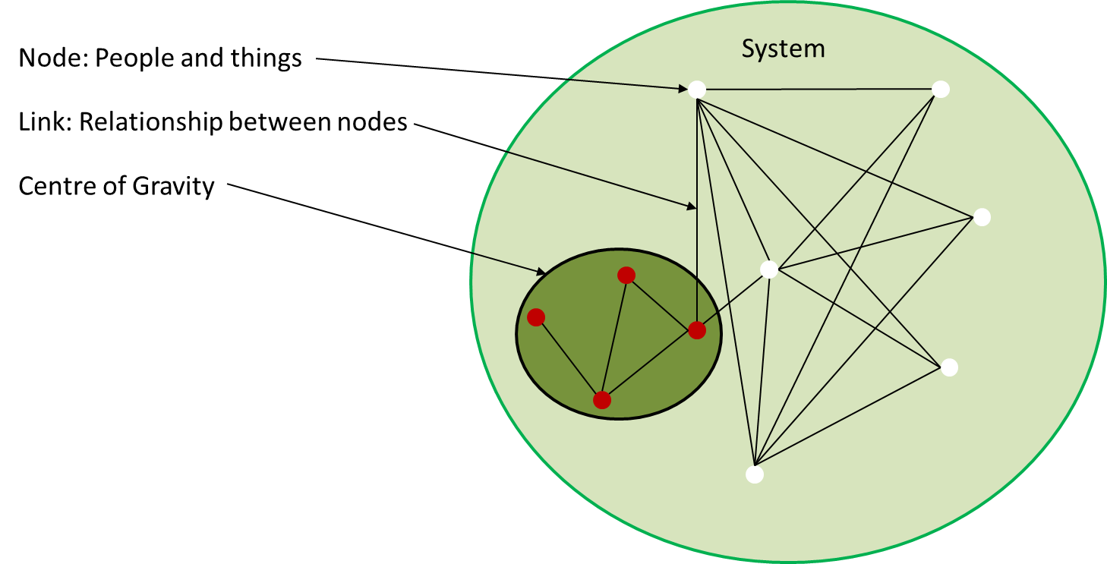

Figure 1 Systems perspective

##### Systems Perspective

A systems perspective of the Operational Environment (see Figure 1 Systems Perspective) assists with identification of enemy COGs and their critical capabilities, requirements, and vulnerabilities. ~~In combat operations,~~ This involves knowing an enemy’s ~~physical and psychological~~ strengths and weaknesses, and how the enemy organizes, fights, and makes decisions. ~~Moreover, the JFC and staff (including targeteers) must understand strengths and weaknesses in other OE systems (political, military, economic, social, information, and infrastructure [PMESII]) and their interaction with the military system~~. VIS analyzes the relevant systems in the operational environment based on understanding objectives, desired effects, and the JFC and JFACC mission, this analysis identifies a number of nodes and links. Identifying nodes and their links helps VIS assess the systems’ important capabilities and vulnerabilities and is the foundation of the systems perspective of the Operational Environment. This analysis identifies the interrelationship of systems and capabilities within an enemy’s COG(s) and decisive points; points for action to influence or change an adversary system behavior. A clear understanding of these relationships will help the JFACC and VIS in the identification of effective options to defeat the enemy COGs.

##### Nodes and Links.

System nodes are the tangible elements within a system that can be “targeted” for action, such as people, materiel, and facilities. Links are the behavioral or functional relationships between nodes, such as the command or supervisory arrangement that connects a superior to a subordinate, the relationship of a vehicle to a fuel source, and the ideology that connects a propagandist to a group of terrorists. Links establish the interconnectivity between nodes that allows them to function as a system — to behave in a specific way (accomplish a task or perform a function).

Thus, the purpose in targeting specific nodes is often to destroy, interrupt, or otherwise affect the relationship between them and other nodes, which ultimately influences the system as a whole. VIS link nodes to each other with sufficient detail to inform the JFACC of potential key nodes. These are nodes that might be related to a COG. Some may become decisive points for military operations since, when acted upon, they could allow the JFC/JFACC to gain a marked advantage over the enemy or contribute materially to attaining a desired effect. Key nodes are likely to be linked to, or resident in, multiple systems. ~~Since each enemy system (infrastructure, military, leadership, etc.) is composed of nodes and links, the capabilities of US instruments of national power can be employed against selected key nodes to attain operational and strategic effects.~~

A COG typically will not be a single node in the system but will consist of a set of nodes and their respective links (relationships). For example, Figure 3, Critical Factors, shows a notional enemy’s COG consisting of nodes and links. A single node might be considered a COG as an exception, such as when the enemy’s senior military leader is also the political leader and the nature of the adversary’s political and military systems is such that the leader’s demise would cause support for the conflict by other leaders in these systems to collapse. Also, systems can be broken down at various level. For example, one might consider an enemy’s key military capability (for example a Corps) to be a single node in the adversary’s military system, while a JFACC who must attack this capability would analyze it as a system of nodes and links in an effort to determine its critical capabilities and vulnerabilities.

##### COG Analysis.

COG analysis is important to targeting efforts because it identifies the enemy’s strengths and weaknesses, and how the adversary organizes, fights, and makes decisions. This analysis helps identify where those sources of power are vulnerable, where critical nodes within them are, and how they can be exploited.

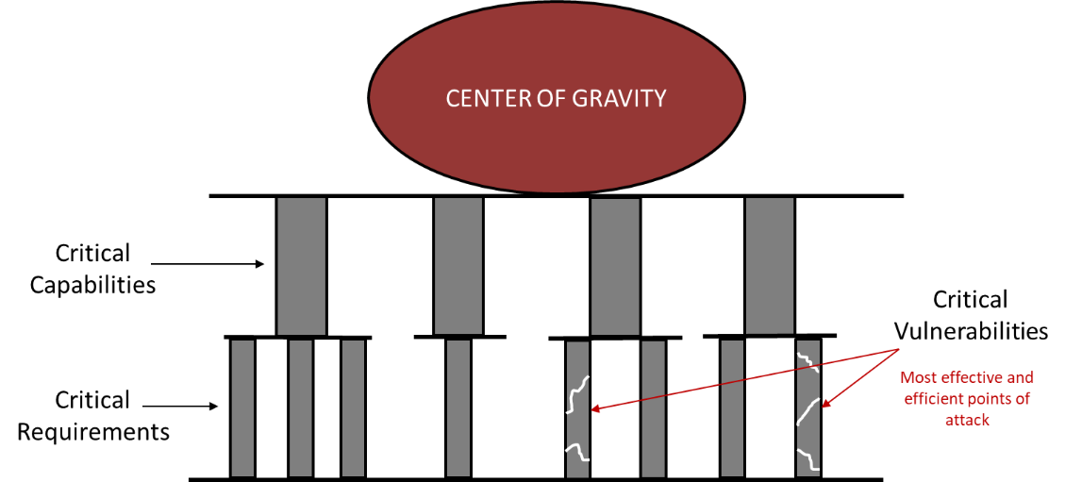

Figure 2 COG Analysis

##### Critical Factors.

Analysis begins with the COG as a source of power. The analysis identifies the inherent abilities that allows the COG to act as such (critical capabilities - CC); identifies the essential conditions, resources, or means (critical requirements - CR) that allow the COG to operate; and then determines where those critical requirements are vulnerable (critical vulnerabilities - CV). Collectively, these are called critical factors. While it can sometimes be difficult to pick CVs from critical requirements or translate the former into explicit target sets, analysis performed during target development may help “operationalize” the targets.

Once the systems analysis is mature, the planners should then try to identify the critical factors within that system. Those elements or functions that enable the COG are its critical capabilities. Once these are identified, planners should determine the critical requirements and CVs. When identifying enemy CVs, the JFACC and VIS will understandably want to focus their efforts against the CV that will do the most decisive damage to an adversary’s COG. However, in selecting those CVs, planners must also compare their criticality with their accessibility, vulnerability, redundancy, ability to recuperate, and impact on the civilian populace, then balance those factors against friendly capabilities to affect those vulnerabilities. The JFACC’s goal is to seek opportunities aggressively to apply force against an enemy in as vulnerable an aspect as possible, and in as many dimensions as possible. In other words, the JFACC seeks to undermine the adversary’s strength by exploiting adversary vulnerabilities, while protecting friendly vulnerabilities from enemies attempting to do the same.

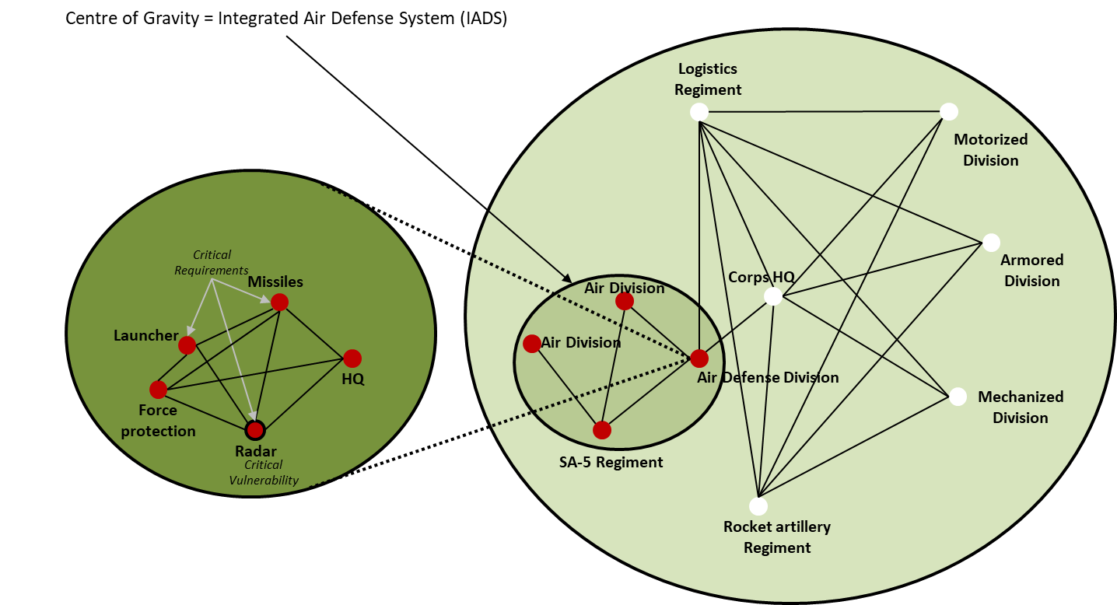

Figure 3 Critical factors

As an example, Figure 3 shows notional critical factors associated with a COG. In this example the enemy’s Integrated Air Defense System (IADS) is defined as the COG. The COG has two air divisions, one SA-5 regiment and one air defense division as the critical capabilities in the IADS. In this example we zoom in on the Air Defense division and identify that they have several nodes that all can be targeted, however only three of them are critical requirements: The missiles, the launchers, and the radar. Of these, the critical vulnerability is the radar since the system will not be able to operate without it, and the radar can be targeted by friendly anti-radiation missiles. This analysis can lead for a recommendation from VIS to JFACC to attack the enemy radars to neutralize the enemy integrated air defense system.

##### Decisive Points.

JFACC and VIS identify decisive points to help them determine where and how to apply friendly capabilities to exploit adversary vulnerabilities. A decisive point is a geographic place, specific key event, critical factor, or function that, when acted upon, allows a commander to gain a marked advantage over an adversary or contributes materially to achieving success (e.g., creating a desired effect, achieving an objective). The most important decisive points can be determined from analysis of critical factors. As part of the node-link analysis associated with a systems perspective, understanding the relationship between a COG’s critical capabilities, requirements, and vulnerabilities can illuminate direct and indirect approaches to the COG. It is likely most of these critical factors will be decisive points, which should then be further addressed in the planning process.

##### Direct Versus Indirect Approach.

The approach is the way JFACC contends with a COG; there are generally three approaches from which to choose. The decision facing JFACC is whether to attack the COG directly, indirectly, or through a combination of the two. A direct approach attacks the enemy’s COG or principal strength by applying combat power directly against it. However, COGs are generally well protected and not vulnerable to a direct approach. Thus, commanders usually choose an indirect approach. An indirect approach attacks the enemy’s COG by applying combat power against a series of decisive points that lead to the defeat of the COG while avoiding enemy strength. In theory, direct attacks against adversary COGs resulting in their neutralization or destruction provide the most direct path to victory — if this can be done in a prudent manner. In the event a direct attack is not a reasonable solution, JFACC should seek an indirect approach until conditions are established that permit successful direct attacks. In this manner, the enemy’s derived vulnerabilities can offer indirect pathways to gain leverage over its COGs.

#### Study of the enemy military

After completion of the COG analysis which focus on the enemy as a system (military, infrastructure, leadership etc.), VIS will go into a more detailed study of the enemy military. VIS will first create or update available threat models such as range rings for various enemy systems and time distance measurements from various locations. VIS will then analyze the current enemy situation before analyzing the enemy capabilities and listing high value targets.

* ~~- - - - - - - - - - --- --- --- ---- ---- ----- ---- ----~~
* ~~VIS will start with analyzing and identifying the enemy’s center of gravity (COG).~~
* ~~VIS will then create or update available threat models. This can be range rings for SAMs, artillery, rocket artillery, SCUD`s etc. In addition, this can be what distances are various enemy aircraft able to fly from their bases (playtime), what the A-A missile threats are (DOR/MAR/Homing/what kind of countermeasures and maneuvers work best to defeat missiles). These threat models should be presented in a graphical form, using for example CombatFlite as background.~~
* ~~VIS will then combine the information and provide an assessment of the enemy’s current capabilities, strengths, and weaknesses. In addition, VIS will identify enemy high value targets (HVT) and list the priority of these.~~

##### Threat Models

Threat models can be range rings for SAMs, artillery, rocket artillery, SCUD`s etc. Furthermore, threat models can also be time-distance from various locations (for either ground or air forces) to get a understanding of how fast an enemy unit can be at a certain location. In addition, threat models can include what distances are various enemy aircraft able to fly from their bases to get an understanding of their playtime or maximum reach. These threat models should be presented in a graphical form, using for example CombatFlite as background.

Threat models may also include A-A missile threats (DOR/MAR/Homing/what kind of countermeasures and maneuvers work best to defeat missiles), or more detailed study of enemy SAM threats (maximum altitude, range, homing, how to defeat with countermeasures or maneuvers).

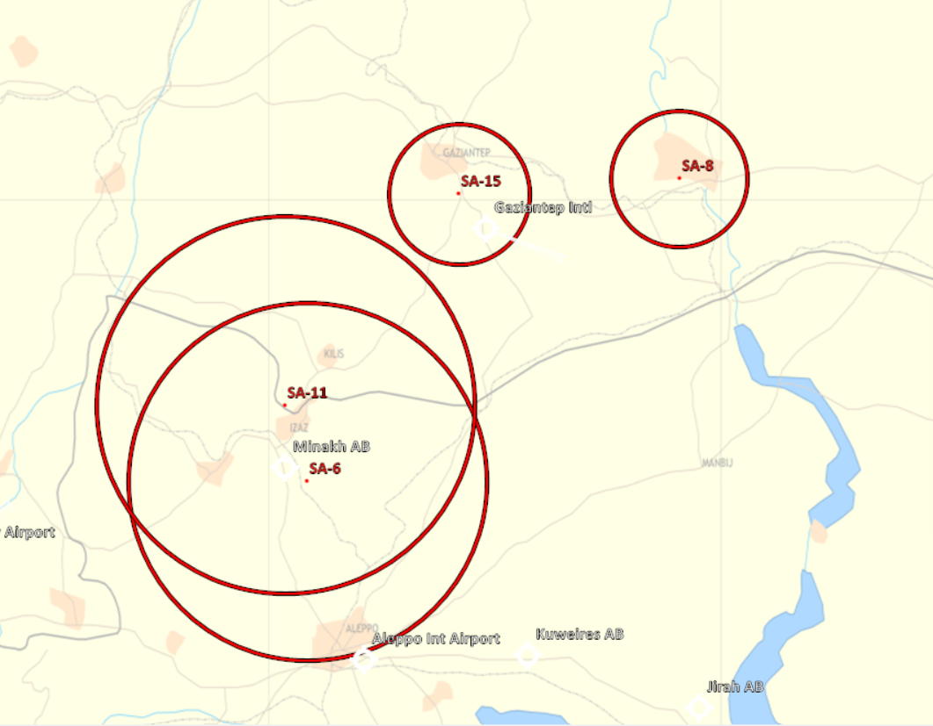

Figure 4 Example Corps Air Defense range rings

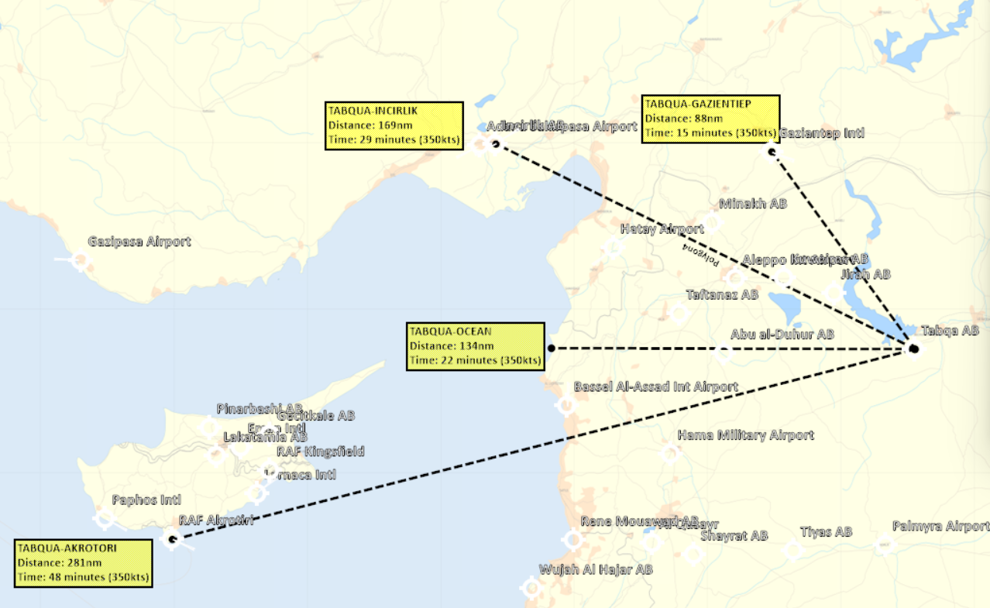

Figure 5 Example Time-distance air

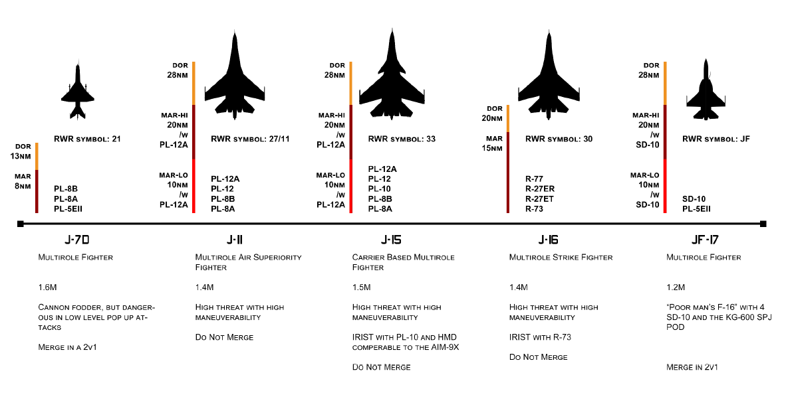

Figure 6 Example A-A Threats

~~describe and graphically portray threat tactics and employment options. They consist of three elements: 1) doctrinal templates, 2) description of preferred tactics, options, and follow on activities, and 3) identification of type high value targets (THVT). Doctrinal templates are "Graphic models based on known or postulated threat doctrine. Doctrinal templates illustrate the deployment pattern and disposition preferred by the adversary when not constrained by the effects of the battlespace environment."11 See Figure 4 for an example of a doctrinal template. THVTs are "Assets or target systems the adversary commander requires for the successful completion of the activity described as part of the threat model."12 THVTs are not "real" targets per se (e.g., an actual facility with a BE number). Rather, they simply describe what is important for execution of the activity being depicted. Later, in step four of the IPB process, these threat models are modified to reflect constraints imposed by the battlespace upon the adversary’s preferred method of operations. In addition to a graphical depiction, threat models are accompanied by textural information that describes the activities noted on the template, likely alternatives if the depicted activity fails (branches) or subsequent operations if the activity succeeds (sequels). Finally, threat models conclude by identifying and ranking the relative importance of THVTs.~~

##### Current Enemy Situation.

VIS determines the current adversary situation through a careful and detailed analysis of relevant order of battle (OB) data including force strength, ~~composition~~, and disposition ~~as well as observed TTPs and current training activities~~.

**Strength**

Strength describes a unit in terms of personnel, weapons, and equipment. Information concerning strength provides VIS/JFACC with an indication of enemy capabilities and helps determine the probable COAs or options open to the enemy. A lack of strength or a preponderance of strength has the effect of lowering or raising the estimate of the capabilities of an enemy force. Likewise, a marked concentration or build-up of units in an area gives VIS/JFACC certain indications of enemy objectives and probable COAs~~. During peacetime, changes in the strength of potential threat/adversary forces are important factors which may indicate changes in the threat’s/adversary’s intention~~. Strength is determined by comparing how a threat/adversary organization is doctrinally staffed and equipped with what the organization actually has on hand. During the a campaign, accurate BDA will aid VIS in keeping track of enemy unit strength. Morale can also be affected throughout a campaign (DCS Skill level high or low) through the steady flow of supplies or a lack of supplies such as food. Morale to the troops can also be raised by visits of high ranking generals.

~~Strength for regular forces is described in terms of personnel, weapons, and equipment. The most important aspect of strength when evaluating a regular force is to determine whether the force has the capability of conducting specific operations. For example, a unit may have adequate weapons systems to conduct an operation, but may not have a sufficient number of trained personnel or crews to man the systems.~~

**Disposition**

Disposition refers to how enemy forces are arrayed on the battlefield/battlespace. It includes the recent, current, and projected movements or locations of tactical forces. Enemy forces are generally conducting some form of offensive or defensive maneuver. ~~Irregular threat/adversary forces are generally in some part of the plan, prepare, execute, and assess phases for an operation such as a raid or ambush.~~ Understanding how the enemy doctrinally arrays itself on the battlefield/battlespace is important in developing a good understanding the enemy in step 3 as a foundaition for step 4.  ~~of threat/adversary models in step 3 of the IPB process and threat/adversary situation overlays in step 4 of the IPB process.~~ VIS familiarizes themselves with graphics developed during threat models that visually depict range fans with weapons’ fire limits and direct and indirect weapons capabilities to better understand enemy weapon systems.

When evaluating an enemy force, disposition refers to geographical location, tactical deployment, and movement of formations. Disposition consists of the location of enemy units and the way these units are tactically (or administratively in times of peace) deployed. In addition, disposition includes the recent, current, and proposed (or probable) movements of enemy units.

Location refers to a geographical area or position occupied by a unit or units. Knowledge of the strength and location of an enemy assists VIS in determining the capabilities of the force.

Tactical deployment is the relative position of units with respect to one another or to the terrain. Tactical formations are designed for executing the various tactical maneuvers. If this deployment can be predetermined, it leads to an accurate appraisal of intentions. The knowledge of how enemy units are echeloned may indicate (if the enemy assumes the offensive) which units will be used in the main attack and which units will be used in supporting reserve roles. Tactical deployment with respect to terrain is also important. A study of dispositions and an analysis of the terrain aid the development of conclusions concerning enemy capabilities, vulnerabilities, and intentions.

Movement of enemy units is also part of disposition. Movement is the physical relocation of a unit from one geographical point to another. Patrol activity may be an indication of planned movement. Movement is significant because it automatically changes the tactical deployment of the enemy forces.

When an enemy unit has moved, is moving, or will be moving, there are a number of actions which may affect the situation; for example, a unit may be moving into an attack position, or moving to reinforce or replace a unit, or perform other mission’s unknown to friendly forces. In view of these possibilities, movement of an enemy unit becomes important, and units are monitored at all times in order for the VIS to provide correct and detailed data on enemy dispositions.

~~5-28. When evaluating a regular enemy force at any point prior to receipt of mission, intelligence staffs will not know the terrain on which either the enemy or friendly force will be operating. Therefore, arraying the enemy on the battlefield/battlespace as commonly seen on an enemy situation overlay is not possible.~~

~~However, it is possible to doctrinally portray how the enemy will array itself on the battlefield/battlespace to conduct specific operations. This process is called threat/adversary templating, and is part of the threat/adversary modeling process. This is an ongoing process that is part of garrison intelligence operations. The threat/adversary templates developed here are reexamined and refined during IPB. The development of threat/adversary templates is the responsibility of intelligence staffs at any echelon.~~

##### Enemy Capabilities.

VIS will then study the enemy doctrine and tactics, and supporting operations to develop a complete picture of the enemy’s capabilities and will sum up the capabilities and limitations

The intelligence staff then combines quantitative OB analysis with a qualitative assessment of the adversary’s readiness, training, and effectiveness to develop a complete picture of adversary capabilities. Comparing the current adversary situation with threat models highlights current strengths and weaknesses.

###### Doctrine and tactics

Doctrine and tactics include tactical doctrine as well as tactics employed by specific units. While tactical doctrine refers to the enemy’s normal organization and employment principles (given in VID Intrep’s), tactics refer to the enemy force’s conduct of operations (given in VID intrep’s and developed based on enemy action observed). Based on knowledge of a enemy’s tactical doctrine, VIS can determine how the enemy force may employ its forces in the offense and defense under various conditions. ~~VIS integrate tactics in threat/adversary templates and other intelligence products~~. VIS will identify the enemy force’s possible actions (defend, reinforce, attack, withdraw, delay).

~~Doctrine and tactics for regular threat/adversary force refer to the TTP that guide threat/adversary force operations.~~ Understanding how the enemy force prefers to operate aids VIS/JFACC’s understanding of potential enemy COAs. TTP for enemy forces can generally be grouped in the following categories:

* Offensive tasks.
* Movement to contact.
* Attack.
* Exploitation.
* Pursuit.
* Defensive tasks.
* Area defense.
* Mobile defense.
* Retrograde.

###### Supporting operations

The enemy force’s adoption of a COA should depend on the ability of its support system to support that action. However, depending on the enemy force’s objectives, possible time constraints, and/or willingness to assume risk this could substantially alter adoption of a COA. With knowledge of these factors, VIS can better evaluate the enemy force capabilities, strength, and combat effectiveness.

The location of a enemy force’s logistical support structure elements aids VIS in determining the disposition of maneuver formations. Logistic information critical for effective intelligence analysis includes:

* Types of supply (food, ammunition or fuel).
* Lines Of Communications (LOCs). (Roads, rivers, railway, sea, air)
* Logistical requirements.
* Distribution priorities and procedures.
* Transportation networks and modes.
* Installations and terminals.
* Maintenance.

###### Capabilities and limitations

Capabilities are the broad COAs and supporting operations that the enemy can take to achieve its goals and objectives. The following five tactical COAs are generally open to military forces in conventional operations: defend, reinforce, attack, withdraw, delay.

Each of these broad COAs can be divided into more specific COAs. An attack may be OCA Strike, envelopment, penetration, or other variations of an attack. A defensive COA can be DCA CAP, Mobile defense or static defense. Other enemy force capabilities include support to broad COAs or specific types of operations, including:

* Deception operations.
* Cyber operations
* Intelligence operations. (Reconnaissance of targets or objectives)
* WMD employment.
* Sabotage, subversion, and terrorist operations (Using special forces).

Enemy capabilities take the form of statements, such as:

* The enemy has the ability to establish 3 CAP’s continually in the north area of operations
* The enemy has the ability to establish QRA alert on 1 airbase
* The enemy has the ability to conduct anti surface operations against friendly surface units (maritime)
* The enemy has the ability to insert up to two infantry battalions in a single lift operation.
* The enemy has the ability to shape the battlefield using artillery for a successful attack at city X
* The enemy can establish a prepared defense by 14 May.
* The enemy can effectively block traffic sea traffic coming out from Crete

When identifying threat/adversary capabilities, VIS will:

* Start with the developed threat models.
* Consider the enemy ability to conduct each operation based on all factors related to the current situation. (The enemy may be under-strength in equipment or personnel, short of logistic support, lacking air support, or the enemy’s troops may be have low morale.)

~~Regular Threat/Adversary Forces~~

~~5-70. A regular threat/adversary force is designed to attack or defend as necessary to accomplish objectives. Determining capabilities and limitations for a regular threat/adversary force requires an understanding of the art and science of war, as well as an understanding of the threat/adversary force itself.~~

##### Describe The Enemy’s Options

The study of the enemy military includes a description of the enemy’s preferred tactics.

The description:

* Lists the options available to the enemy  ~~should the operation fail or succeed.~~
* Prevents the threat models from becoming more than a “snapshot in time” of the operation being depicted.
* Aids in mentally wargaming the operation over its duration and during the development of enemy COAs
* Addresses typical timelines and phases of operation, points where unit’s transition from one form of maneuver to the next and how each warfighting function contributes to the success of the operation (Command and control, maneuver, fires, logistics, intelligence).

VIS describes the actions of the supporting warfighting function in enough detail to allow for identification and development of HVTs. VIS also examines each phase separately because target values may change from phase to phase.

###### Objectives

VIS describes and decides what goal or goals the enemy is trying to achieve. ~~Threat/adversary objectives are often, but not always, what the unit’s mission is trying to prevent; they are often actions taken by the threat/adversary to prevent unit mission accomplishment.~~

Enemy objectives will be specific to the type of enemy, the AOR, the unit’s composition and mission, and other factors. For example, a corps can have an objective to occupy a large area of enemy territory, while a battalion or brigade can have an objective to control a village or city. A fighter squadron can have as its objective to provide ground support to an attack, or to establish CAP or QRA. VIS also describes the enemy objective in terms of purpose and end state. ~~A number of different functions must be executed each time a enemy force attempts to accomplish a mission.~~

###### Time event matrix

VIS may develop a time-event matrix to describe how an enemy normally conducts specific types of operations. For example, it may be impossible to graphically depict the complex relationships between the air, naval, and ground operations of an enemy’s operation. In this case, a time event matrix could be used to show the sequencing of specific types of enemy operations and supporting operations, as well as changes in the organization, composition, and likely disposition of enemy forces during each phase of the operation (see Table 4 Time event matrix). A Time event matrix may aid VIS in identifying what targets are more important at certain times, or what indicators to look for to anticipate certain actions from the enemy.

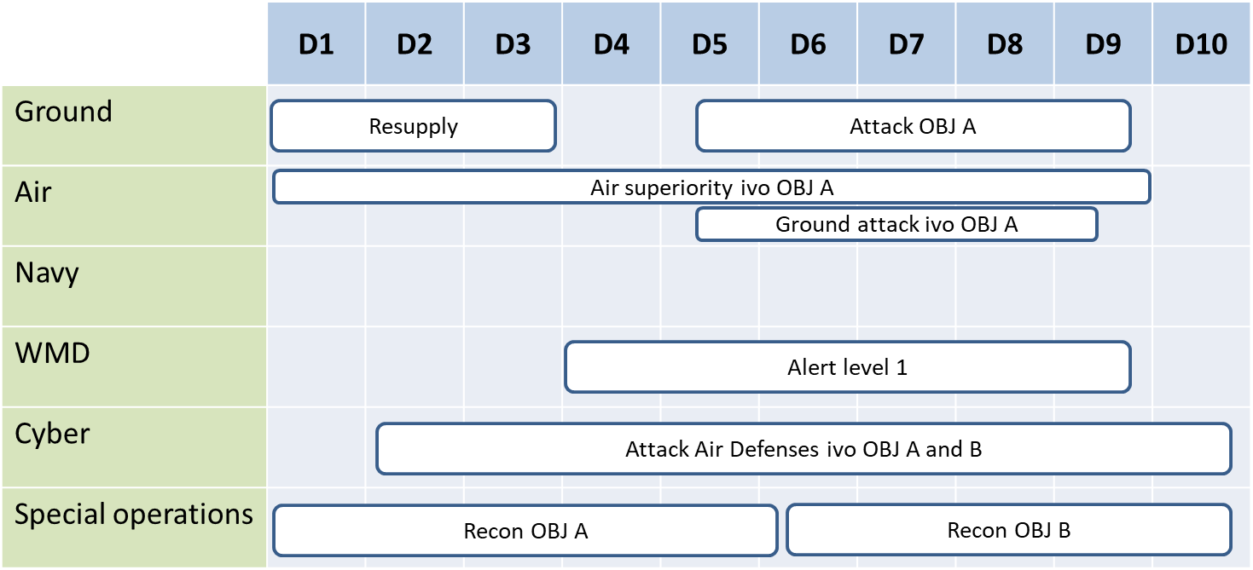

Table 4 Time event matrix

In this example the enemy ground forces are preparing to attack objective A, but before they can start their attack, they need to resupply their forces. Special operations are conducting reconnaissance of the objective, while cyber operations are trying to attack the air defenses in the vicinity of (IVO) objective A in order to facilitate the air operations for creating air superiority and ground attack IVO OBJ A. Just prior to the ground attack, the WMD forces are raising its alert level to 1 in order to disperse forces to avoid being attacked in an anticipated response to the attack on OBJ A.

##### High Value targets (HVT)

The study of the enemy military should also include a list of High Value Targets (HVTs). These targets are identified by combining judgment with the evaluation of the information contained in intelligence reports and the work on the IPB so far. Assets are identified that are critical to the success of the enemy’s mission, that are key to the enemy’s supporting operation, or that are crucial to the enemy’s adoption of various variants to the operation.

For example, an enemy ground force that are attacking a heavily defended area may need artillery and rocket artillery to grind down the defenses. While doing this shaping operation the enemy is vulnerable for attacks from the air and the ability to deny attacks form the air are crucial and therefore its air defense assets are high value targets together with the necessary artillery for defeating the defending force.

Or for example, when mentally wargaming an enemy air attack against friendly targets supported by a well-prepared air defense system, it is logical to conclude that the enemy will need a substantial air defense suppression package as part of its operation to ensure the success of the attack. In this case, the artillery and air assets that form this suppression package are HVTs.

~~For example, an adversary ground force defending a front across a peninsula may be vulnerable to amphibious flanking attacks in its rear area. In this situation, the adversary’s ability to deny access to its rear area coastal waters may be crucial, and therefore its coastal defense assets (artillery, antiship cruise missiles, local surface and subsurface combatants) may constitute HVTs. SCA can be useful to identify and broaden the JFC’s understanding of HVTs as well as potentially revealing additional options for lethal and nonlethal actions against them and determining second- and third-order effects of those actions. Within IW environments, adversary HVTs may include keys nodes within the associated human threat network. For example, the adversary may be dependent on support from local tribal/village leaders, or transnational criminal/drug trafficking organizations to operate in the local vicinity, town, village, or sub-province, or to gain access to friendly bases through contract or local national employees. Either of these groups may also exert influence with regional or international violent extremist organizations, and they all may provide either direct or indirect support to adversary operations. In this instance, the~~

~~individuals used as middlemen to communicate or coordinate among tribal/village elders~~

~~or criminal organizations may constitute HVTs. The JFC, in conjunction with the~~

~~national IC, collaborates to identify HVTs with appropriate analytic production centers.~~

~~This collaboration should be conducted by any available secure communications means.~~

The following techniques may be useful in identifying and evaluating HVTs:

(1) Identify HVTs by mentally wargaming and thinking through the operation under consideration and how the enemy will use the assets to support it.

(2) Determine how the enemy might react to the loss of each identified HVT. Consider the enemy’s ability to substitute other assets (from another unit or a different area), or to adopt a different option.

(3) Evaluate and rank order all HVTs according to their relative worth to the adversary’s operation (using target value analysis, see below). Also, analyze whether a target’s value depends on, or changes with, each phase of the operation.

~~(4) Construct a target value matrix by grouping HVTs according to their function. The target value matrix should indicate the relative worth of each HVT category and describe how an attack on that category (to include the timing of the attack) would affect the adversary’s operation (see Figure IV-6).~~

###### Target value analysis (TVA)

HVTs should be prioritized by their relative value to the enemy’s operation. Target value analysis assists in prioritizing HVTs. Target value analysis is a process led by VIS as part of targeting that quantifies the relative value of HVTs with each other in relation to the enemy operations. This analysis is based in part on the conclusions reached by VIS upon evaluating the enemy in the study of the enemy military. ~~The IPB products required to support target value analysis are the threat template, the HVT list, and the threat capability statement. These products assist the fires cell and the rest of the staff in—~~

* ~~Providing a focus for the commander’s target acquisition effort.~~
* ~~Identifying priorities for the engagement of enemy targets to facilitate the mission’s success.~~
* ~~Identifying effects criteria.~~

**NOTE**: While target value analysis is conducted initially during IPB in the air campaign planning, it is a separate process that is repeated throughout the execution of the air campaign as part of targeting. To be effective, this analysis depends on the most current intelligence related to the enemy. Initially, based on the understanding of the enemy developed during step 3 of IPB, target value analysis should be refined based on the enemy COAs developed during step 4 of IPB, and refined continually based on changes ~~to the threat overlay~~ during operations. Whenever conducted, VIS supports target value analysis with the most up-to-date threat-related intelligence.

###### CARVER matrix

The CARVER matrix is a target value analysis tool used to identify and prioritize specific targets, so attack resources can be used efficiently (See table 5 Carver matrix). CARVER stands for criticality, accessibility, recoverability, vulnerability, effect, and recognizability.

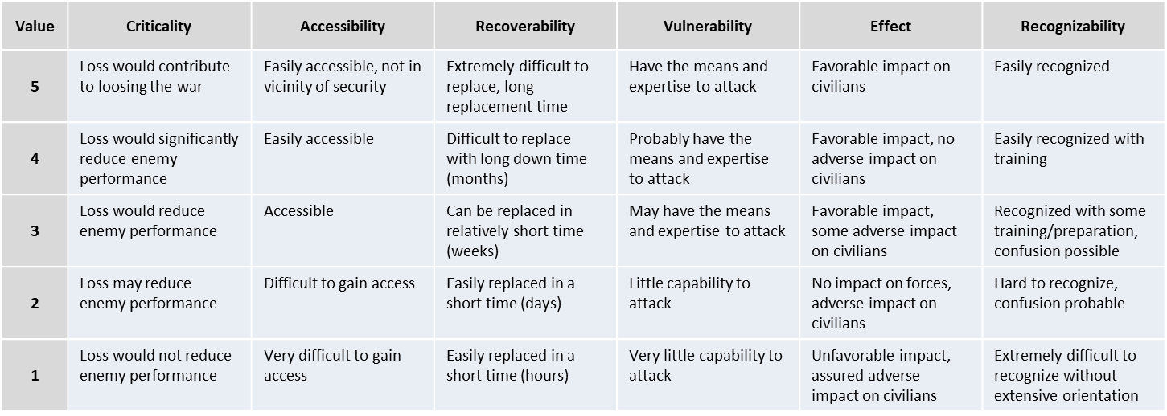

Table 5 Carver matrix

CRITICALITY

Criticality means target value. This is the primary consideration in targeting. A target is critical when its destruction or damage has a significant impact on military, political, or economic operations. Targets within a system must be considered in relation to other elements of the target system. The value of a target will change as the situation develops, requiring the use of the time-sensitive methods which respond to changing situations. For example, when one has few locomotives, railroad bridges may be less critical as targets; however, safeguarding bridges may be critical to maneuvering conventional forces which require use of such bridges.

ACCESSIBILITY

A target is accessible when an operational element can reach the target with sufficient personnel and equipment to accomplish its mission. A target can be accessible even if it requires the assistance of knowledgeable insiders. This assessment entails identifying and studying critical paths that the operational element must take to achieve its objectives and measuring those things that aid or impede access.

RECOVERABILITY

A target's recoverability is measured in time; that is, how long will it take to replace, repair, or bypass the destruction of or damage to the target? Recoverability varies with the sources and type of targeted components and the availability of spare parts availability.

VULNERABILITY

A target is vulnerable if the operational element has the means and expertise to successfully attack the target. When determining the vulnerability of a target, the scale of the critical component needs to be compared with the capability of the attacking element to destroy or damage it.

EFFECT

The effect of a target attack is a measure of possible military, political, economic, psychological, and sociological impacts at the target and beyond. This is closely related to the measure of target criticality. The type and magnitude of given effects desired will help planners select targets and target components for attack. Effect in this context addresses all significant effects, whether desired or not, that may result once the selected target component is attacked. Traditionally, this element has addressed the effect on the local population, but now there are broader considerations.

RECOGNIZABILITY

A target's recognizability is the degree to which it can be recognized by an operational element and intelligence collection and reconnaissance assets under varying conditions. Weather has an obvious and significant impact on visibility. Rain, snow, and ground fog may obscure observation. Road segments with sparse vegetation and adjacent high ground provide excellent conditions for good observation. Distance, light, and season must also be considered. Table 5 is an example of a CARVER matrix.

Example:

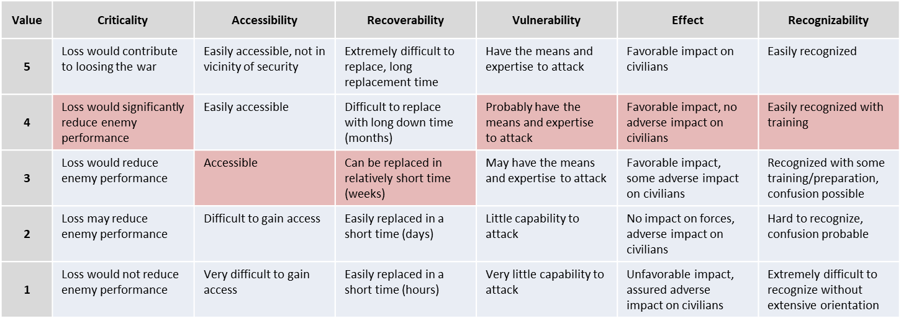

Table 6 Carver matrix example 1: MLRS

In the example above in table 6 we have a MLRS unit from the Rocket artillery regiment, which is a Corps resource. Since this is a Corps resource it is likely protected by Corps or Division Air defenses and placed outside artillery range from the FLOT. The MLRS unit have a CARVER value of 22.

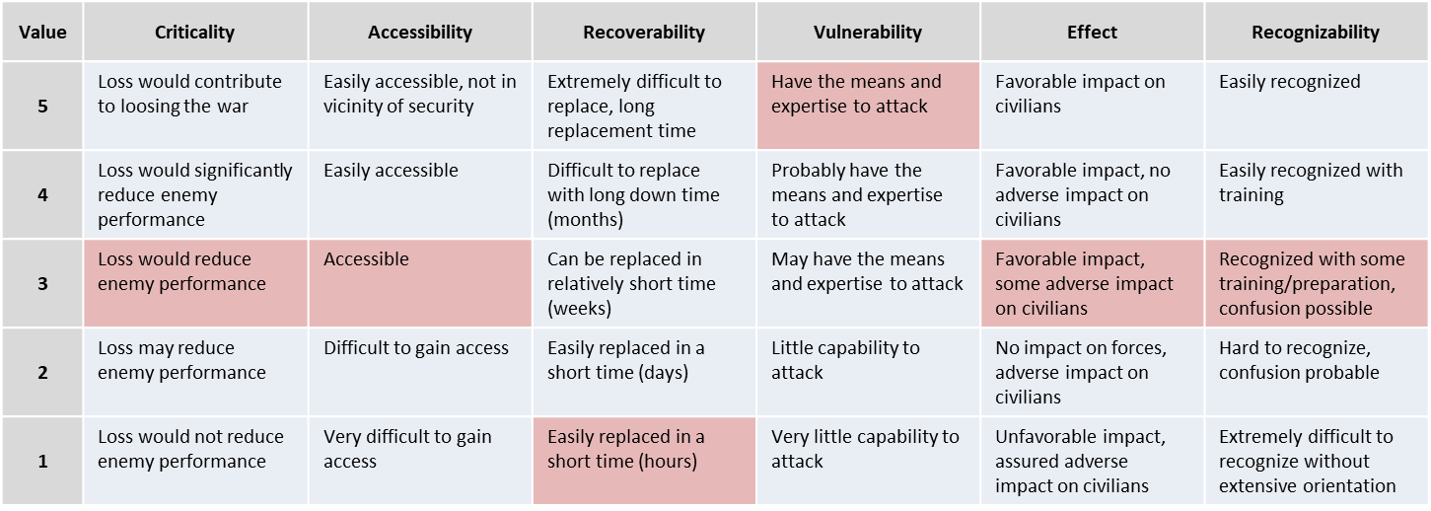

Table 7 Carver matrix example 2: Artillery

In the example above in table 7 we have a brigade artillery unit that are located close to the FLOT. Since this is a brigade resource supporting a maneuver battalion it does not have any specific defenses other than manpads. The artillery unit is located close to a civilian village. This gives a CARVER value of 18.

#### Step Three Final Results:

1. A listing of enemy COGs.

2. Graphic threat models. Such as SAM rings, altitude distance. Aircraft A-A missile threats DOR/MAR etc. Range rings for Artillery, rocket artillery, MLRS, SCUDs.

3. A definitive and current enemy order of battle (OOB) (Ground and Air excel spreadsheet).

4. A assessment of the enemy’s current capabilities, strengths, and weaknesses.

5. A prioritized listing of High Value Targets (HVTs).

### Step Four: Determine Enemy Courses of Action.

This final step identifies, develops, and prioritizes enemy COAs consistent with the COGs developed in step three, the enemy’s doctrine, and their assessed objectives. Step four’s purpose is to identify likely enemy COAs that can be exploited to shape the battlespace and accomplish the friendly mission. ~~Crucial to this step is the identification of associated high value targets (HVT) that the adversary must preserve in order to execute their intended COAs~~ and named areas of interest (NAI) which are used to determine which of the projected COAs the adversary has actually chosen. Information derived and products produced while performing steps one through three are fused together to project what the enemy is likely to do given the environment and his capabilities. ~~Finally, as friendly information requirements are identified during execution, decision support products are produced to ensure the commander has the right information at the right time.~~

~~Sub Steps.~~

~~In order to meet the needs and requirements of Air Force planning and execution processes, the Air Force IPB model step four consists of six sub steps. These steps are also step four’s final products whether presented orally, graphically, or textually.~~

~~1. Identify the adversary’s likely objectives and desired end state.~~

~~2. Evaluate and prioritize adversary COAs and their associated COGs.~~

~~3. Explicitly identify threat assumptions.~~

~~4. Identify targets valuable to the enemy in executing COAs and nominate for attack those targets that best will achieve the chosen friendly COA and objectives.~~

~~5. Identify collection requirements that monitor significant battlespace characteristics, provide indications on which COA the adversary has chosen, and assist JFACC in assessing the operational effectiveness.~~

~~6. Produce decision support products that ensure intelligence sensors and producers are arrayed to collect, process, exploit and disseminate the right data at the right time to support key operational decisions.~~

#### The Final Result of IPB—The COA Package.

Throughout the IPB process several intermediate intelligence products might be produced, which are helpful to the planning process and can be used for a myriad of other purposes. However, these earlier products are preparatory to the final result. The culmination of the IPB process yields very specific intelligence products, which are tailored to meet the needs of JFACC being supported. At a minimum, two COAs should be developed—the enemy’s most likely COA (ML COA) and the most dangerous COA (MD COA). This gives JFACC a "best estimate" and "worse case" for planning purposes. If time allows, alternative enemy COAs are developed. Each COA includes a description of expected enemy objectives and end states, enemy activities, the associated time and phases expected in executing the COA, expected force dispositions, associated COGs, a list of assumptions about the enemy made when projecting the COA, a list of refined HVTs, and a list of NAIs~~. This information is then combined into decision support products, which ensure collection assets are on hand to monitor adversary COA projections and provide key battlespace information at the time that the commander needs it. The various components of a COA package are defined and an example of a basic decision support product is included below.~~

~~High Value Target (HVT). "A target the enemy commander requires for the successful completion of the mission. The loss of high value targets would be expected to seriously degrade important enemy functions throughout the friendly commander’s area of interest."~~

~~Named Areas of Interest (NAI). "The geographical area where information that will satisfy a specific information requirement can be collected. Named areas of interest are usually selected to capture indications of adversary courses of action but also may be related to conditions of the enemy or the battlespace."~~

## Targeting

As part of the IPB process, VIS will identify a range of targets that are included or can be added to the Joint Target List (JTL). As part of air campaign planning, VIS support the targeting process by refining the Joint Target List (JTL) and include the priority (see annex 4 target priorities) on individual targets based on the effect they have on the enemy system.

### Target Analysis.

Target analysis is an examination of potential targets to determine relevance to stated objectives, military importance, and priority of attack. Target Analysis consist of Target system analysis (TSA) and Target Value Analysis (TVA)It is a process produced through the VIS intelligence production process. Typical products include TSA and nodal system analysis studies generally used as a baseline for target selection. In CNA planning, for example, TSA uses an expanded methodology to examine all aspects of information flow to expose interrelationships and criticality. Targeting personnel use these products to identify target systems and system components supporting JFC/JFACC objectives. Planners use the results of iterative target analysis throughout the campaign and in all phases of targeting to update objectives, guidance, and assessments. While target analysts look at all aspects of the target system.

#### Target System Analysis

Target system analysis (TSA) is a process that analyses systems, networks, components and their elements with a view to identifying the best target to effect JFC/JFACC’s requirement. TSA forms the basis of target identification and is at the very center of intelligence support to targeting. TSA aids and simplifies target selection, is crucial to BDA, helps priorities target materials production and identifies intelligence gaps. TSA identifies the relative importance of individual target system components, elements and nodes. TSA examines:

* Specific target system functions
* Target systems’ dependencies on, and linkages to, other target systems
* The impact of exploitation of particular target elements on the overall system as well as on other target systems which are functionally related through those target elements.

This is conducted as a system and nodes and link analysis similar to what is done for COG’s.

The first step is identifying those target system(s) supporting enemy activity. While a single target may be significant because of its own characteristics, the target’s real importance lies in its relationship to other targets within an operational system. Target systems are usually complex, with interdependent components (see Figure 7 Target System Components and Elements) and contribute to a wide variety of activities directed toward pursuit of system goals. Examples of target systems are an enemy’s command& control structure, air defense structure, ground forces and facilities, and various form of industry (Ammunition, food, fuel).

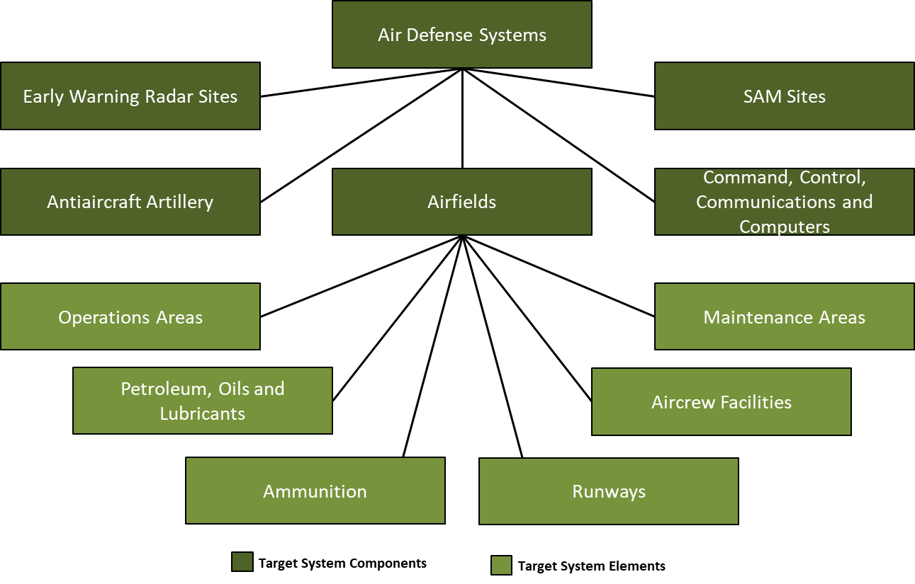

Figure 7 Target System Components and Elements

A target component is a set of targets within a target system performing a similar function. Emphasis is shifted from the system to the specific activities, such as industries and basic utilities involved in producing parts of an end product. The same general analytic process applies for non-industrial target systems. For example, the components of a enemy Air Defense system might include Early Warning radar sites, antiaircraft artillery, airfields, SAM sites, and Command&Control. Each of the components can be broken down into the supporting elements. Targeting personnel should use the target value analysis when examining the target system components and elements

#### Target Value Analysis (TVA)

Target value analysis is a process led by VIS as part of targeting that quantifies the relative value of targets with each other in relation to the enemy operations. This analysis is based in part on the conclusions reached by VIS upon evaluating the enemy and the targets in the Target System Analysis. TVA will use the Carver matrix to prioritize targets. See Section 3.1.3.2.5.2 Carver Matrix.

### Target validation

Validation is a part of target development that ensures all targets meet the objectives and

criteria outlined in the JFC and JFACC’s guidance and ensures compliance with the law of war and rules of engagement. ~~Targets are validated against multinational concerns in a bilateral environment.~~

Target vetting and validation should be revisited as new intelligence becomes available or the situation changes. Target validation is done by targeting personnel, in consultation with the planners, servicing advocate general, and other experts and agencies, as required.

Target validation asks such questions as:

* Do the targets meet Joint Force Commander (JFC)/JFACC objectives and guidance?
* Does the desired target effect support the end state?
* Is engaging the target lawful? What is the law of war and rules of engagement considerations?
* Does the target contribute to the enemy capability and will to wage war?
* Is the target (still) operational? Is it (still) a viable element of a target system? Where is the target located?
* Will striking the target arouse political or cultural “sensitivities?”
* How will striking the target affect public opinion (enemy, friendly, and neutral)?
* Are there any facilities or targets on the no-strike targets collocated with the target being validated?
* What is the relative potential for collateral damage or collateral effects, to include casualties? Consider collateral damage concerns in relation to law of war, rules of engagement, and JFC/JFACC’s guidance.
* ~~What psychological impact will operations against the target have on the adversary, indigenous populations, friendly forces, and multinational partners?~~
* Is it feasible to engage this target at this time? If not, could it be targeted at another time? What is the risk?
* Would engaging the target generate significant environmental impacts or arouse environmental sensitivities?
* Will engaging the target negatively affect friendly operations due to current or planned friendly exploitation of the target?
* How will actions taken against the target impact other operations?
* What is the impact of not conducting operations against the target?

### TST

Time sensitive targets (TST) are high priority targets designated by the Joint Force Commander or JFACC that warrant immediate response, either because of their threat to friendly forces, or because of their highly lucrative but fleeting nature.

Some examples of potential TST could include:

* Mobile rocket launchers
* Mobile high threat surface-to-air missile systems
* Mobile command and control (C2) vehicles and facilities
* Vessels or aircraft that pose a significant threat and demand an immediate action (for example about to lay a mine field)
* Weapons of mass destruction and their supporting systems
* Fixed targets (e.g. a previously untargeted bridge that is about to be crossed by an enemy armoured counterattack force rapidly becomes time-sensitive).

### Risk levels

The level of acceptable risk awareness is critical to successful targeting during planning and execution. During execution of time sensitive targets, increases risk due to insufficient time for the more detailed coordination and deconfliction that takes place during pre-planned targeting. JFACC/VIS must assess risk early, determine what constitutes acceptable risk, and communicate their intent. Certain targets may be determined to be such a threat to the force or mission accomplishment that a higher level of risk is accepted in order to attack the target immediately upon detection. Issues for consideration in the risk assessment include:

* Risk to friendly forces (fratricide), risk to non-combatants, and collateral damage potential
* Law of armed conflict and rules of engagement compliance
* Increased risk to attacking forces due to accelerated planning and coordination
* Redundant attacks and wasting limited resources
* Non-optimal weapon selection and employment
* Opportunity cost of diverting assets from their planned missions

These considerations are balanced against the danger of not attacking the target in time and thus risking mission failure, harm to friendly forces, or losing the opportunity to strike the target. More commonly, the risk associated with dynamic targeting involves the trade-off of diverting ISR and strike assets from already scheduled missions to emerging targets. This is done when commander’s priority dictates. Planning options such as reserving on-call assets can mitigate much of this opportunity cost.

### VIS targeting output

The output of VIS targeting is an updated and validated Joint Target List (JTL) as an input for the execution of the air tasking cycle in the execution of the air campaign. VIS targeting effort also gives VIS unique subject matter expert understanding of the enemy that will aid VIS in the role as advisors for JFACC, aircrew and controllers during execution. VIS targeting also gives VIS a understanding of the enemy to provide nominations to time sensitive targets for JFACC and JFC approval.

### Air Campaign Planning Targeting Meeting

Representatives from VIS and JFACC meet to synchronize their effort prior to executing the air campaign. This can be conducted as a meeting but may also be conducted by providing the necessary information if time for a meeting is not possible. The Air Campaign Planning Targeting meeting is only conducted once and is done prior to the detailed planning of ATO day 1 on the air campaign.

The Air Campaign Planning Targeting Meeting ideally kick of JFACC air campaign planning step 4: strategy identification and is conducted after VIS is finished with the IPB.

VIS will start the targeting meeting with presenting:

* Current enemy situation (ground, air, IADS)
* Enemy Center of Gravity
* Enemy ML/MD COA
* Enemy HVT list
* Intelligence Requirements (intelligence gaps)
* Recommendations for targeting in various phases
  + Big picture (not individual targets)
  + For example:
    - Recommend neutralizing enemy A-A interference by runway destruction on Airfield A, B and D at the start of the campaign as this will prevent enemy A-A Squadrons based at these airfields from taking off and taking part in combat.
    - Recommend destroying enemy long-range artillery prior to friendly ground assault in order to avoid friendly forces being engaged by artillery during their offensive.
    - Recommend destroying Corps air defenses (SA-6, SA-11, SA-15, and SA-8) by the three first days of the conflict to facilitate for AR/CAS to support Land Component Commander (LCC)
    - Recommend destroying food supplies to lower morale after initial air defenses are neutralized.
* Recommended Time Sensitive Targets (TST)

JFACC will then present the following information:

* Current friendly situation (Ground and air, including supporting assets and ordnance status. Also include what airbases aircraft will operate out from).
* Guidance from CJTF (Directions and Guidance or orders received with guidance)
* JFACC objectives
* Anticipated air support needed for supporting LCC and MCC .
* What assets are available targeting efforts (What kind of aircrafts, how many aircrafts for planning assumptions)

The information presented by both VIS and JFACC give everyone a good understanding of the overall enemy and friendly situation and will create the background for the following discussion about the targeting strategy and suggested phasing of the campaign.

Output of the meeting is:

* Common understanding of enemy center of gravity between VIS and JFACC
* Targeting strategy: What to target and when (target priority, “big picture”)
* Draft phasing of the campaign (what to target at what time)
* Time Sensitive Target list

# VIS Execution of the air campaign

The execution of the air campaign cycle starts with section 4.4 Planning and direction, so for the first mission in a campaign, start at section 4.4. For all other ATO days in the campaign, the flow described below is the normal flow during the campaign (After the first ATO day). In preparation for ATO D2, VIS will start with processing and exploitation of information/intelligence from ATO D1, before producing intelligence and disseminating it to users. After dissemination VIS will start preparing for ATO D2 by doing the planning and direction step, followed by collection.

## Processing and exploitation

VIS should establish a master log of all intelligence: VIS Intelligence log. All reports, observations and information should be registered in this VIS Intelligence log. HOPEFULLY TECHNICAL TOOLS FOR AUTOMATION.

## Production

Production converts data into intelligence and creates the knowledge needed for the

planning and execution of operations. The intelligence must deliver knowledge, in context, in

time, and in a form usable in the decision-making process. Intelligence production involves filtering, recording, evaluating, analyzing, synthesizing, and assessing all information relevant to a particular IR. During the production phase, information is:

* Evaluated to determine the reliability of the source and the credibility of the information.
* Analyzed to isolate significant elements.
* Integrated with other relevant information and previously developed intelligence.
* Interpreted to form logical conclusions and predictions that clarify the situation and support the commander’s decision-making process.
* Produced in the format most suitable to the user (JFACC, aircrew or controllers).

Analytical Process

VIS personnel use a framework described as screening, analysis, synthesis, and estimation. This framework calls for a disciplined approach to gathering and understanding information. The

analyst must place information in context and relate it to the current situation, planned or ongoing operations.

### Step 1: Screen Collected Information

During this ~~step the execution of single-source intelligence or all-source analysis~~, analysts continuously filter the volume of information or intelligence received ~~through the continuous push and pull of information~~. It is during the screen phase that analysts sort information based on relevancy and how it ties to the analytical questions or hypotheses they developed in earlier steps in the intelligence cycle to fill information gaps. They do this by conducting research and accessing only the information that is relevant to their PIRs/IRs, mission, or time. Analysts also screen the volume of information based on the information source’s reliability and the information accuracy, as explained below.

|  |  |
| --- | --- |
| **Reliability** | |
|  |  |
| A | **Completely reliable**: Clearly a known source or reliable information |
| B | **Usually reliable:** A known source that provides reliable information |
| C | **Fairly reliable:** A source that has reported information with a degree of reliability |
| D | **Not usually reliable:** Typically, a source who provide information with a heavy bias, or past data was no validated |
| E | **Unreliable:** Information provided is not reliable; typically, information cannot be confirmed by any means possible with any degree of certainty |
| F | **Reliability cannot be judged**: There is no basis for estimating the reliability |
| **Accuracy** | |
| 1 | **Confirmed by other sources:** One can state with certainty there is corroborating information |
| 2 | **Probably true:** There is no actual proof, but no reason exists to assess, the source of the information is already available |
| 3 | **Possibly true:** Information may not at present be available to refute the accuracy |
| 4 | **Doubtfully true:** There is information that contradicts the accuracy |
| 5 | **Improbable:** No confirmation, and the information contradicts other reliable/accurate sources |
| 6 | **Truth cannot be judged:** Information does not meet the criteria above |

Table 1 Evaluation ratings for source reliability and information accuracy

Time permitting, analysts research by accessing information and intelligence from VIS master intelligence log, earlier intelligence reports, intelligence summaries. AAR’s.

~~databases, the internet (attributed to open-source information), collaborative tools, broadcast services, and other sources such as automated systems~~. This screening enables analysts to focus their ~~analytical~~ efforts on only the information that is pertinent to their specific analytic problem. ~~(See ATP 2-22.9 for more information on open-source information; see appendix A for more information on automated systems.)~~

Analysts may decide to retain or exclude information based on results from the screen phase. While the excluded information may not be relevant to the current analytical question, the information is maintained in the VIS intelligence log as it may answer a follow-on question from a new analytical question.

### Step 2: Analysis

Analysts must possess a thorough knowledge of military operations, the operational

environment, the friendly situation, IRs, and the threat situation.

VIS personnel will:

* View collected information in the context of the mission, commander’s intent, and IRs.
* Identify key elements of the situation to formulate hypotheses, make deductions from those hypotheses, and reach conclusions.
* Divide the battlespace into component parts to isolate and define the elements of significant information (physical dimension, time, threat force structure, battlespace activities, and other characteristics) to facilitate understanding and satisfy the user’s needs.
* Compare the existing situation to new information to determine whether it relates to identified IRs and to assess its impact on the current intelligence estimate.

Analysts examine relevant information or intelligence using reasoning and analytic techniques, which enable them to see information in different ways and to reveal something new or unexpected. It may be necessary to gain more information or apply a different technique, time permitting, until a conclusion is reached, or a determination is made.

Reliable and accurate information is integrated into the analytical production. Data that is less reliable or accurate is not discarded; it is retained for possible additional screening with other established information or if new requirements arise that are relevant to existing data.

### Step 3: Synthesis

Synthesis determines relationships that exist among information and pieces the information together into a coherent, meaningful picture. VIS personnel will:

* Identify and integrate relationships between individually significant pieces of information with the existing operational environment to provide a new picture of the situation.
* Discern emerging patterns in environmental conditions or enemy activity.

As analysts reach new conclusions about the threat activities during the analyze phase, they should corroborate and correlate this information with prior intelligence holdings using reasoning and analytic techniques. Analysts determine how new information relates to previous analytical conclusions. New information may require analysts to alter or validate initial conclusions. Analysts must continue to evaluate and integrate reliable and accurate information relevant to their mission.

Analysts resume the analysis based on questions (hypotheses) they established during the screen and analyze phases. At this point, analysts begin to draw conclusions that translate into an initial determination that is likely to require additional analysis and, in certain instances, additional collection~~. They employ the analytic tradecraft standards to assess probabilities and confidence levels; they employ the action-metrics associated with analytical rigor to draw accurate conclusions. However, some of~~ ~~these conclusions may present alternative COAs not previously considered during IPB. These COAs must be presented to the commander and staff because they might have operational implications. (Appendix C discusses the analytic tradecraft standards and the action-metrics associated with analytical rigor.)~~

An analyst’s ultimate goal is finding threat vulnerabilities and assisting the commander and staff in exploiting those vulnerabilities—despite having answered the commander’s PIR. If the intelligence analysis does not answer the commander’s PIR, the analyst should reexamine the guidance, consider recommending different collection strategies, and review information previously discarded as nonessential. Sometimes, the cause for not answering the requirement is the analyst’s misunderstanding of the commander’s PIR or guidance, thus the analyst must return to the original question posed by the commander and reevaluate the initial hypothesis

### Step 4: Estimation

Estimation, the bottom line of the analytical process, is based on detailed studies of the tactical situation, experience, intelligence successes, the application of specific tools and methods, and the supported commander’s intelligence needs. Estimation must describe the current conditions and present an image of future possibilities. Analysts then determine the enemy’s:

* Capabilities.
* Intent.
* Probable COAs.
* Likely reactions to friendly operations.

Well-founded estimates help manage uncertainty about the situation and facilitate planning and

executing successful operations.

Analysts must properly express and explain uncertainties associated with any major analytical judgment. When briefing their analytical results, VIS personnel, should be able to assess the likelihood of an event happening, expressed by using estimative language. Phrases ~~(such as we judge, we assess, and we estimate)~~ commonly used to convey analytical assessments and judgments, are not facts, proofs, or knowledge. Intelligence analysts use estimative language, ~~shown in figure C-1,~~ to convey their assessment of the probability or likelihood of an event ~~and the level of confidence ascribed to the judgment.~~

~~Then, they must express their confidence level—high, moderate, or low—in that assessment. For intelligence analysts to reach a high level of confidence in the accuracy of their analytical assessment, they must apply the actions of high analytical rigor found in table C-1 on page C-5.~~

|  |  |  |  |  |  |  |  |
| --- | --- | --- | --- | --- | --- | --- | --- |
| Expressions of likelihood | Almost no chance | Highly unlikely | Unlikely | Even chance | Likely | Highly likely | Almost certain |
| Probability | 01-05% | 05-20% | 20-45% | 45-55% | 55-80% | 80-95% | 95-99% |

Table 2: Estimative language expression of likelihood

#### Expressing Confidence in Assessments

VIS may also add their confidence level on their assessments. Confidence levels express the strength of the assessment given the reasoning, methodologies, gaps, and assumptions; the number, quality, and diversity of sources; and the potential for deception. ~~To avoid confusion, assessment language and confidence levels are not combined in the same sentence.~~

Confidence in a judgement is based on three factors: The number of key assumptions required, the credibility and diversity of sources, and the strength of the argumentation. Each factor should be assessed independently and then in concert with the other factors to determine the confidence level. Confidence levels are ascribed using high, moderate, and low levels of confidence in analytical assessments:

* **High confidence level.** High confidence generally indicates that sound reasoning and/or methodologies have been applied; no linchpin assumptions have been made; no critical gaps relevant to the issue are evident; consistent evidence from a variety of independent sources supports the judgment; the potential for deception is low; the body of reporting is not consistent with a plausible alternative; and/or the nature of the issue allows one to render a solid judgment. A high confidence judgment, however, is not a fact or a certainty, and such judgments still carry a risk of being inaccurate.
* **Moderate confidence level**. Moderate confidence generally indicates that potentially critical assumptions are used to fill gaps; some inconsistencies exist, but the preponderance of evidence supports the judgment; the information is credibly sourced and plausible but is not of sufficient quality or is not sufficiently corroborated to warrant high confidence; moderate potential for deception exists; and/or the body of reporting leaves open the possibility of a plausible alternative explanation of events.
* **Low confidence level**. Low confidence generally indicates that key assumptions have been used to fill critical gaps; significant inconsistencies or questions exist regarding the evidence; the information is fragmented or uncorroborated or is of questionable credibility and/or plausibility; high potential for deception exists; and/or the body of reporting supports an alternative explanation of events.

## Dissemination

Distribute reports and intelligence

## Planning and direction

### Intelligence Collection

VIS intelligence effort begins with receipt of the mission and the CJTF/JFACC's guidance. On-hand intelligence is rarely sufficient to support comprehensive planning and decision-making needs and gaps will remain. Such intelligence gaps are known as intelligence requirements (IR).

An intelligence requirement is any subject, general, or specific, upon which there is a need for the collection of information, or the production of intelligence. Intelligence requirements (IR) are questions about the enemy and the environment, the answers to which JFACC, aircrew or controllers requires to make sound decisions. The breadth of potential intelligence gaps, however, will generally far exceed intelligence capabilities available. Thus, it is important to focus intelligence operations on those intelligence requirements crucial to mission success. We call these requirements priority intelligence requirements (PIR) (This does not mean that only PIR can be collected on. Both PIR and IRs can be collected on and used for production of intelligence).

Generally, the difference between a PIR and an IR is that JFACC must have the answer to the PIR to make a decision. At any one time there are not many PIRs in effect. PIRs are prioritized among themselves and may change in priority over the course of an evolution. It is JFACC who designates the priority intelligence requirements (based on recommendations or nominations from VIS) and therefore provides direction to the intelligence effort.

The lowest priority PIR takes precedence over the highest priority IR. IRs are questions typically generated by VIS, aircrew or controllers but not ones that JFACC feels they needs answered before making decisions. While there are ideally a few PIRs, there may be many IRs. Like PIRs, IRs should be prioritized against each other to support effective intelligence planning and operations. PIRs and IRs have the following characteristics.

Each PIR or IR:

* Asks only one question.
* Focuses on specific facts, events or activities concerning the enemy or the battlespace.
* Is tied to mission planning, decision-making, or execution.
* Provides a clear, concise statement of what intelligence is required.
* Contains geographic and time elements to limit the scope of the requirement.

Example PIR

* Will Russian military forces intervene in Syria on D5?
* How will Russian military forces intervene in Syria in phase 2?
* What are Syrian air defense posture ivo Damascus in phase 3?
* Where are Syrian SCUDs located on D4?
* Where are Syrian rocket artillery located at the start of phase 1?

Example IR

* Are Syrian SA-11 still operational IVO Tabqua on D3?
* Are Russian SU-34 based on Bassel Al Assad in phase 2?
* What are Syrian air defense posture ivo Jirah in phase 3?
* What is the status of Syrian QRA on D3?

For VIS, any RFI from JFACC, aircrew or controllers are an IR (or should be converted into an IR).

VIS may create Named Areas of Interest (NAI) that will aid in the collection of information

Named Areas of Interest are the geographical area where information that will satisfy a specific information requirement can be collected. Named areas of interest are usually selected to capture indications of adversary courses of action but also may be related to conditions of the enemy or the battlespace.

The first thing VIS will do with their prioritized list of IR/PIRs are to develop indicators that may aid in answering the question. Some IR/PIRs only have one or a few indicators, while other IR/PIRs are very complex and have many indicators. The indicators and answer to these will aid in the production of intelligence while answering the IR/PIR. See example of indicators below.

Example IR with indicators

* Are Syrian SA-11 still operational IVO Tabqua on D3?
  + Are SA-11 vehicles seen IVO Tabqua?
  + Are SA-11 radar transmission reported ivo Tabqua
  + Are SA-11 vehicles seen or reported leaving Tabqua?
* Are Russian SU-34 based on Bassel Al Assad in phase 2?
  + Are there air tracks that have terminated at Bassel Al Assad?
  + Are SU-34 reported ivo Syria?
  + Where are SU-34 aircraft originating?
  + What is the current composition of aircraft on Bassel Al Assad?
  + Is there Russian presence on Bassel Al Assad?
  + What kind of Russian activity are reported on Bassel Al Assad in phase 1?
* What are Syrian air defense posture ivo Jirah in phase 3?
  + What SAM units are located ivo Jirah?
  + What AAA units are located ivo Jirah?
  + What radar activity are reported ivo Jirah?
  + What aircrafts are currently based at Jirah?
* What is the status of Syrian QRA on D3?
  + What are the times from detection to launch for Syrian QRA at Tabqa?
  + What are the times from detection to launch for Syrian QRA at Jirah?
  + What aircrafts are used as QRA aircrafts?
  + What kind of weapons are the QRA aircrafts using?
  + Do the QRA aircraft have external fuel tanks?
  + What are the QRA aircraft tactics once airborne?
  + From what airbases were Syrian aircraft launched on D1 and D2?

When VIS have a prioritized list of IRs and PIR’s with indicators, VIS will make a decision for each IR/PIR if they belong in one of the following three categories:

* Production
  + This means that VIS have enough information about this IR/PIR to start producing intelligence to answer the IR/PIR. Follow steps as outlined in section 4.2
* Collection
  + VIS do not have sufficient information about this IR/PIR to start producing intelligence, but by using JFACC assets (aircrew or controllers) they can collect more information in subsequent ATO days to get information to answer the IR/PIR later.
* RFI
  + VIS do not have sufficient information about this IR/PIR to start producing intelligence and JFACC assets are likely not able to collect relevant information to answer til IR/PIR. VIS will then submit an RFI to VID for additional information that may help contribute to answering the IR/PIR later.

**Collection**

For IR/PIRs that are categorized as for collection VIS will ensure they have indicators that are observable/reportable so that aircrew and controllers are able to answer them during the flight. Indicators are given a number tied to the IR/PIR so that pilots can answer the correct indicator, and that it will make it easier for VIS to collect the information and make sense of it during intelligence collection. For example, if IRs are labelled with numbers 1-10, then indicators can be given as X.1, X.2 etc. Example:

* IR 1: What is the status of Syrian QRA on D3?
  + 1.1: What are the times from detection to launch for Syrian QRA at Tabqa?
  + 1.2: What are the times from detection to launch for Syrian QRA at Jirah?
  + 1.3: What aircrafts are used as QRA aircrafts?
  + 1.4: What kind of weapons are the QRA aircrafts using?
  + 1.5: Do the QRA aircraft have external fuel tanks?
  + 1.6: What are the QRA aircraft tactics once airborne?

Having multiple assets answer the same IR/PIR (either the same indicators or different indicators) provides VIS with the best possible information to be able to answer the IR/PIR during production of intelligence as this will give different perspectives.

VIS will inform JFACC about the IRs they have listed for collection as an input to the targeting meeting. After the targeting meeting, JFACC will use the inputs and give order in the ATO for relevant flights to collect on the indicators listed. If required JFACC may also task flights with intelligence collection as the mission for the flight.

It is important for VIS and JFACC to not overload aircrew and controllers with IR/PIRs with many indicators if the flight is tasked with doing something else. As a rule of thumb, all flights should have at least a few indicators that they should answer after the flight. If a flight is dedicated for collecting intelligence, the aircrew/controllers may have a longer list of IR/PIR and indicators for that specific flight.

The various indicators do not necessarily work for everyone, and VIS and JFACC should ensure that they give the task to collect on the right indicator to an asset that is suited for answering the questions. See example below:

* IR 1: What is the status of Syrian QRA on D3?
  + 1.1: What are the times from detection to launch for Syrian QRA at Tabqa?
    - AWACS Controller
  + 1.2: What are the times from detection to launch for Syrian QRA at Jirah?
    - AWACS Controller
  + 1.3: What aircrafts are used as QRA aircrafts?
    - Aircrew
  + 1.4: What kind of weapons are the QRA aircrafts using?
    - Aircrew
  + 1.5: Do the QRA aircraft have external fuel tanks?
    - Aircrew
  + 1.6: What are the QRA aircraft tactics once airborne?
    - AWACS controller and aircrew

MAKE A SYSTEM FOR RFI HANDLING UP AND DOWN + IR HANDLING + CR + CM

### Targeting

### Targeting meeting

As part of the air tasking cycle JFACC and VIS may meet to conduct a targeting meeting. Ideally the targeting meeting start JFACCs stage 2 (Targeting, weaponeering, MAAP and AOD) in the Air Tasking Cycle.

Representatives from VIS and JFACC meet to synchronize their effort prior to the next ATO day. This can be conducted as a meeting but may also be conducted by providing the necessary information if time for a meeting is not possible. The targeting meeting can be conducted for each ATO day, or for any interval JFACC and VIS deem necessary (For example every other ATO day, or once for every phase). Ideally the targeting meeting start JFACCs stage 2 in the Air Tasking Cycle for each ATO.

VIS will start the targeting meeting with presenting:

* Weather (forecast for next period)
* Current enemy situation (ground, air, IADS)
* BDA last ATO
* Enemy ML/MD COA next ATOs (24-72 hours out) (Any changes to already briefed ML/MD COA)
* Current TST list
* Intelligence Requirements (intelligence gaps)
* Any recommendations for targeting

JFACC will then present the following information:

* Current friendly situation (Ground and air, including supporting assets and ordnance status) and planned operations next period.
* New guidance from higher CJTF (Directions and Guidance or orders received with guidance)
* Air requests from Land Component Commander (LCC or Maritime Component Commander (MCC).
* What assets are available for next ATO day (to be tasked with targeting)

The information presented by both VIS and JFACC give everyone a good understanding of the enemy and friendly situation. The next item to be presented are JFACC and VIS nominations to the Joint Prioritized Target List for the next ATO. After the nominations VIS and JFACC will discuss and agree on a prioritized list of the targets. If there are any discrepancies, JFACC will have the final word. This will be the approved JPTL for next ATO cycle.

JFACC and VIS will also present and suggest a draft JPTL for the subsequent ATO cycle so both VIS and JFACC know what the likely priorities on the subsequent ATO cycle are.

Finally, VIS and JFACC validated the time sensitive target list (make sure to add new TSTs if required, or remove TSTs if applicable).

## Collection

During ATO execution VIS will have no active role for the collection. This will be handled by aircrew and AWACS controllers.

~~XXXXXXXXXXXXXXXXXXXXXXXXXXXXXXXXXXXXXXX~~

~~XXXXXXXXXXXXXXXXXXXXXXXXXXXXXXXXXXXXXXXXXXXXXXXXXXXXXXXXXXXX~~

Collection management (CM) is defined as “In intelligence usage, the process of converting intelligence requirements into collection requirements, establishing, tasking or coordinating with appropriate collection sources or agencies, monitoring results and retasking, as required.” The CM process is a staff activity that is focused on decisions and choices that concern collection requests (CRs) and requests for information (RFI). Such requests may originate from the unit commander, the operations staff, or the intelligence staff. They may also be levied by external organizations, such as theater headquarters, a joint task force headquarters, as well as lateral and subordinate units. The source and scope of levied requirements are typically related to the collection capabilities or tasking/requesting authority of a given unit. There are a variety of ways to task the intelligence system to gain needed information for operational use. A myriad of collectors, ranging from humans to airborne collectors that are controlled manually or are software-driven, are tasked to fulfill intelligence requirements. It is the responsibility of intelligence support personnel at the unit level to accurately determine the direction and flow of intelligence information. Intelligence needs, referred to as requirements, are registered based on time sensitivity. Requirement’s definitions, as they apply to the air operation, are as follows:

* Time Critical Requirements - Requester needs in less than 24 hours, tactical in nature. Missions already employed or alert assets will usually be tasked (e.g., request for the location of a SCUD TEL that has recently launched a missile is a fleeting requirement).
* Routine Requirements - Requester needs in 24 hours or more, supports routine combat operations. Will be addressed through the collections process (e.g., creation of collection targets to search for specific enemy units that have not yet been located in the AOR).
* Standing Requirements - Established before a contingency arises and provides a baseline for the intelligence problem set (i.e., request to monitor airfields for operational activity).

The objective of the CM process is to satisfy the commander's essential elements of information (EEIs). These are necessary to accomplish the given mission and assigned operational tasks. The collection manager is a central figure of the process, serving to coordinate and facilitate the activities of two cyclic, mutually supporting functions: the translation and development of taskings, referred to as Collection Requirement Management (CRM), and the employment of intelligence collection resources, known as Collection Operations Management (COM). The two functions are structured to support the operational commander's mission statement in a responsive manner (figure 2.2).

~~IR eller RFI~~

~~Intelligence gaps or information needs are formally labeled intelligence requirements (IR). An intelligence requirement is any subject, general or specific, upon which there is a need for the collection of information, or the production of intelligence.~~

~~PIRs are those intelligence requirements for which a commander has an anticipated and stated priority in the task of planning and decision-making. PIRs are prioritized among themselves and may change in priority over the course of an evolution. Only the commander designates PIRs.~~

~~Generally, the difference between a PIR and an IR is that a commander must have the answer to the PIR to make a decision. At any one time there are not many PIRs in effect.~~

~~The lowest priority PIR takes precedence over the highest priority IR. IRs are questions typically generated by the staff but not ones that the commander feels he needs answered before making decisions. While there are ideally a few PIRs, there may be many IRs. Like PIRs, IRs should be prioritized against each other to support effective intelligence planning and operations. PIRs and IRs have the following characteristics.~~

~~Each PIR or IR:~~

* ~~Asks only one question.~~
* ~~Focuses on specific facts, events or activities concerning the enemy or the battlespace.~~
* ~~Is tied to mission planning, decision-making, or execution.~~
* ~~Provides a clear, concise statement of what intelligence is required.~~
* ~~Contains geographic and time elements to limit the scope of the requirement.~~

# Chapter XX: Theory INPUTS

## Intelligence

Intelligence strives to accomplish two objectives. First, it provides accurate, timely, and relevant knowledge about the enemy (or potential enemy) and the surrounding environment. In other words, the primary objective of intelligence is to support decisionmaking by reducing uncertainty about the hostile situation to a reasonable level—recognizing, of course, that the fog of war renders anything close to absolute certainty impossible. In achieving its primary objective, intelligence performs four related tasks. First, it identifies and evaluates existing conditions and enemy capabilities. Second, based upon those existing conditions and capabilities, it estimates possible enemy courses of action, providing insight into possible future actions. Third, it aids in identifying friendly vulnerabilities the enemy may exploit. Finally, intelligence assists in the development and evaluation of friendly courses of action based on the results of the first three tasks.

Intelligence uncovers conditions which can be exploited and simultaneously provides warning of enemy actions. Intelligence thus provides the basis for our own actions, both offensive and defensive.

~~The second intelligence objective is that it assists in protecting friendly forces through counterintelligence. Counterintelligence includes both active and passive measures intended to deny the enemy valuable information about the friendly situation. Counterintelligence also includes activities related to countering hostile espionage, subversion, and terrorism. Counterintelligence directly supports force protection operations by helping the commander deny intelligence to the enemy and plan appropriate security measures.~~

~~The two intelligence objectives demonstrate that intelligence possesses both positive—or exploitative—and protective elements~~. Intelligence uncovers conditions which can be exploited and simultaneously provides warning of enemy actions. Intelligence thus provides the basis for our own actions, both offensive and defensive.



### Information

**Information as a Resource.** Information is one of the most precious resources available to any decision maker (JFACC, aircrew or controller). By nature, humans are information processors who seek knowledge of the past, present, and prospects for the future. Without valid information, decision makers have no logical basis for choosing one course of action over another. Increasing information generally decreases uncertainty in decision making, up to a point of diminishing returns, where too much information can confuse a situation. In a sense, information is like fire insurance. It has little value until it is needed, but then it is invaluable.

**Sources of Information.** Information can take many forms and be derived from many sources. Information can result from observing or reporting an event. It can be derived from the manipulation of facts through computation. It can also result from professional opinions, judgments, and interpretations by participants. Information may be objective or subjective. Usually, it comes from a combination of sources and is a presentation of both fact and insight.

**Characteristics of Information.** Information has many characteristics and does not come without cost. Acquiring sufficient, accurate, and timely information can be very expensive. It can be perishable and is generally imperfect. Consequently, information from one source should be verified with another source whenever possible. Frequently, information derived from one source can be used as a cue in researching other sources or in collecting additional or different information. Information can be acquired through various methods. Each has advantages, and all have inherent and environmental limitations and constraints. The observer, as a source of information, is often biased. Observers are also limited by what can be seen. Since it is difficult to observe an elaborate and dynamic system, the tendency is to “freeze” the situation and examine individual system parts in a static state. In doing so, essential ingredients are frequently lost. There is often the danger of attributing a great degree of precision to imperfect assessments or measurements. Because of these many limitations, information varies in validity and reliability.

**~~Information Threshold.~~** ~~The information threshold is that point in time when one has accumulated enough information to make a valid decision. In theory, one should keep collecting information until the information threshold or the point of adequacy is reached. As figure 2.1 suggests, independent information sources 1, 2, and 3 do not provide sufficient information to reach the threshold. But when information from all three sources is combined, the threshold is reached and the point of diminishing returns (that is, when the additional information costs more to collect than the value gained from having it) is reached. Keep in mind that the point of adequacy for information is adjustable depending on the fidelity of information needed. If the various portions are viewed as an “information budget”, the information threshold and collection resources can be managed accordingly.~~

### Intelligence

**Intelligence Processing**. Since information does not present itself for exploitation, it must be sought, gathered, assembled, and processed into usable form. The outcome is the transformation of raw information into intelligence suitable for making valid decisions. Intelligence is required for both planning campaigns (JFACC) and for planning and conducting tactical operations (JFACC, aircrew and controllers).

~~There are three levels of intelligence support: strategic, operational, and tactical. Strategic intelligence is required for the formulation of strategy, policy, and military plans and operations at national and theater levels. Operational intelligence is required for planning and conducting campaigns and major operations to accomplish objectives within theaters or areas of operations. Tactical intelligence is required for planning and conducting tactical operations.~~ Intelligence sources are the means or systems used to observe, sense and record, or convey information. There are seven primary intelligence source types: imagery, human, signals, measurement and signature, open source, technical, and counterintelligence.

The overall objective of intelligence is to enable commanders and combat forces to “know the enemy” and operate smarter. It helps commanders across the range of military operations by collecting, analyzing, fusing, tailoring, and disseminating intelligence to the right place at the right time for key decision making. Intelligence provides indications of enemy intentions and guides decisions on how, when, and where to engage enemy forces to achieve the commander’s objectives. It assists in combat assessment through munitions-effects assessment and bomb-damage assessment

Intelligence organizations integrate technical and quantitative assessments with analytical judgments based on detailed knowledge of the way the enemy thinks and operates. Intelligence personnel should maintain an independent perspective. Commanders anticipate that even the best intelligence may not provide a complete picture, especially when the enemy is practicing deception or when the intelligence is derived from a single source. Still, intelligence gives commanders the best available estimate of enemy capabilities, COGs, and courses of action.

### Intelligence cycle

Intelligence provides clear, brief, relevant, and timely analysis on enemy capabilities and intentions for planning and conducting military operations. The intelligence community uses the intelligence cycle which is broken down into five separate categories or steps.

The intelligence cycle is defined as: “*the steps by which information is converted into intelligence and made available to users*”. The five steps in the cycle are:

* **Planning and direction**: determination of intelligence requirements, preparation of a collection plan, issuance of orders and requests to information collection agencies~~, and a continuous check on the productivity of collection agencies.~~
* **Collection:** acquisition of information and the provision of this information to processing and/or production elements.
* **Processing:** conversion of collected information into a form suitable to the production of intelligence.
* **Production**: conversion of information into intelligence through the integration, analysis, evaluation, and interpretation of all source data and the preparation of intelligence products in support of known or anticipated user requirements.
* **Dissemination**: conveyance of intelligence to users in a suitable form.

~~Interaction with Air tasking Cycle~~

~~Stage 1: Objectives and effects. Directions & Guidance (Planning and direction)~~

~~Stage 2: Targeting, weaponeering, MAAP and AOD (processing production)~~

~~Stage 3: ATO and ACO production (dissemination)~~

~~Stage 4: Execution (collection)~~

#### Planning and direction

The first phase in the intelligence cycle is planning and direction. This phase consists of the identification of intelligence requirements and the planning of intelligence operations and activities to satisfy those requirements. JFACC directs the intelligence effort; VIS manages this effort for JFACC. In so doing, the VIS is guided by the JFACC's intent, the established priority intelligence requirements, and specific guidance provided by JFACC for the conduct of the intelligence effort. Planning and direction encompass the supervision of collection, processing, production, and dissemination operations as well as developing the intelligence structure necessary to support planned or ongoing operations.

#### Collection

Collection is the second phase of the intelligence cycle. During collection, organic, attached, and supporting intelligence sources collect and deliver information to the appropriate processing or production unit—or, in some instances, directly to the appropriate commander for immediate action. Effective collection depends upon the use of a variety of mutually reinforcing sources. Necessary, planned redundancy and overlap of sources increase the reliability of information and can reduce the effectiveness of enemy deception or denial efforts.

#### Processing and exploitation

Processing and exploitation are the third phase of the intelligence cycle, the conversion of raw data into a form suitable to produce intelligence. Largely a technical function, processing and exploitation converts the data into an understandable form and enhances its presentation. Examples of processing and exploitation include developing and interpreting a piece of film, translating a foreign-language text, or decoding an encrypted radio report. Not all information requires processing; some is collected in a form already suitable for production. Sometimes processing and exploitation occurs automatically during collection.

Registering in log for 132nd

#### Production

The fourth phase of the intelligence cycle is production, the activities by which processed data is converted into intelligence. Production involves evaluating the pertinence, reliability, and accuracy of information. It involves analyzing information to isolate significant elements. It includes integrating all relevant information to combine and compare those elements of information with other known information.

Finally, production involves interpreting the information to form logical conclusions that bear on the situation and that support the commander's plan to engage the enemy. Production is a process of synthesis—the most important action in developing usable intelligence for the commander. Production arranges the intelligence pieces to form coherent images. It is this step which adds meaning to these pieces, creating knowledge. Synthesis does not generally create a complete image—totally filling in the gaps and eliminating uncertainty— but it should provide an image from which the commander can reach an acceptable level of understanding. In the end, synthesis answers the all-important question: "What effect does all of this have on our ability to accomplish the mission?"

#### Dissemination

The fifth phase of the intelligence cycle is dissemination, the timely conveyance of intelligence in an appropriate form and by a suitable means to those who need it. Depending on its importance and time-sensitivity, intelligence may be disseminated—" pushed"——directly to users, or it can be sent to an accessible data base from which commanders can "pull" that intelligence which they need (see figure 3). Intelligence flows by any number of channels or methods. The form intelligence takes can influence dissemination. Some intelligence can be transmitted almost instantaneously to multiple users via a digital communications link, while other intelligence must be physically delivered by courier. The channel or means of dissemination is less important than the arrival of the intelligence at the proper destination on time and in a form readily usable to the commander. Depending on the urgency and time-sensitivity of the intelligence, it may follow established communications channels, or it may be broadcast to the entire force simultaneously as an alert or alarm.

The final phase in the intelligence cycle is utilization. The commander may provide direction, information may be collected and converted into intelligence, and the intelligence may be disseminated, but unless that intelligence is exploited through decision and action, it has served no purpose. Utilization is not a function of intelligence per Se, but rather of command and control—making the decision and then carrying it out. This reinforces two important points made earlier: first, intelligence has no value for its own sake but assumes value only when acted upon; and secondly, intelligence is inextricably linked to command and control.

No one phase of the intelligence cycle is more important than the others—they are interdependent. Without proper direction, the other phases will be uncoordinated and ineffective. Without effective collection, there may be too much or too little information, and the information obtained may prove irrelevant. Without processing and production, the resulting mass of information may appear meaningless. Lengthening production time will delay dissemination. The first four phases of the intelligence cycle offer marginal value unless the intelligence arrives to the right person in time and in a useful form to support decision-making. Finally, intelligence operations are wasted if commanders fail to understand and act upon the knowledge intelligence offers. For simplicity, the intelligence cycle is described as a sequential method; however, in practice, it is a dynamic process responsive to changes in the situation and the commander's evolving intelligence needs.

### Intelligence Collection

VIS intelligence effort begins with receipt of the mission and the CJTF/JFACC's guidance. On-hand intelligence is rarely sufficient to support comprehensive planning and decision-making needs and gaps will remain. Such intelligence gaps are known as intelligence requirements (IR).

Intelligence requirements (IR) are questions about the enemy and the environment, the answers to which JFACC, aircrew or controllers requires to make sound decisions. The breadth of potential intelligence gaps, however, will generally far exceed intelligence capabilities available. Thus, it is important to focus intelligence operations on those intelligence requirements crucial to mission success. We call these requirements priority intelligence requirements (PIR).

Priority intelligence requirements (PIRs) are intelligence requirements associated with a decision that will critically affect the overall success of the command's mission. Priority intelligence requirements constitute JFACC’s guidance for the intelligence collection, production, and dissemination efforts. The nature and scope of intelligence requirements will vary with the level of command and its mission. Further, the type of operation and at what particular phase of planning or execution the commander states a requirement will be major influences on its breadth and complexity. However, it is the commander who designates the priority intelligence requirements and therefore provides direction to the intelligence effort.

Collection management (CM) is defined as “In intelligence usage, the process of converting intelligence requirements into collection requirements, establishing, tasking or coordinating with appropriate collection sources or agencies, monitoring results and retasking, as required.” The CM process is a staff activity that is focused on decisions and choices that concern collection requests (CRs) and requests for information (RFI). Such requests may originate from the unit commander, the operations staff, or the intelligence staff. They may also be levied by external organizations, such as theater headquarters, a joint task force headquarters, as well as lateral and subordinate units. The source and scope of levied requirements are typically related to the collection capabilities or tasking/requesting authority of a given unit. There are a variety of ways to task the intelligence system to gain needed information for operational use. A myriad of collectors, ranging from humans to airborne collectors that are controlled manually or are software-driven, are tasked to fulfill intelligence requirements. It is the responsibility of intelligence support personnel at the unit level to accurately determine the direction and flow of intelligence information. Intelligence needs, referred to as requirements, are registered based on time sensitivity. Requirement’s definitions, as they apply to the air operation, are as follows:

* Time Critical Requirements - Requester needs in less than 24 hours, tactical in nature. Missions already employed or alert assets will usually be tasked (e.g., request for the location of a SCUD TEL that has recently launched a missile is a fleeting requirement).
* Routine Requirements - Requester needs in 24 hours or more, supports routine combat operations. Will be addressed through the collections process (e.g., creation of collection targets to search for specific enemy units that have not yet been located in the AOR).
* Standing Requirements - Established before a contingency arises and provides a baseline for the intelligence problem set (i.e., request to monitor airfields for operational activity).

The objective of the CM process is to satisfy the commander's essential elements of information (EEIs). These are necessary to accomplish the given mission and assigned operational tasks. The collection manager is a central figure of the process, serving to coordinate and facilitate the activities of two cyclic, mutually supporting functions: the translation and development of taskings, referred to as Collection Requirement Management (CRM), and the employment of intelligence collection resources, known as Collection Operations Management (COM). The two functions are structured to support the operational commander's mission statement in a responsive manner (figure 2.2).

IR eller RFI

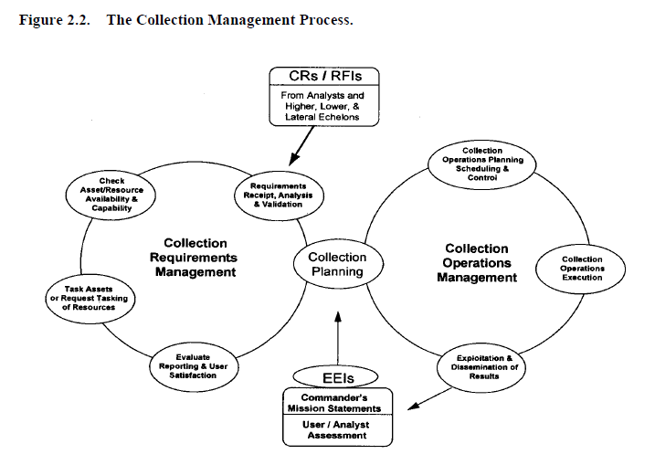

Intelligence gaps or information needs are formally labeled intelligence requirements (IR). An intelligence requirement is any subject, general or specific, upon which there is a need for the collection of information, or the production of intelligence.

PIRs are those intelligence requirements for which a commander has an anticipated and stated priority in the task of planning and decision-making. ~~In Marine Corps usage, an intelligence requirement associated with a decision that will critically affect the overall success of the command’s mission (MCRP 5-12C).~~ PIRs are prioritized among themselves and may change in priority over the course of an evolution. Only the commander designates PIRs.

Generally, the difference between a PIR and an IR is that a commander must have the answer to the PIR to make a decision. At any one time there are not many PIRs in effect.

The lowest priority PIR takes precedence over the highest priority IR. IRs are questions typically generated by the staff but not ones that the commander feels he needs answered before making decisions. While there are ideally a few PIRs, there may be many IRs. Like PIRs, IRs should be prioritized against each other to support effective intelligence planning and operations. PIRs and IRs have the following characteristics.

Each PIR or IR:

* Asks only one question.
* Focuses on specific facts, events or activities concerning the enemy or the battlespace.
* Is tied to mission planning, decision-making, and execution.
* Provides a clear, concise statement of what intelligence is required.
* Contains geographic and time elements to limit the scope of the requirement.

## Intelligence Preparation of the Battlefield (IPB)

Intelligence preparation of the battlespace (IPB) is a four-step systematic process of analyzing the threat and environment to help the JFACC better understand the many variables that can influence the mission and operations. ~~The IPB methodology is an effective analytical process that can be used during peacetime, crisis, or at the tactical, operational, and strategic levels of war. While most of the individual actions that constitute IPB are nothing new to Air Force intelligence, establishing a consistent process will provide greater focus, thereby improving the overall effectiveness of aerospace power.~~

Specifically, IPB focuses on the relationship between the threat and environment, along with the effect of that interaction on both friendly and enemy courses of action. IPB results in the production of enemy courses of action, named areas of interest, and high-value targets, which are inputs to the JFACC campaign planning, intelligence collection, and targeting processes. When done properly, IPB facilitates getting “inside” the enemy’s decision-making cycle~~. IPB is viewed by the US Air Force as a valuable methodology for focusing intelligence on the commander and the commanders’ supporting C2 elements. Additional advantages include integrating analysis, collection management, and targeting processes, as well as providing a standardized analytic approach for training purposes. Air Force intelligence entities at all levels of command should use IPB principles, focusing on environmental and threat characteristics and activities that significantly influence air, space, and information operations. However, specific IPB products and procedures are left to the discretion of local commanders.~~

## Combat Assessment

**Combat Assessment.** Effective campaign planning demands a continuing evaluation of the effect of operations on the campaign plan. While the JFC directs the overall combat assessment (CA), the JFACC provides the necessary expertise to assess ongoing air operations. In this respect the JFACC continuously evaluates the results of his operations and provides his assessments to the JFC who consolidates and evaluates the overall campaign. The JFACC’s CA plan incorporates Battle Damage Assessment (BDA), Munitions Effectiveness Assessment (MEA), and recommendations for re-strikes. The CA plan also considers the forces employed, munitions, timing of attacks, and the effects of specific attacks against enemy targets and remaining capabilities. As the cycle continues, the JFACC analyses remaining enemy capabilities and determines the enemy’s likely courses of action, all the while balancing targeting priorities and overall targeting efforts. The JFC is always ‘kept in the loop’.

## ~~Duties~~

~~Intelligence officer~~

~~The intelligence officer synchronizes the information collection plan and provides information on the~~

~~current enemy situation as well as provides estimates as to what the enemy is capable of doing in the future.~~

~~The intelligence officer provides assessments of probable enemy actions, analyzes, and identifies targets~~

~~based on the commander's guidance. The intelligence officer duties include:~~

~~ Develop and provide IPB products to the other targeting working group members.~~

~~ Develop and refine HVTs.~~

~~ Pass HPTs and suspected HPTs to the fires cell.~~

~~ Develop and refine HPT data.~~

~~ Develop, monitor, and refine the HPTL, AGM, and BDA requirements with other members of~~

~~the targeting working group.~~

~~ Distribute the information collection plan to collection managers.~~

~~ Provide input to the fires cell on target selection standards.~~

~~ Periodically reassess the HPTL, AGM, and BDA requirements with the operations plans and~~

~~operations officer.~~

~~ Receive BDA and, with the deputy fire support coordinator, determines if an attack achieved the~~

~~desired effects or if additional attacks are required.~~

~~ Provide input for the decision support template.~~

~~The intelligence operations officer's actions follow:~~

~~ Maintain the target database.~~

~~ Evaluate and analyze combat information with the FAIO to identify HVTs and recommend~~

~~HPTs.~~

~~ Apply the criteria for timeliness and accuracy from the target selection standards.~~

~~ Report HPTs to the FAIO.~~

~~ Recommend NAI and TAI to the intelligence officer to support targeting.~~

~~ Coordinate with the collection manager to ensure adequate intelligence collection to support~~

~~targeting.~~

~~Brigade intelligence officer:~~

~~The S-2 is responsible for preparing the information collection plan and maintaining information on the~~

~~current enemy situation. He provides assessment of possible enemy actions, provides analyses, and identifies~~

~~targets based on the BCT commander’s guidance. Specific targeting responsibilities include:~~

~~ Developing target arrays.~~

~~ Providing enemy capabilities and projected courses of action.~~

~~ Providing IPB products to the targeting working group and targeting board.~~

~~ Developing high-value targets (HVT).~~

~~ Determining with the brigade targeting officer which HPTs can be acquired with organic assets.~~

~~ Developing support requests for acquiring high-payoff targets beyond the capabilities of organic~~

~~assets.~~

~~ Coordinating the collection and dissemination of targeting information with the targeting officers in~~

~~the fires cell.~~

~~ Developing and supervising implementation of the information collection plan.~~

~~ Advising the operations officer about assessment collection capabilities.~~

~~ Coordinating with the brigade FSO for indirect fires to support the information collection plan.~~

Intelligence cycle

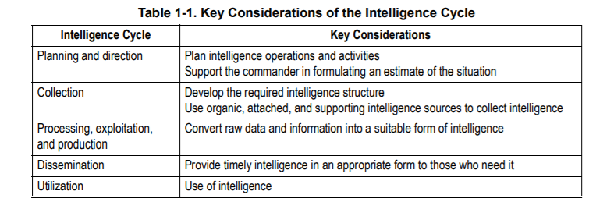

## Targeting

Targeting recommends the best means to attain a goal. It integrates intelligence information

about the threat, the target system, and target characteristics with operations data on friendly force posture, capabilities, weapons effects, objectives, rules of engagement, and doctrine. Targeting matches objectives and guidance with inputs from intelligence and operations to identify the forces necessary to achieve the objectives

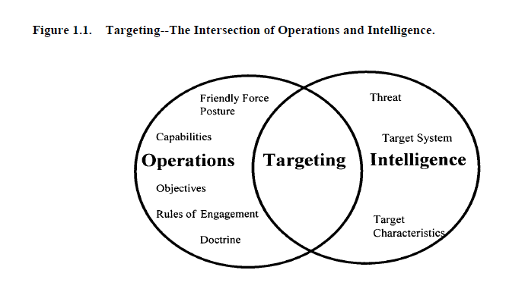

The targeting process is an analytical, systematic approach that focuses targeting efforts on

supporting operational planning and facilitates force employment. A model has been constructed that centers around six phases considered the framework for the targeting process (figure 1.2). This chapter will briefly describe each step in this theoretical construct; later chapters will describe the specifics involved in each step. The six steps of the targeting process are:

• Objectives and guidance derivation

• Target development

• Weaponeering

• Force application

• Execution planning

• Combat assessment

**5.3. Targeting Process Phases.**

**1.5.3.1. Objectives and Guidance Derivation** . Objectives and guidance are the foundation of

the targeting process. In this phase, the objectives and guidance are developed and disseminated

to the targeteer. Objectives are developed at the national, theater, and component levels. Guidance

is generally provided at the National and war fighting CINC-level. Both objectives and guidance

must be quantifiable and unambiguous in order to be effective.

**1.5.3.2. Target Development.** This is the examination of potential target systems and their components

to determine change to system criticality and vulnerability to attack. This phase distills

the commander's objectives into lists of targets. The product of this phase is a suggested target list

with recommended priorities assigned and extent of desired damage.

**1.5.3.3. Weaponeering Assessment.** In this part of the process, planners assess the types and

quantity of weapons estimated to achieve a desired level of damage to the individual targets. The

product of this phase is a list of recommended weapons and aircraft for each target and a validated

list of weapon impact points for each target. Weaponeering takes into account target vulnerabili10

ties, weapons effects and reliability, delivery accuracy, delivery conditions, as well as damage criteria.

**1.5.3.4. Force Application.** The force application phase uses the information generated in the

target development and weaponeering assessment phases to determine the best force necessary to

meet operational objectives. At this point, the decision maker is provided with fused intelligence

on the target and weapon systems recommendations. It is here that operations and intelligence

merge their planning efforts to meet the CINC’s guidance.

**1.5.3.5. Execution Planning.** Execution planning prepares input for and supports the actual tasking,

construction, and subsequent execution by weapon systems. Input includes data concerning

the target, weaponeering calculations, employment parameters, and tactics. The operational command

is responsible for monitoring the ATO/ITO, making any changes necessary and providing

support to the units. Under Air Force doctrine of centralized control, decentralized execution, unit

commanders are given the freedom and flexibility to execute the plan, as they see fit.

**1.5.3.6. Combat Assessment.** After mission execution, the quality of the whole process is

assessed. Improvements in force employment, munitions design and situation assessments

emerge from this appraisal of post-strike data. The results of this effort affect future combat operations

and can change theater objectives. The product of this phase is tailored to the decision makers.

‘

THE TARGETING PROCESS

3.1. Overview. The targeting process is a conceptual construct used to explain how targeting is performed. The process is performed at various levels of command and execution. Though driven by intelligence, it is not the purview of any one community. Community boundaries are beginning to blur between operations and intelligence. This should help consolidate targeting functions. The targeting process includes actions that produce target intelligence and target materials (through analysis and fusion of multi-source intelligence) and applied in support of operational decision making and force employment.

This process includes the steps by which targets are recommended and is comprised of six phases:

• Objectives and guidance derivation

• Target development

• Weaponeering

• Force application

• Execution planning

• Combat assessment

3.1.1. These phases are bi-directional and iterative. Often, they overlap and targeteers perform several of them simultaneously.

3.2. Phases of the Targeting Process.

3.2.1. **Objectives and Guidance Derivation** . Objectives and guidance derivation comprise the

foundation of the targeting process, originating at the national level and becoming more specific and dynamic at progressively lower echelons of command. Unified command objectives establish priorities for targeting, damage criteria, and restrictions on force employment. Guidance includes principles of war, the international Law of Armed Conflict (LOAC), and established rules of engagement. Objective and guidance should be clear and unambiguous so as to be interpretable at the lowest level of command. The necessary first step as a targeteer is to understand objectives and guidance to provide correct targeting advice to commanders. (Within an Air Force AOC, objectives and guidance will normally come from the Strategy Division.)

3.2.2. **Target Development** . During target development, a planner analyzes a potential target system and its components to estimate the commander’s best course of action to achieve a given objective. All-source intelligence data bases are reviewed and potential target systems and targets are selected for consideration. A subset of target development is target analysis, which examines potential targets to determine military importance, priority of attack, and weapon feasibility to obtain a desired level of damage, casualties or to achieve the desired effect. The selected target systems are then further analyzed to determine their components and critical elements. A priority listing of these critical elements is used for weaponeering assessment. Target development includes validation of the target and nomination to the appropriate authority.

3.2.3. **Weaponeering** . The output of weaponeering is a recommendation of the quantity, type, and mix of lethal and non lethal weapons needed to achieve a probable level of target damage or effects while avoiding unacceptable collateral damage. It is important to note weaponeering results are probabilistic and not predictive. Considerations are:

• Target vulnerability

• Weapon effects

• Munitions delivery errors

• Delivery tactics

• Damage criteria

• Probability of kill

• Weapon reliability

3.2.4. **Force Application.** Force application planning is the fusion of target nominations with the

optimum available lethal and non lethal force. In this phase, forces are analyzed to determine likely results to be achieved against target systems and their activities. For lethal force, this is based on probabilities of damage and arrival for a weapon system. For non lethal force this is based on the expected outcome (consequences). The result of force application is a strike package nomination for the commander's approval that has coordinated recommendations from operations, plans, and intelligence. This includes actions in preparation for attack once force selection recommendations are approved. Targeteers prepare the target intelligence portion of plans and assist in air tasking order (ATO) preparation.

3.2.4.1. During force selection, targeting analysts work closely with operators and planners to

match targets with available weapon systems, munitions, and possible non lethal force options.

Force sizing is then optimized in light of available resources and other constraints.

3.2.4.2. Targeteers also assist in attrition analysis or calculations for potential friendly force losses to enemy defenses. Attrition analysis bears on both delivery tactics and optimal force sizing.

3.2.5. **Execution Planning** . Execution planning is the more detailed planning required to actually fly the mission and employ weapons. It is both a component and unit function. At the air operations center (AOC), preparation for the execution of the ATO entails review of plans, weather, logistics, and current situation. At the unit level, it involves mission planning. Unit functions for targeteers have evolved with the automation of mission planning tools, and the laborious work of hand drawn radar predictions, old mensuration tools, and slide rule weaponeering is approaching an end. With a single Air Force-wide intelligence tool (Combat Intelligence System) and a single mission planning tool (Air Force Mission Support System), we have begun to standardize targeting tasks and ease training problems.

3.2.5.1. Targeteers provide the approved targets list, weaponeering, and target materials, such as

maps, charts, mensurated coordinates, and imagery. They assist operators in selecting mission

routing, axis of attack, aimpoints, and fuze settings.

3.2.5.2. Targeting planners also prepare mission folders containing charts (annotated with ingress and egress routing, and aimpoints), strip charts, threat data, and battle damage assessment (BDA) reporting guidelines.

3.2.6. **Combat Assessment** . Effective campaign planning and execution require a continuing evaluation of the impact of joint force combat operations on the overall campaign. Combat assessment (CA) evaluates combat operations effectiveness in achieving command objectives and recommends changes to tactics, strategies, objectives, and guidance. It has several sub assessments including mission assessment (MA), battle damage assessment (BDA), and munitions effectiveness assessment (MEA). The military end state, as written in the campaign estimate and modified during an operation, is directly linked with CA. CA compares the results of the operation to the objectives to determine mission success or failure within the guidance parameters. More important than a review, it looks forward to determine if additional missions are needed and/or if modification to the objectives is necessary. Combat assessment is one concept with many implementations.

A target is

1. An entity or object that performs a function for the adversary considered for possible engagement or other action.

2. In intelligence usage, a country, area, installation, agency, or person against which intelligence operations are directed.

3. An area designated and numbered for future firing.

4. In gunfire support usage, an impact burst that hits the target (joint publication [JP] 3-60).

Targets include mobile and stationary forces, equipment, and facilities that an enemy commander can use to conduct operations. Targeting is the process of selecting and prioritizing targets and matching the appropriate response to them considering operational requirements and capabilities (JP 3-0). The emphasis of targeting is on identifying enemy resources (targets) that if destroyed or degraded will contribute to the success of the friendly commander’s mission.

The expected results of a successful attack eliminating a resource begin to place limits on the enemy commander’s available tactical options.

Targeting personnel identify critical target subsets that when successfully acquired and

attacked significantly diminish enemy capabilities. Denying critical resources to the enemy

makes him vulnerable and expands friendly opportunities for success in battle. Successful

targeting requires that the commander synchronize information related capabilities, intelligence, maneuver, fire support systems, nonlethal effects, and special operations forces to attack and eliminate critical target(s) using the most effective system in the right time and place. Targeting is a complex and multidiscipline effort that requires coordinated interaction among many command and staff elements.

The functional elements necessary for effective collaboration are represented in the targeting working group. A working group is a grouping of predetermined staff representatives who meet to provide analysis, coordinate and provide recommendations for a particular purpose or function (FM 6-0). These representatives include, but are not limited to, the fires, intelligence, current operations, future operations, and plans cells. Representatives from these cells are essential to the execution of targeting. Other members of the staff may help them in the planning and execution phases of targeting. Close coordination among all cells is crucial for a successful targeting effort. Sensors and collection capabilities under the control of external agencies must be closely coordinated and carefully integrated into the execution of attacks especially those involving rapidly moving, fleeting, or dangerous targets. In addition, the appropriate means and munitions must attack the vulnerabilities of different types of targets.

The enemy presents a large number of targets that must be engaged with available intelligence,

acquisition, and attack assets. The targeting process weighs the benefits and the cost of engaging various

targets in order to determine which targets, if engaged, are most likely to contribute to achieving the desired

end state. Adhering to the five targeting guidelines should increase the probability of creating desired

effects while diminishing undesired or adverse collateral effects. These guidelines are:

● Targeting focuses on achieving the commander’s objectives. It is the function of targeting to

achieve efficiently those objectives within the parameters set at the operational level, directed

limitations, the rules of engagement, or rules for the use of force, the law of war, and other

guidance given by the commander. Every target nominated must contribute to attaining the

commander’s objectives.

● Targeting seeks to create specific desired effects through lethal and nonlethal actions. Target

analysis encompasses all possible means to create desired effects, drawing from all available

capabilities. The art of targeting seeks to create desired effects with the least risk and

expenditure of time and resources.

● Targeting directs lethal and nonlethal actions to create desired effects.

● Targeting is a fundamental task of the fires warfighting function that encompasses many

disciplines and requires participation from many staff elements and components.

● Targeting creates effects systematically. A targeting methodology is a rational and iterative

process that methodically analyzes, prioritizes, and assigns assets against targets systematically

to create those effects that will contribute to achieving the commander’s objectives. If the

desired effects are not created, targets may be considered again in the process or operations may

have to be modified.

**TIME-SENSITIVE TARGETS**

1-16. A *time-sensitive target* is a joint force commander validated target or set of targets requiring

immediate response because it is a highly lucrative, fleeting target of opportunity or it poses (or will soon

pose) a danger to friendly forces (JP 3-60). A time-sensitive target (TST) is a joint force commander

(JFC) designated target or target type of such high importance to the accomplishment of the JFC mission

**1-4 ATP 3-60 7 May 2015**

**Target Guidelines and Philosophy**

and objectives or one that presents such a significant strategic or operational threat to friendly forces or

allies, that the JFC dedicates intelligence collection and attack assets to ensure success.

1-17. TSTs comprise a very small or limited number of planned targets due to the required investment of

assets and potential disruption of planned execution, and are only those targets designated by the JFC and

identified as such in the JFC guidance and intent. TSTs are normally executed dynamically; however, to be

targeted successfully, they require considerable deliberate planning and preparation within the joint

targeting cycle.

1-18. Service component

**D3A IN MILITARY DECISIONMAKING PROCESS**

1-22. The decide function coincides with the MDMP from the receipt of mission through the issuing of the

approved plan or order. The detect function is a continuing function that starts with the commanders

approval of the plan or order and is accomplished during execution of the plan or order. Once detected,

targets are attacked and assessed as required. Targeting working groups are used as a vehicle to focus the

targeting process within specified time.

1-23. D3A methodology functions occur simultaneously and sequentially during the operations process.

Decisions are made during the planning of future operations. Current operations simultaneously detect,

deliver, and assess targets based on current targeting decisions.

**Decide**

1-24. The decide function is the most important and requires close interaction between the commander and

the intelligence, plans, operations, fires cell, and servicing judge advocate. The staff officers must clearly

understand the following:

● Unit mission.

● Threat vulnerabilities.

● Commander’s intent.

● Commander’s planning guidance.

● Rules of engagement.

1-25. With this information, the staff officers can prepare their respective running estimates. From the

standpoint of targeting–the fire support, intelligence, information related capabilities, and operations

estimates are interrelated and closely coordinated among each cell. Key staff products include target value

analysis and the intelligence estimate from the targeting and intelligence officers. War gaming allows the

deputy fire support coordinator (DFSCOORD) or fire support officer (FSO) to develop the decide function

products.

**7 May 2015 ATP 3-60 1-7**

**Chapter 1**

**Detect**

1-26. The detect function is conducted during the execution of the OPORD. Target acquisition assets

gather information and report their findings back to their controlling headquarters, which in turn pass

pertinent information to the tasking agency. Some collection assets provide actual targets, while other

assets must have their information processed to produce valid targets. Not all of the information reported

would benefit the targeting effort, but it may be valuable to the development of the overall situation. The

target priorities developed in the decide function are used to expedite the processing of targets. Situations

arise when the engagement, upon location and identification, of a target is either impossible (for example

out of range) or undesirable (outside of but moving toward an advantageous location for the attack).

Critical targets that we cannot or choose not to attack in accordance with the attack guidance should be

tracked to ensure they are not lost. Tracking suspected targets expedites execution of the attack guidance.

Tracking suspected targets keeps them in view while they are validated. Planners and executers must keep

in mind that assets used for target tracking may be unavailable for target acquisition.

**Deliver**

1-27. The deliver function’s main objective is to attack targets in accordance with the attack guidance

provided. The tactical solution (the selection of a weapon system or a combination of weapons systems)

leads to a technical solution for the selected weapon. The technical solution includes the following:

● Specific attack unit.

● Type of ordnance.

● Time of attack.

● Coordinating instructions.

**Assess**

1-28. Commanders continuously assess the operational environment and the progress of operations, and

compare them to their initial vision and intent. Commanders adjust operations based on their assessment to

ensure objectives are met and the military end state is achieved. The commander and his staff assess the

results of mission execution. If combat assessment reveals that the commander’s guidance or conditions of

operational success have not been met, detect and deliver functions of the targeting process must continue

to focus on the targets involved.

1-29. The assessment process is continuous and directly tied to the commander’s decisions throughout

planning, preparation, and execution of operations. Staffs assist the commander by monitoring the

numerous aspects that can influence the outcome of operations and provide the commander timely

information needed for decisions. The commander’s critical information requirements are linked to the

assessment process by the commander’s need for timely information and recommendations to make

decisions. Planning for the assessment identifies key aspects of the operation that

**DECIDE**

2-6. The decide function begins the targeting cycle. This step provides the overall focus and sets priorities

and criteria for intelligence collection and engagement planning. The decide function draws heavily on the

staff’s knowledge of the enemy, (to include their tactics, culture, and ideology), a detailed intelligence

preparation of the battlefield (IPB), and continuous assessment of the situation. Targeting priorities must be

addressed for each phase or critical event of an operation. The decisions made are reflected in visual

products. The products are as follows:

● The *high-payoff target list* is a prioritized list of high-payoff targets by phase of the operation

(FM 3-09). A *high-payoff target* is a target whose loss to the enemy will significantly contribute

to the success of the friendly course of action (JP 3-60). A high-payoff target (HPT) is a highvalue

target (HVT) that must be acquired and successfully engaged for the success of the

friendly commander’s mission. A *high-value target* is a target the enemy commander requires

for the successful completion of the mission (JP 3-60).

● The Decide function helps build the information collection plan. HPTs are nearly always a

priority intelligence requirement (PIR).

● Target selection standards address accuracy or other specific criteria that must be met before

targets can be attacked.

● **The *attack guidance matrix* is a targeting product approved by the commander, which**

**addresses the how and when targets are engaged and the desired effects.**

**Prerequisite Information and Intelligence for Targeting**. To begin target planning the following information requirements should be addressed to prevent waste of resources.

Intelligence on Enemy Defensive and Offensive Posture, Capabilities, and Intentions. The targeteer must have current, accurate intelligence on the enemy's status and predisposition.

**Target System, Component, and Element Characteristics.** Targeteer’s must have current, accurate intelligence on the physical, functional, mobility, and environmental characteristics of potential enemy targets.

**Friendly Force Posture and Capabilities.** The targeteer should know what forces will be available for offensive operations and the capabilities of these forces. Care must be taken to prevent potential options from being overlooked because a capability is assumed not to be available. If a force capability not available at the beginning of an analysis can be demonstrated to be clearly superior, it may be possible to obtain the capability. In any event, targeting personnel should be aware of current and potential force capabilities and consider them during their analysis.

**Concept of Operations, Mission Objectives, and Rules of Engagement.** The targeteer must understand the concept of operations and mission objectives in order to conduct an analysis that results in target recommendations to achieve those objectives. They should remember that most offensive operations take place in a joint service environment. Consequently, the scheme of maneuver of other component forces should be known to make all systems effective, and the operation of the USAF component should be integrated as much as possible with them. Even though the Unified commander is responsible for integrating operations by the various service components, this can only happen in fact if the effort is made at the working level, during the basic planning.

For targeteer’s to function effectively, they must understand Air Force and Joint doctrine. Doctrine is important because it is based on the capabilities of the US military and states fundamental concepts upon which planning should be based.

### Support to Targeting

A target is an entity or object that performs a function for the threat considered for possible engagement or other action. (DOD Dictionary) Targeting is the process of selecting and prioritizing targets and matching the appropriate response to them, considering operational requirements and capabilities. During IPB steps three and four, the intelligence staff identifies high-value targets associated with each enemy capability or COA. This aids the fires cell as they conduct TSAs.

An example targeting model, decide, detect, deliver, and assess (also referred to as D3A) for the targeting process is as follows:

Decide:

* IPB supports identifying potential targets and entities through COG and critical vulnerability analysis. (Note: CARVER is a target analysis and vulnerability assessment framework— criticality, accessibility, recognizability, vulnerability, effect, and recuperability.)
* Intelligence prioritizes, develops, and nominates targets to include on appropriate target and engagement lists in coordination with operations.

Detect:

* Intelligence requirements are developed.
* Collection assets and resources are leveraged; the target or entity is acquired and tracked.

Deliver:

* Intelligence assesses the ability to create desired effects.
* Intelligence supports developing MOE.
* Intelligence supports collateral damage estimates and weaponeering for commander approval.

Assess:

* Intelligence supports BDA by identifying the functional, operational, and system effects of engaging the target or entity.
* Collection assets are leveraged to support collecting MOEs and measures of performance. Note: Additional targeting process models include find, fix, finish, exploit, analyze, and disseminate (referred to as F3EAD) and find, fix, track, target, engage, and assess (referred to as F2T2EA).

### CARVER TOOL

CRITICALITY

Criticality means target value. This is the primary consideration in targeting. A target is critical when its destruction or damage has a significant impact on military, political, or economic operations. Targets within a system must be considered in relation to other elements of the target system. The value of a target will change as the situation develops, requiring the use of the time-sensitive methods which respond to changing situations. For example, when one has few locomotives, railroad bridges may be less critical as targets; however, safeguarding bridges may be critical to maneuvering conventional forces which require use of such bridges.

ACCESSIBILITY

A target is accessible when an operational element can reach the target with sufficient personnel and equipment to accomplish its mission. A target can be accessible even if it requires the assistance of knowledgeable insiders. This assessment entails identifying and studying critical paths that the operational element must take to achieve its objectives, and measuring those things that aid or impede access.

RECOUPERABILITY

A target's recouperability is measured in time; that is, how long will it take to replace, repair, or bypass the destruction of or damage to the target? Recouperability varies with the sources and type of targeted components and the availability of spare parts availability.

VULNERABILITY

A target is vulnerable if the operational element has the means and expertise to successfully attack the target. When determining the vulnerability of a target, the scale of the critical component needs to be compared with the capability of the attacking element to destroy or damage it.

EFFECT

The effect of a target attack is a measure of possible military, political, economic, psychological, and sociological impacts at the target and beyond. This is closely related to the measure of target criticality. The type and magnitude of given effects desired will help planners select targets and target components for attack. Effect in this context addresses all significant effects, whether desired or not, that may result once the selected target component is attacked. Traditionally, this element has addressed the effect on the local population, but now there are broader considerations.

RECOGNIZABILITY

A target's recognizability is the degree to which it can be recognized by an operational element and intelligence collection and reconnaissance assets under varying conditions. Weather has an obvious and significant impact on visibility. Rain, snow, and ground fog may obscure observation. Road segments with sparse vegetation and adjacent high ground provide excellent conditions for good observation. Distance, light, and season must also be considered. Table C-1 is an example of a CARVER matrix tool.

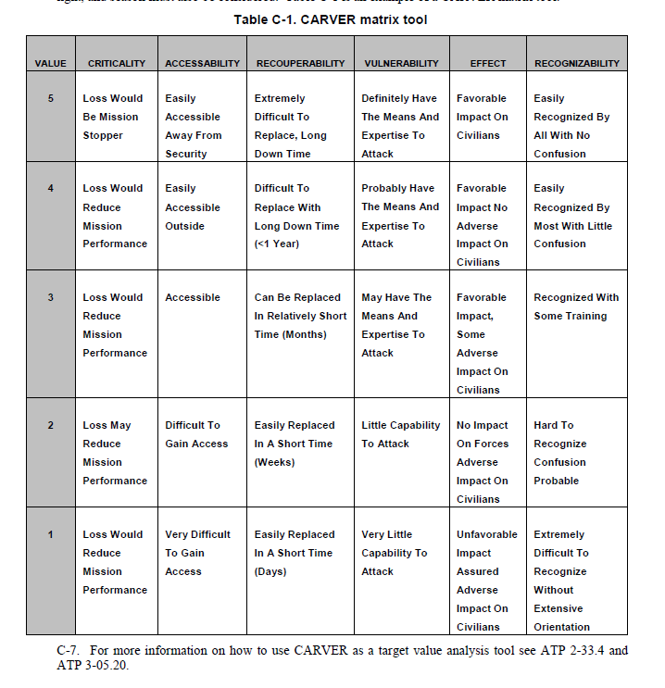

### Joint Target List (JTL)

### Joint Prioritized Target List (JPTL)

### BDA

**Battle Damage Assessment (BDA).** BDA is the timely and accurate estimate of damage resulting from the application of military force, either lethal or non lethal, against a predetermined objective. Battle damage assessment can be applied to the employment of all types of weapon systems (air, ground, naval, space, IW, and special forces) throughout the range of military operations. BDA is primarily an Intelligence responsibility with required inputs and coordination from Operations. Battle damage assessment is composed of physical damage assessment, functional damage assessment, and target system assessment (figure 9.2). BDA is the study of damage on a single target or set of targets. It is used for target study and target system analyses, reconstitution estimates, weaponeering, database updates, and for deciding restrikes. BDA was previously known in the air-to-surface arena as “bomb damage assessment” which still retains its own definition in JCS Pub 1-02. The BDA process answers the following questions:

• Did the weapons impact the target as planned?

• Did the weapons achieve the desired results and fulfill the objectives, and therefore purpose, of the attack?

• How long will it take enemy forces to repair damage and regain functionality?

• Can and will the enemy compensate for the actual damage through substitution?

• Are restrikes necessary to inflict additional damage, to delay recovery efforts, or attack targets not successfully struck?

• What are the collateral effects on the target system as a whole, or on other target systems?

## Air Campaign planning

### IPB

IPB is a systematic, four step analytical methodology employed to reduce uncertainties concerning the adversary and to exploit or minimize environmental factors. It is a continuous process, which enables JFACC to visualize the full spectrum of adversary capabilities, potential centers of gravity (COG), and possible courses of action (COA) across all dimensions of the battlespace. IPB assists VIS personnel to identify facts and assumptions about the battlespace environment and the enemy. This facilitates planning and the development of JFACCs Concept of Operation. During execution, IPB provides the basis for intelligence direction and synchronization that supports JFACCs Concept of operation (formulated through the JAOP) by tying ISR collection and analysis efforts to key decision points.

A key difference between air and surface warfare is that air forces can strike directly at key target sets that have strategic results, without having to go through the process of drawn-out attrition at the tactical level of war. Air Force platforms deploy globally and will often pursue strategic, operational, and tactical objectives with very little time separation. Within the Air Force context, intelligence personnel will probably not have the luxury of focusing their IPB on only one level of warfare. Finally, aerospace power is the dominant force employed by the United States against an adversary’s war making potential. To do this effectively, the Air Force IPB process must focus on carefully identifying and analyzing adversary COGs, as well as identifying adversary COAs traditionally associated with the IPB process. Air Force doctrine defines COGs as "Those characteristics, capabilities, or localities from which a military force, nation, or alliance derives its freedom of action, physical strength, or will to fight. They exist at the strategic, operational and tactical levels of war."7 Airmen must understand the adversary’s COGs, his potential and probable COAs, the interrelationships between them, and the adversary’s overall ability to conduct military operations, in order to facilitate effective aerospace planning and execution at the strategic and operational levels of warfare. Thus, while the processes will be very similar, there will be some significant differences in emphasis and approach.

The VIS IPB process consists of four basic steps:

1. Define the Battlespace Environment

2. Describe the Battlespace’s Effects

3. Evaluate the Adversary

4. Determine Adversary COAs

While the IPB process is sequential, it is also continuous and cyclical. It must be conducted before, during, and after an operation, and while planning for and executing other contingencies as they arise. With the acquisition of new information, intelligence staffs modify their assessments of the battlespace, the adversary, and all potential COGs and COAs.

#### Step One: Define the Battlespace Environment:

The first step of the IPB process focuses on defining the limits of the battlespace. This is done by determining and evaluating JFACC's assigned Area of Responsibility (AOR), area of interest (AI), and mission. The AOR is that portion of the battlespace in which military operations are conducted to accomplish a specific mission. The AI is that area of concern to the commander, including the area of influence, areas adjacent thereto, and extending into enemy territory to the objectives of current or planned operations. This area also includes areas occupied by enemy forces who could jeopardize the accomplishment of the mission. The AI is usually larger than the AOR.

The purpose of step one is to bound the intelligence problem and identify for further analysis specific features in the environment, activities within it, and the space where they exist that may influence available COAs or the commander’s decisions. Once the AOR and AI are defined, and mission objectives and desired end states are determined, the commander determines the time available for planning. Time available determines the level of IPB detail possible. Concurrently, the battlestaff analyzes existing information to highlight gaps for future intelligence collection and analysis to acquire the adversary and environmental data needed to complete the remaining steps of the IPB process at a level of detail sufficient to support the JFACC’s decision-making process.

**Step One Final Results:**

1. Preliminary priority intelligence requirements (PIR) delineating the scope and detail required for the mission being planned, which evolve as the IPB process develops.

2. The identification of significant battlespace characteristics affecting JFACC`s mission.

3. The identification of intelligence gaps and priorities, which also evolve as the IPB process develops.

4. An initial set of intelligence collection and production requirements that support further IPB analysis and the JFACC’s mission.

#### Step Two: Describe the Battlespace’s Effects.

The battlespace imposes constraints and provides opportunities to adversary and friendly forces that are crucial in predicting possible adversary COAs and developing friendly COAs. Step two’s purpose is to determine how the battlespace affects both threat and friendly operations. Step two is not solely an intelligence function. In some cases other functional areas provide the majority of this information. For example, Air Force Weather is responsible for collecting, analyzing, predicting, tailoring, and disseminating weather and space environmental data to command staffs and operators required to plan and execute the mission.

**Step Two Final Results:**

The final product(s) of step two are varied and may take several forms from simple briefings to complex computer-based battlespace simulations and visualizations. The result should be products that:

1. Depict the total environment’s effect on possible broad friendly and adversary COAs at the strategic and operational levels.

2. Depict the battlespace’s impact on friendly and adversary weapons systems at the tactical level.

TIME AND DISTANCE (FROM VARIOUS AIRBASES or large cities)

SLOC

ROADS

Mobility corridors

Avenue of approach (ground and air)

MOUNTAINS (BLIND ZONES)

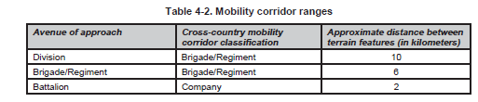

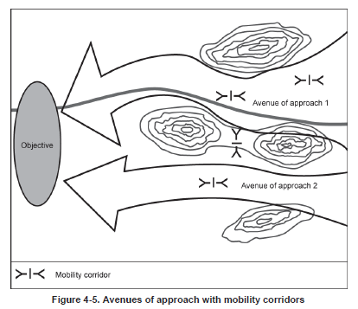

#### Step Three: Evaluate the Adversary.

The purpose of step three is to determine the adversary’s COGs, capabilities, doctrinal principles, and applicable tactics, techniques, and procedures (TTP). Step three also distills VIS knowledge of the adversary into specific intelligence products that succinctly communicate this information to JFACC and aircrew/controllers on events. This step involves:

1. Analyzing and identifying adversary COGs. (See JFACC TTP COG LINK)

2. Creating or updating threat models.

3. Determining the current adversary situation.

4. Identifying adversary capabilities.

**Centers of Gravity.** COG analysis is conducted after an understanding of the broad operational environment has been obtained and before a detailed study of the adversary’s fielded military forces occurs. The battlestaff analyzes leadership, resources, infrastructure, population, transportation systems, and internal and external relationships of the adversary to determine from which elements the adversary derives freedom of action, physical strength, or the will to fight. A determination is made if candidate COGs are truly critical to the enemy strategy and must include a thorough examination of the mechanisms by which COGs influence and affect enemy strategy. Once determined, COGs identified in this step are a significant input to the aerospace campaign plan and provide a foundation for target development.

**Threat Models.** Threat models describe and graphically portray threat tactics and employment options. They consist of three elements: 1) doctrinal templates, 2) description of preferred tactics, options, and follow on activities, and 3) identification of type high value targets (THVT). Doctrinal templates are "Graphic models based on known or postulated threat doctrine. Doctrinal templates illustrate the deployment pattern and disposition preferred by the adversary when not constrained by the effects of the battlespace environment."11 See Figure 4 for an example of a doctrinal template. THVTs are "Assets or target systems the adversary commander requires for the successful completion of the activity described as part of the threat model."12 THVTs are not "real" targets per se (e.g., an actual facility with a BE number). Rather, they simply describe what is important for execution of the activity being depicted. Later, in step four of the IPB process, these threat models are modified to reflect constraints imposed by the battlespace upon the adversary’s preferred method of operations. In addition to a graphical depiction, threat models are accompanied by textural information that describes the activities noted on the template, likely alternatives if the depicted activity fails (branches) or subsequent operations if the activity succeeds (sequels). Finally, threat models conclude by identifying and ranking the relative importance of THVTs.

**Current Adversary Situation.** The intelligence analyst determines the current adversary situation through a careful and detailed analysis of relevant order of battle (OB) data including force strength, composition, and disposition as well as observed TTPs and current training activities.

**Adversary Capabilities.** The intelligence staff then combines quantitative OB analysis with a qualitative assessment of the adversary’s readiness, training, and effectiveness to develop a complete picture of adversary capabilities. Comparing the current adversary situation with threat models highlights current strengths and weaknesses.

Step Three Final Results:

1. A listing of adversary COGs.

2. Graphic threat models. (SAM rings, altitude distance. Aircraft A-A missile threats DOR/MAR etc). Range rings for Artillery, rocket artillery, MLRS, SCUDs)

3. A prioritized listing of THVTs for various adversary operations.

4. A definitive and current adversary OB (Ground and Air excel spreadsheet).

5. A qualitative assessment of the adversary’s current capabilities, strengths, and weaknesses.

#### Step Four: Determine Adversary Courses of Action.

This step identifies, develops, and prioritizes adversary COAs consistent with the COGs developed in step three, the adversary’s doctrine, and their assessed political/military objectives. Step four’s purpose is to identify likely adversary COAs that can be exploited to shape the battlespace and accomplish the friendly mission. Crucial to this step is the identification of associated high value targets (HVT) that the adversary must preserve in order to execute their intended COAs and named areas of interest (NAI) which are used to determine which of the projected COAs the adversary has actually chosen. Information derived and products produced while performing steps one through three are fused together to project what the adversary is likely to do given the environment and his capabilities. Finally, as friendly information requirements are identified during execution, decision support products are produced to ensure the commander has the right information at the right time.

Sub Steps. In order to meet the needs and requirements of Air Force planning and execution processes, the Air Force IPB model step four consists of six sub steps. These steps are also step four’s final products whether presented orally, graphically, or textually.

1. Identify the adversary’s likely objectives and desired end state.

2. Evaluate and prioritize adversary COAs and their associated strategic, operational or tactical COGs.

3. Explicitly identify threat assumptions.

4. Identify targets valuable to the adversary in executing probable COAs and nominate for attack those targets that will achieve the chosen friendly COA and objectives.

5. Identify collection requirements that monitor significant battlespace characteristics, provide indications on which COA the adversary has chosen, and assist the commander in assessing his operational effectiveness.

6. Produce decision support products that ensure intelligence sensors and producers are arrayed to collect, process, exploit and disseminate the right data at the right time to support key operational decisions.

The Final Result of IPB—The COA Package. Throughout the IPB process several intermediate intelligence products are produced, which are helpful to the planning process and can be used for a myriad of other purposes. However, these earlier products are preparatory to the final result. The culmination of the IPB process yields very specific intelligence products, which are tailored to meet the needs of the commander being supported. At a minimum, two COAs are always developed—the adversary’s most likely COA and the most dangerous COA. This gives the commander a "best estimate" and "worse case" for planning purposes. If time allows, alternative adversary COAs are developed. Each COA includes a description of expected adversary activities, the associated time and phase lines expected in executing the COA, expected force dispositions, associated COGs, a list of assumptions about the adversary made when projecting the COA, a list of refined HVTs, High Payoff Targets (HPT), and a list of NAIs. This information is then combined into decision support products, which ensure collection assets are on hand to monitor adversary COA projections and provide key battlespace information at the time that the commander needs it. The various components of a COA package are defined and an example of a basic decision support product is included below.

High Value Target (HVT). "A target the enemy commander requires for the successful completion of the mission. The loss of high value targets would be expected to seriously degrade important enemy functions throughout the friendly commander’s area of interest."

High Payoff Target (HPT). "A target whose loss to the enemy will significantly contribute to the success of the friendly course of action. High-payoff targets are those high-value targets, identified through wargaming, target systems analysis, or commander’s guidance, which if acquired and successfully attacked would significantly contribute to the success of the friendly commander’s mission and objectives."

Named Areas of Interest (NAI). "The geographical area where information that will satisfy a specific information requirement can be collected. Named areas of interest are usually selected to capture indications of adversary courses of action but also may be related to conditions of the battlespace."

~~Decision Support Template (DST). "A DST represents a graphic record of wargaming. It depicts decision points, timelines associated with movement of forces and the flow of the of the operation, and other key items of information required to execute a friendly COA."16 Not all decision points are based on intelligence. However, a DST should support those that are based on intelligence indicators, or measures of success relating to the adversary. Decision support products should focus on those necessary to assist the JFACC in making decisions at campaign phase points or key ATO execution events.~~

~~Decision Support Matrix (DSM). "A DSM supports the DST by providing details on the type of activity expected at each NAI, the times the activity is expected to occur, and the activity associated with a given adversary COA, key battlespace events, or battlespace conditions."17 A critical component of the DSM is a well thought out collection management plan which provides multi-sensor coverage (IMINT, SIGINT, HUMINT, MASINT) supporting the JFC/JFACC’s campaign/ATO planning, decision, and execution cycle. The identification of intelligence collection requirements depends on the prediction of specific activities and the areas in which they are expected to occur, which, when observed, will reveal which COA the adversary has adopted. The DSM can also be used to assist analysts in performing battle damage assessment (BDA) and munitions effectiveness assessments (MEA), while enabling the JFACC to evaluate campaign objectives, aerospace measures of merit, and making reattack recommendations.~~

### Interaction with JFACC`s air campaign planning

Campaign planning

Step 1: Operational Environment research - Step 1 / Step 2 Define battlespace environment + describe battlespaces effects

Step 2: Centers of Gravity identification - Step 3: Evaluate the adversary

Step 3: Objective determination - Step 3: Evaluate the adversary

Step 4: Strategy identification Step 4: Determine adversary courses of action

Step 5: JAOP Production

Interaction with Air tasking Cycle

* **Planning and direction**: determination of intelligence requirements, preparation of a collection plan, issuance of orders and requests to information collection agencies, and a continuous check on the productivity of collection agencies.
* **Collection:** acquisition of information and the provision of this information to processing and/or production elements.
* **Processing:** conversion of collected information into a form suitable to the production of intelligence.
* **Production**: conversion of information into intelligence through the integration, analysis, evaluation, and interpretation of all source data and the preparation of intelligence products in support of known or anticipated user requirements.
* **Dissemination**: conveyance of intelligence to users in a suitable form.

Interaction with Air tasking Cycle

Stage 1: Objectives and effects. Directions & Guidance (Planning and direction)

Stage 2: Targeting, weaponeering, MAAP and AOD (processing production)

Stage 3: ATO and ACO production (dissemination)

Stage 4: Execution (collection)

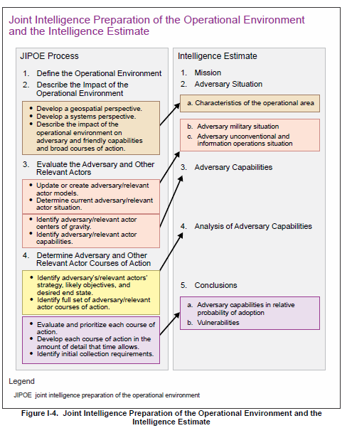

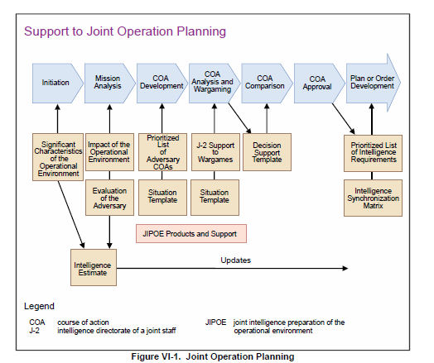

### Targeting

Development/refinement of JTL, recommend priorities to JFACC (SME on enemy), HVT, HPT from IPB

## Execution of the Air Campaign: Air Tasking Cycle

Intelligence collection during execution differs significantly from intelligence collection during planning. Intelligence collection support during the precrisis or warning phases requires developing a large volume of basic intelligence and preparation of broad-scope estimates needed to develop and analyze COAs. However, intelligence collection support during the execution phase must try to satisfy a much larger body of IRs in a significantly greater degree of detail. For example, the nature of the intelligence required by a MAGTF commander to decide if a noncombatant evacuation operation is feasible differs radically from the type and detail of intelligence required by the mission commander who will execute the operation.

Another major difference is the time available to satisfy IRs. In the execution phase there is a significant increase of time-sensitive IRs. Intelligence must often be developed in hours, minutes or even seconds. Success often depends on the ability to provide immediate answers to critical questions regarding threat force dispositions and intentions.

### Intelligence collection

#### Collection Management.

### Targeting

#### Targeting meeting

~~As part of the air tasking cycle JFACC and VIS may meet to conduct a targeting meeting.~~

~~Representatives from VIS and JFACC meet to synchronize their effort prior to the next ATO day. This can be conducted as a meeting but may also be conducted by providing the necessary information if time for a meeting is not possible. The targeting meeting can be conducted for each ATO day, or for any interval JFACC and VIS deem necessary (For example every other ATO day, or once for every phase). Ideally the targeting meeting start JFACCs stage 2 in the Air Tasking Cycle for each ATO.~~

~~VIS will start the targeting meeting with presenting:~~

* ~~Weather (forecast for next period)~~
* ~~Current enemy situation (ground, air, IADS)~~
* ~~BDA last ATO~~
* ~~Eny ML/MD COA next ATOs (24-72 hours out) (Any changes to already briefed ML/MD COA)~~
* ~~Current TST list~~
* ~~Intelligence Requirements (intelligence gaps)~~
* ~~Any recommendations for targeting~~

~~JFACC will then present the following information:~~

* ~~Current friendly situation (Ground and air, including supporting assets and ordnance status) and planned operations next period.~~
* ~~New guidance from higher CJTF (Directions and Guidance or orders received with guidance)~~
* ~~Air requests from Land Component Commander (LCC or Maritime Component Commander (MCC).~~
* ~~What assets are available for next ATO day (to be tasked with targeting)~~

~~The information presented by both VIS and JFACC give everyone a good understanding of the enemy and friendly situation. The next item to be presented are JFACC and VIS nominations to the Joint Prioritized Target List for the next ATO. After the nominations VIS and JFACC will discuss and agree on a prioritized list of the targets. If there are any discrepancies, JFACC will have the final word. This will be the approved JPTL for next ATO cycle.~~

~~JFACC and VIS will also present and suggest a draft JPTL for the subsequent ATO cycle so both VIS and JFACC know what the likely priorities on the subsequent ATO cycle are.~~

~~Finally VIS and JFACC validated the time sensitive target list (make sure to add new TSTs if required, or remove TSTs if applicable).~~

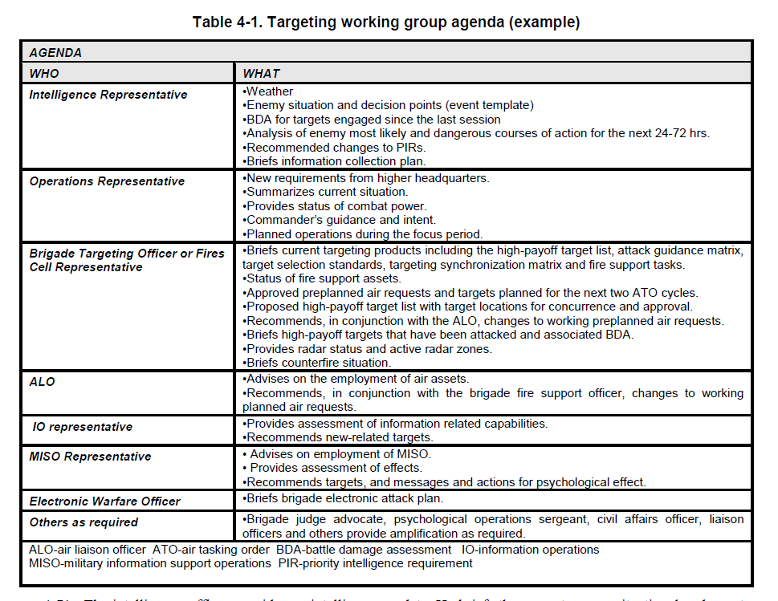

~~The intelligence officer provides an intelligence update. He briefs the current enemy situational and event~~

~~templates, current HVTs with locations, the commander’s critical information requirements, NAI, and an~~

~~overview of the current information collection plan. He provides BDA on targets previously engaged since the last~~

~~session of the targeting working group and the impact on the enemy COA. Most importantly, he prepares a~~

~~predictive analysis of the future enemy COA for the next 24-72 hours using the event template and a list of HVTs.~~

~~Finally, he briefs changes to the commander’s critical information requirements for review by the staff. The~~

~~intelligence officer’s products must be tailored to the designated time period to be discussed at the session but~~

~~generally include:~~

~~ The enemy situation.~~

~~ Review of the current information collection plans.~~

~~ BDA of targets engaged since the last session of the targeting working group or targeting board and~~

~~the impact on the enemy COA.~~

~~ An analysis of the enemy’s most probable COA and locations for the next 24 to 36 hours (possibly~~

~~projecting out 72 hours for targets subject to attack through ATO nominations).~~

~~ Recommended changes to the PIRs for the commander’s approval (if the commander is present), or~~

~~review by the staff.~~

~~4-72. The operations officer or his representative discusses any particular guidance from the commander,~~

~~changes to the commander's intent, and any changes since the last session of the targeting working group or targeting board to include task organization, requirements from higher headquarters to include recent fragmentary~~

~~orders and taskings, current combat power, the current situation of subordinate units, planned operations, and~~

~~maneuver assets and resources available. Finally, he informs the staff of the status of assets and resources~~

~~available for the targeting process. The operations officer’s products must be tailored to the designated time~~

~~period to be discussed at the session but generally include a friendly situation update that:~~

~~ Briefs any new requirements from higher headquarters since the last targeting working group or~~

~~targeting board session.~~

~~ Summarizes the current tactical situation.~~

~~ Informs on the status of available assets and resources (combat power).~~

~~ Briefs any particular guidance from the commander and changes to his intent.~~

~~ Briefs planned operations during the period covered by the targeting working group or targeting~~

~~board session.~~

~~4-73. The targeting officer or fires cell representative briefs fire support assets available including status of fire~~

~~support tasks, radars, CAS sorties available, status of naval surface fire support, ammunition availability, HPTL,~~

~~target selection standards, AGM, and targeting synchronization matrix.~~

~~4-74. The brigade fire support officer reviews approved planned air requests (alternatively, this may be briefed~~

~~by the Air Force ALO) for the period covered by the session and those planned for the next two ATO cycles—~~

~~normally done in 24-hour increments. In coordination with the Air Force ALO, he also recommends changes to~~

~~the working planned air requests and nominations for the planning cycle. He provides proposed targeting guidance~~

~~for the designated periods, and a new targeting synchronization matrix with the proposed list of high-payoff~~

~~targets and locations, for the staffs' concurrence and refinement.~~

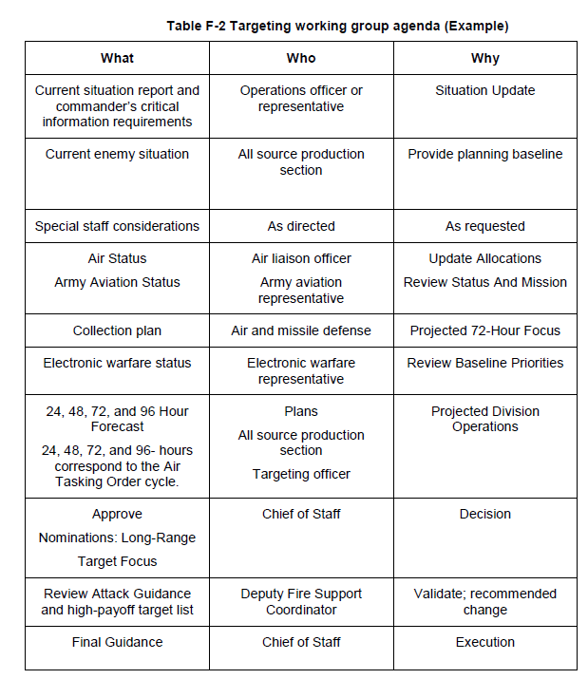

### Missions

The following missions can be tasked to support with dedicated intelligence collection in the 132nd:

* NTISR
* AR
* SCAR

### Products

Intelligence summary

Intelligence report

### INTELLIGENCE CONFIDENCE LEVELS IN ANALYTIC JUDGMENTS

VIS analysts should distinguish between what is known with confidence based on the facts of the situation and the OE and what are untested assumptions.

Intelligence can be facts that have been observed, or it can be a conclusion based on facts of

such certainty that it is considered to be knowledge. Intelligence can also be conclusions and

estimates deduced from incomplete sets of facts or induced from potentially related facts.

JFACC’s determination of appropriate objectives and operations may rest on knowing whether intelligence is “fact” or “assumption,” and knowing the particular logic used to develop an intelligence estimate, as well as knowing the confidence level VIS places on the provided intelligence and related analytic conclusions.

The following chart is intended to illustrate confidence in analytic judgments intelligence personnel may use to indicate a subjective judgment regarding the degree of confidence they place on the analytic conclusions contained in intelligence products. Confidence levels may be used by VIS to present analysis and conclusions to decision makers (JFACC, pilots and controllers) in a uniform, consistent manner.

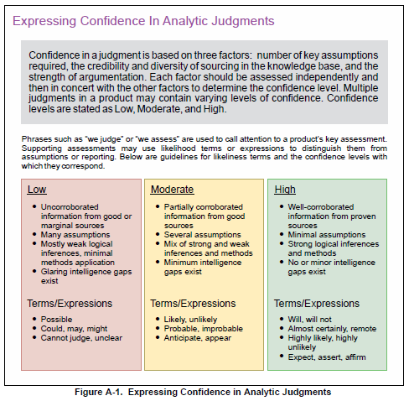

### Information Requirement

An IR is information “regarding the adversary and other relevant aspects of the operational environment that need to be collected and processed in order to meet the intelligence requirements of a commander.”2 Often written in the form of a question, a typical IR could be “What is the enemy’s capability and intent to attack friendly forces along Route Aggies?” To utilize limited collection assets in the most efficient manner, focusing intelligence collection and analysis prevents overwhelming the commander with information. The most important IRs are designated as commander’s critical information requirements (CCIRs) based on staff inputs and the commander’s scheme of maneuver. CCIRs are “critical to facilitating timely decision-making”, and may be categorized as either priority intelligence requirements (PIRs~~) or friendly force information requirements (FFIRs).~~~~3~~~~The IR above regarding Route Aggies would be selected by the commander as a CCIR if it would trigger key decisions such as the reallocation of forces or initiation of branches or sequels to the operations plan. Even if not selected as a CCIR, it still has merit for staff members and analysts to track in order to gain and maintain situation awareness, and could be designated as a CCIR at a later time~~

|  |
| --- |
| ~~Purposes of Air Reporting at the Tactical Level of War~~ |
| ~~1. Tactical threat warning~~ |
| ~~2. Mission planning~~ |
| ~~3. Targeting~~ |
| ~~4. Combat assessment~~ |
| ~~5. Threat assessment~~ |
| ~~6. Target imagery~~ |
| ~~7. Artillery and naval gunfire adjustment~~ |
| ~~8. Observation of ground battle areas, targets, or sections of airspace~~ |

|  |
| --- |
| ~~Purposes of Air Reporting at the Operational Level of War~~ |
| ~~1. Provide the intelligence information crucial to understanding a threat’s weaknesses in order to develop friendly courses of action~~ |
| ~~2. Help define the critical vulnerabilities of a threat’s national structure and military capabilities~~ |
| ~~3. Provide information on terrain; weather; and the threat’s size, movement, and situation~~ |
| ~~4. Provide threat assessment~~ |
| ~~5. Identify targets~~ |

|  |
| --- |
| ~~Purposes of Air Reporting at the Strategic Level of War~~ |
| ~~1. Locate threat centers of gravity and strategic targets~~ |
| ~~2. Warn of hostile intent and actions~~ |
| ~~3. Analyze threat deployment and employment~~ |
| ~~4. Assess damage to threat and friendly targets~~ |
| ~~5. Determine threat force structure~~ |
| ~~6. Identify the threat’s electronic order of battle~~ |
| ~~7. Provide threat indications and warning~~ |

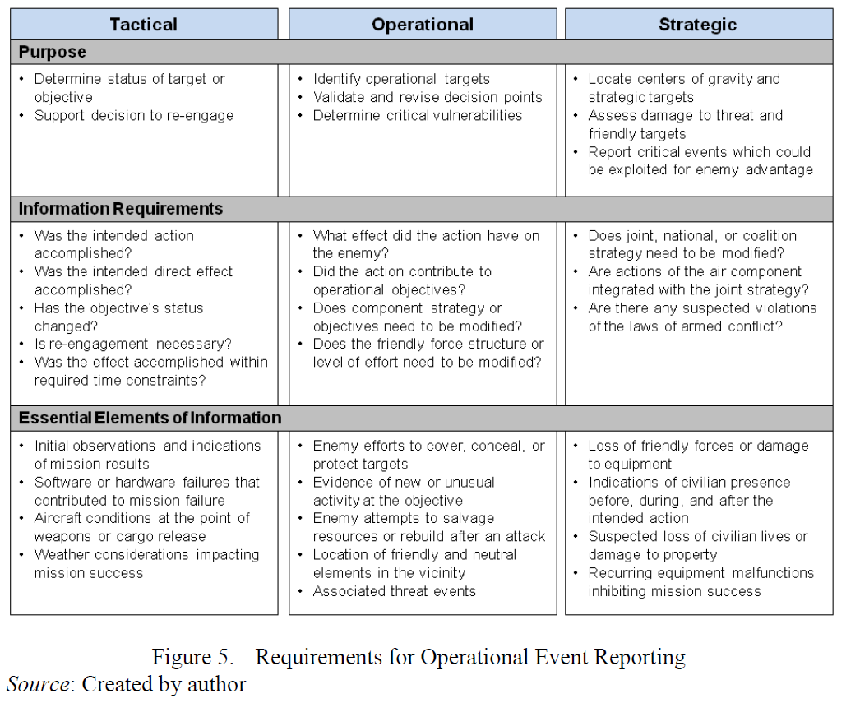

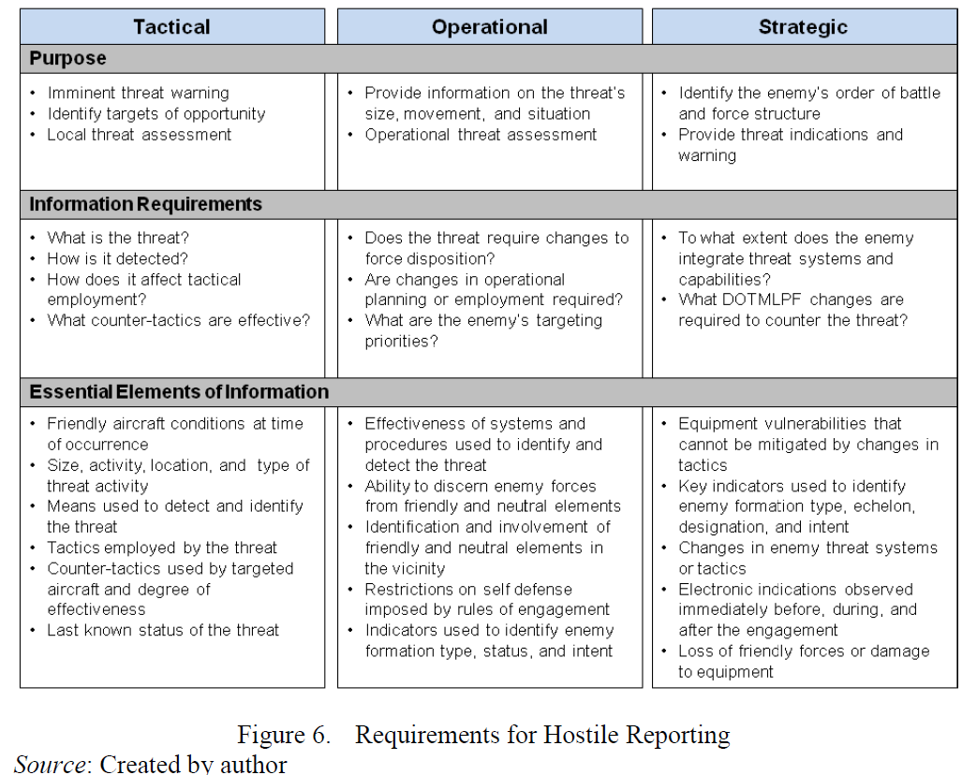

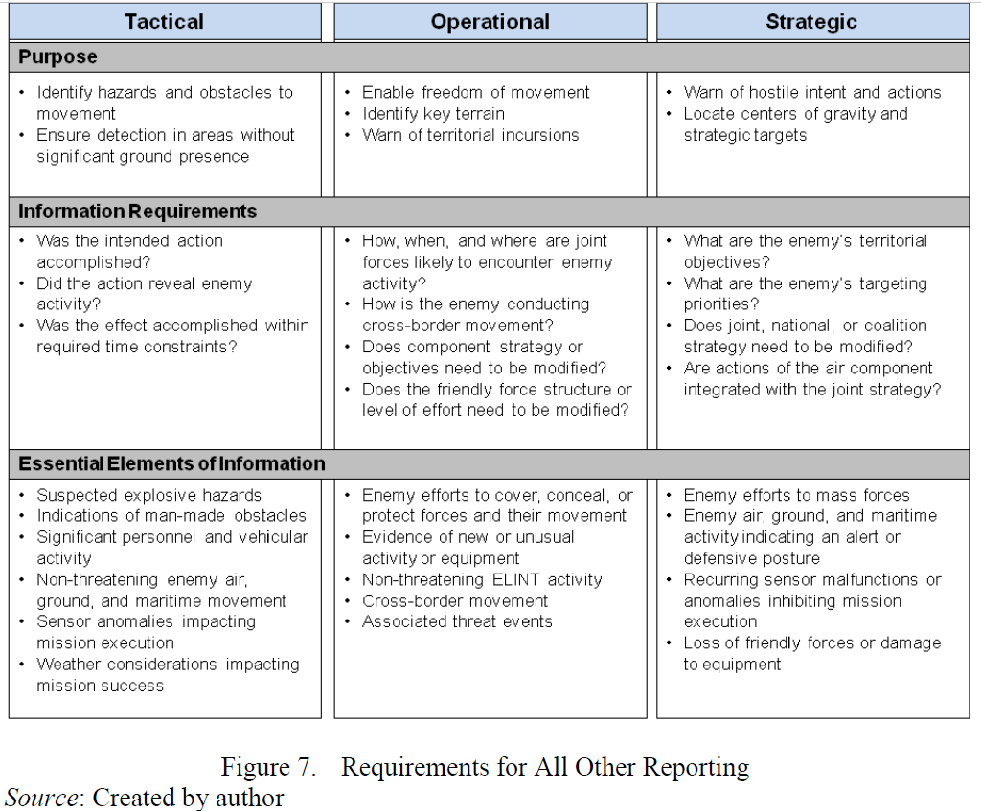

# Chapter 3: 132nd Flow

In the 132nd, the workflow for VIS is divided into two major parts. Part 1 is conducted prior to the first campaign mission and the output will be the Joint Air Operations Plan (JAOP). If the campaign goes over a long period of time (many events), then part 1 can also be used to update or refine the plan before a new phase in the campaign is started. Part 2 is the detailed planning conducted prior to each event and the main output is the Air Operations Directive (AOD) and Air Tasking Order (ATO).

**CAUTION:**

It is very easy to get too focused on products and creating the “correct” products and documents. The most important thing for JFACC is to plan and have a plan for the campaign as a whole and specifically for each event. The products are just a way of communicating the plan to everyone involved (Mission designer, AWACS controllers, JTACs and pilots). The best way to plan is to talk together while looking at a map, once plan or concept is agreed upon, then one can use the documents to convey the plan and necessary instructions to everyone involved. With the process explained below, the production of the actual product comes last, and it is important to do the first steps/stages without focusing on the output product (JAOP/AOD)

**NOTE:**

No one expects intelligence to be 100% accurate. There is uncertainty, conflicting information, inaccurate reporting, lack of reporting. VIS use their best judgement based on the facts and information available to provide the most accurate picture of the situation.

**NOTE:**

Real life will likely always prevent everyone from being committed 100% to the entire process every time. That is not a problem, and everyone should be prepared to be flexible and make decisions or have products that are not 100% respecting that this is a hobby for everyone and understand that people may have limited time to support from time to time.

## General concepts

When using JFACC and VIS construct in 132nd events the following guiding principles are effective:

* One ATO Day is divided into several events.
  + This is decided between mission designer and JFACC/VIS volunteers
  + Typically, one ATO day consist of minimum 2 events
  + The benefit this gives is that the products created for an event is still valid also for the next event and thus, events can be conducted at a more rapid pace. The only artificiality is that for event number two, JFACC will need to create a new ATO to facilitate for the signups on the actual date. But other products such as AOD, JPTL, ACO is still valid with the same information. For each ATO day JFACC/  
    VIS will be informed prior to planning that ATO day how many events the ATO day is divided into, and what time windows the events will cover (day and/or night).
* ATO day in a campaign is given the name D1 (for first day of campaign), D2 (second day), etc.
  + If more events are conducted on the same ATO day, then the event number for the day is added:
    - ATO Day 1, event 1: D1.1.
    - ATO Day 1, event 2: D1.2
    - ATO Day 2, event 3: D2.3.

## VIS Ambition 1

VIS ambition 1 is the most ambitious. This alternative includes full participation from VIS in both planning the campaign and during execution. In this alternative VIS will support both JFACC and pilots/controllers in their preparation and planning for the events.

See section 4.1 and section 4.2 for best practice on how to organize VIS.

## VIS Ambition 2

VIS ambition 2 is the middle ambition for VIS. This alternative includes full participation from VIS in the execution of the campaign only, and no VIS participation in the campaign planning. VIS will in this alternative support both JFACC and pilots/controllers in their preparation and planning for events.

See section 4.1 and section 4.2 for best practice on how to organize VIS.

## VIS Ambition 3

VIS ambition 3 is the lowest ambition for VIS. This alternative includes only support to pilots in execution of the event. VIS will in this ambition only focus on enemy air threat and SAM’s that are threats to pilots.

See section 4.1 and section 4.2 for best practice on how to organize VIS.

## Part 1 Planning: Air Campaign planning

The goal for VIS Air Campaign planning is to provide JFACC with the necessary understanding and situational awareness (SA) on the enemy and situation for JFACCs planning of the air campaign. VIS supports JFACC air campaign planning using the VIS Intelligence Preparations of the Battlespace (IPB) process that consist of four steps:

Step 1: Define the Battlespaces Environment

Step 2: Describe the Battlespace`s Effects

Step 3: Evaluate the Enemy

Step 4: Determine Enemy Course of Actions (COA)

VIS may start planning at the same time as JFACC, or VIS may start earlier than JFACC in planning. The VIS IPB process is connected to JFACC Air Campaign planning in the following way:

* VIS IPB Step 1 and 2 are an input to JFACC Air Campaign Planning step 1 (Operational Environment Research).
* VIS IPB Step 1-3 are inputs to JFACC Air Campaign Planning step 2 (Center of Gravity Identification).
* VIS IPB step 1-4 are inputs to JFACC Air Campaign Planning step 3 (Objective Determination) and step 4 (Strategy identification).

**So, while there are a lot of work and time-consuming tasks in the Intelligence Preparations of the Battlespace (IPB), it will pay dividends when it is completed before the start of the air tasking cycle. The workload is reduced between each planned event and events can be conducted at a higher pace as VIS have a deep understanding of the enemy and the battlespace.**

During the various steps, intelligence reports can be produced on specific topics (For example treat from enemy a-a missiles such as MAR distances and homing and most effective countermeasures or maneuvers, threat from enemy aircrafts, threat from enemy SAMs). This are basic intelligence based on the equipment and any available information (VID Intrep Generic ground force structure and VID Intrep generic air force structure) adjusted for the current campaign so JFACC and participants in the campaign better understand the threats they are facing.

### Step 1: Define the Operational Environment

In step 1 VIS decide what areas they should focus on (which countries and how far out to sea). Typically, this will be the enemy country, and neighboring countries in addition to any potential alliance partners. This area will be defined as the area of influence (AI).

### Step 2: Describe the Operational environment`s Effects

In this step VIS will study the enemy and its order of battle, the terrain. Input to this step are VID intrep`s provided for the situation/campaign and VID basic intelligence (INTREP VID B-001 Generic Ground Force Structure and INTREP VID B-002 Generic Air Force Structure).

VIS will start with determining the current enemy situation through an analysis of relevant order of battle inputs in VID intrep`s and basic intelligence. How are the enemy forces positioned in the AOR is one of the key answers that come out of this sub-step. Another output is the definitive and current adversary order of battle (for example in a spreadsheet) for updating and keeping track of BDA of the enemy forces (and what remaining forces are still left in the area of operations) during the execution phase of the campaign.

In this step VIS will also look at the map (using CombatFlite) on the AOR/AII and look at important features that will aid in subsequent steps:

* Time and distance (from various airbases, at different speeds)
* Time and distance (from bases or major cities following major roads)
* Identify blind zones (for enemy SAM/EW radars). A detailed study of the terrain to see opportunity and limitations.
* Identify mobility corridors for enemy ground forces
* Identify sea lines of communications (seaports)
* Identify key terrain that may be important for the enemy or friendly forces

### Step 3: Evaluate the Enemy

In this step VIS will evaluate and analyze the enemy. Input to this step is VID intrep`s provided for the situation/campaign and VID basic intelligence (INTREP VID B-001 Generic Ground Force Structure and INTREP VID B-002 Generic Air Force Structure).

VIS will start with analyzing and identifying the enemy’s center of gravity (COG).

VIS will then create or update available threat models. This can be range rings for SAMs, artillery, rocket artillery, SCUD`s etc. In addition, this can be what distances are various enemy aircraft able to fly from their bases (playtime), what the A-A missile threats are (DOR/MAR/Homing/what kind of countermeasures and maneuvers work best to defeat missiles). These threat models should be presented in a graphical form, using for example CombatFlite as background.

VIS will then combine the information and provide an assessment of the enemy’s current capabilities, strengths, and weaknesses. In addition, VIS will identify enemy high value targets (HVT) and list the priority of these.

### Step 4: Determine Enemy Course of Actions (COA)

In this step VIS will identify and develop the enemy most likely and most dangerous course of action (ML/MD COA). The purpose is to identify the enemy COAs so they can be exploited to accomplish the friendly mission. Information derived and products produced while performing steps one through three are fused together to project what the adversary is likely to do given the environment and his capabilities.

VIS will also identify high value targets (HVT) and other targets that are valuable to the enemy in executing the COAs and nominate for attack those targets that will achieve the chosen friendly COA and objectives.

VIS will identify any collection requirements that monitor indicators that can inform VIS on which COA the enemy are using (or if there will be a shift from one COA to another COA).

Once step 4 is completed, the outputs from all steps can be combined into one report that will aid JFACC in their planning of the air campaign. Intelligence from the various steps will also aid VIS and JFACC in the execution phase of the campaign.

### The Air Campaign Planning Targeting Meeting

With IPB complete, VIS and JFACC meet to conduct the Air Campaign Planning Targeting Meeting. This meeting ideally kicks off JFACC’s step 4 in the air campaign planning. See section 3.2.1 for more information about the Air Campaign Planning Targeting Meeting

## Part 2 Execution: Air Tasking Cycle (per ATO day)

Throughout the process VIS members follow overall guidance and priorities given by JFACC in JAOP and AOD.

### Per event

After an 132nd event VIS follow the intelligence cycle in the steps listed below. Step 1-3 focus on the previous ATO day, while step 4-5 focuses on the next ATO day.

#### Step 1 Processing:

All relevant information is registered in the VIS intelligence log and is organized for further production of intelligence. Pictures (screenshots), BDA report, observations, radar, RWR information, additional intelligence (VID) are all registered in the log for easier use during step 2 Production. All registered items are given a reference number to keep track and avoid double reporting. In addition to the intelligence log, all entries are also exported to a CombatFlite file. This make it easier for VIS members to see connections and how the various entries are related to each other and to enemy activity in step 2.

TO DO:

* FIND SOMEONE TO MAKE A FUNCTION FOR AUTOMATICLY CREATING THIS LOG FROM AAR OR INTEL REPORTING (EITHER FROM CURRENT WEBSITE AAR, OR CREATE NEW INPUT FOR INTELREPORTING). WITH THIS FUNCTION VIS SHOULD ALSO HAVE THE OPPERTUNTY TO CREATE MANUAL ENTRIES IN THE LOG, FOR EXAMPLE FROM VID INTELLIGENCE REPORTS
* NEED TO FIND SOMEONE TO MAKE A FUNCTION TO EXPORT FROM THE LOG TO COMBATFLITE TO AVOID UNNECESSARY TIME FOR PLOTTING FOR VIS MEMBERS)
* **ENDSTATE IS TO AVOID VIS MEMBERS NEEDING TO SPEND MUCH TIME DOING THIS STEP. FOCUS SHOULD BE ON THE REST OF THE PROCESS**.

#### Step 2 Analysis and Production

VIS members use all available information from last ATO day, previous events, intelligence reports and background intelligence reports and create a summary of intelligence after that ATO day. The intelligence summary may consist of:

* BDA from last ATO day
* Current enemy ground disposition (facts+assessment)
* Current enemy air disposition (facts+assessment)
* Current enemy air defense disposition (facts+assessment)
* Assessed enemy most likely course of action (ML COA) and most likely dangerous course of action (MD COA) for next 24-48 hours (next event), and more long-term (next phases)
* Recommendations
* Intelligence gaps/Intelligence requirements

In addition to the intelligence summary, VIS may produce additional intelligence reports (INTREP) on specific subjects. For example, going more into detail about capabilities, assessments on topics such as air defense, enemy air forces, enemy high value units, specific area, enemy course of actions etc.

NOTE: Focus is on understanding the enemy and the situation doing the analysis of available information and intelligence. The products are just a way of conveying the information. **Do not feel restricted by any template or specific product. Convey the intelligence in any way suitable.**

#### Step 3 Dissemination

Once VIS have created an intelligence summary of the last ATO day, the report is published and made available for both JFACC and all participants in the campaign in a suitable form. The intelligence and understanding of the situation and the enemy that VIS have can be either a written report or can be presented verbally at briefings. The product itself is not what is important. The product is just a way to convey the information in the most efficient way.

#### Step 4 Planning and direction

As a preparation for the next event, VIS members look at overall guidance in JAOP and AOD and look at their current intelligence gaps and based on this identify intelligence requirements that are presented to JFACC. JFACC will include these intelligence requirements into their air tasking cycle (stage 2) and if prioritized flights will be tasked to collect information to answer the intelligence requirements. The intelligence gaps can also be forwarded to VID (mission designer) as a request for information (RFI).

With all intelligence produced and disseminated during step 3 and 4 VIS have the necessary intelligence and SA to support JFACC for the next event. During this step VIS and JFACC therefore may conduct a “targeting meeting”.

##### Targeting meeting

Representatives from VIS and JFACC meet to synchronize their effort prior to the next event. This can be conducted as a meeting but may also be conducted by providing the necessary information if time for a meeting is not possible. The targeting meeting can be conducted for each ATO day, or for any interval JFACC and VIS deem necessary (For example every other ATO day, or once for every phase). Ideally the targeting meeting start JFACCs stage 2 in the Air Tasking Cycle.

See section 2.8.2.1 for detailed information about Targeting meeting.

#### Step 5 Collection

In step 5, VIS have no active role.

During the next ATO day, participants collect necessary information based on the intelligence requirements

### Special topics

VIS may also work independently of the air tasking cycle if working on special topics such as: “*Will state X intervene in the conflict, and if so, when and how will they intervene*” or “*What is the status of state X chemical weapon program*”. All intelligence gaps and collection should be tied into the air tasking cycle, but the reports may be presented only once in the campaign either before a phase change, or when it is needed to answer important intelligence gaps for JFACC before deciding what to do.

When working with special topics, VIS members follow the same intelligence steps as listed in the air tasking cycle but will typically start with planning and direction before collection is done. Once VIS have received enough information VIS then process the information before analyzing the data and producing intelligence. The cycle can then be repeated how many times as necessary until VIS have enough for a product (either verbally or written) that can be disseminated.

# VIS organization

Best practice for VIS is:

## Air campaign planning

It is recommended that one member of the VIS team is in charge, as it will be easier to maintain overall understanding and making sure the entire team gets through the process. To get a through and good understanding of the enemy and the situation it is recommended that all VIS members conduct the steps in the IPB without breaking out in various teams. This will give the best overall understanding that will aid during the air tasking cycle.

## Air tasking cycle:

For the execution of the campaign through the air tasking cycle it is recommended that VIS members organize themselves in teams (based on interest and who people like to work with)

It is recommended that various VIS members organize themselves in teams:

* Air/Air defense (IADS)
  + This team will focus on the enemy’s air forces, their SAM systems or IADS. This team may keep an updated orbat and BDA over enemy air assets and the status of IADS
  + There is a potential overlap with the team working with the ground picture, as the enemy ground forces also have SAM’s in their orbat. But these are systems primarily supporting the enemy’s ground forces so there may be need for some coordination with the ground team on who is responsible for the SAMs
  + This team is typically supporting pilots/controllers in OCA/DCA/SEAD operations, while also support Air Interdiction and Long Range strikes.
  + This team also function as a subject matter expert for JFACC on enemy Air and Air defense.
* Ground (Enemy ground forces)
  + This team will focus on the enemy’s ground forces, their position and activity
  + This team will try to identify locations for enemy high value targets such as headquarters, artillery, logistics
  + This team will try to anticipate what the ground forces will be doing in the future
  + This team is typically supporting pilots/controllers in CAS/AR missions
  + This team also function as a subject matter expert for JFACC on enemy ground forces.
* Targeting/Overall scenario
  + This team will focus on the “big picture” and keep track of other countries and what they are doing
  + This team also focuses on the campaign and its objectives, and is thus the best suited to focus on the air interdiction campaign and the targeting for the overall campaign
  + This team also try to keep track of the enemy ML and MD COA, and can give recommendation if the enemy switch from a ML to a MD COA so JFACC can make necessary changes.
  + This team is typically mostly focused on supporting JFACC.
  + Ideally the person leading the VIS effort is part of this team.

# ANNEX

## Annex 1: Worksheet for understanding objectives

Objective (XX)

Identify the enemy activity to be affected (**WHAT** do we want to do?)

Answer:

Identify the target system(s) performing the activity (Against **WHOM?)**

Answer:

Identify the specific location where enemy activity should be modified (**WHERE** do we want to affect the enemy activity)

Answer:

Determine the opportune time and duration to impact the enemy (**WHEN** and for **HOW LONG** do we want to impact the objectives?)

Answer:

Identify logical, available assets that can reach the objective target(s) within time constraints (**HOW** do we want to reach the objective).

Answer:

State attainable, quantifiable criteria against which effectiveness/success will be measured (**TO WHAT DEGREE** do we want to reach the objective)

Answer:

Perform cost analysis to estimate the cost versus potential benefit. (**HOW MUCH** will it cost to reach the objective, and is it **WORTH** it?)

Answer:

Check the objective against all known guidance. (**WHY** do we want to reach the objective?)

Answer:

### Example

Objective 1: Destroy Country X capability of using weapons of mass destruction

Identify the enemy activity to be affected (**WHAT** do we want the enemy to do?)

**Answer:**

* Stop production of chemical weapons
* Unable to deliver WMD toward friendly countries.

Identify the target system(s) performing the activity (Against **WHOM?)**

**Answer:**

* 361st SCUD Battalion
* Chemical weapon storage in location A
* Chemical weapon storage location B
* Chemical weapon research facility A
* Chemical weapon production facility B

Identify the specific location where enemy activity should be modified (**WHERE** do we want to affect the enemy activity)

**Answer:**

* 361st SCUD Battalion deployed to Desert Y
* Chemical weapon production facility B located in city X.

Determine the opportune time and duration to impact the enemy (**WHEN** and for **HOW LONG** do we want to impact the objectives?)

**Answer:**

* WMD delivery means: As soon as possible
* Chemical weapon factory B: As soon as possible, out of action for 6 months.

Identify logical, available assets that can reach the objective target(s) within time constraints (**HOW** do we want to reach the objective).

**Answer:**

* AR mission to locate and destroy 361st SCUD Battalion in desert Y
* Strike mission against chemical weapon production factory

State attainable, quantifiable criteria against which effectiveness/success will be measured (**TO WHAT DEGREE** do we want to reach the objective)

**Answer**:

* 361st SCUD BN: 8 of 8 SCUD TEL destroyed
* Chemical weapon production factory: Entire building collapsed

Perform cost analysis to estimate the cost versus potential benefit. (**HOW MUCH** will it cost to reach the objective, and is it **WORTH** it?)

**Answer:**

* AR mission against 361st SCUD BN in desert Y: Low threat, single flights can be tasked to search and destroy SCUD
  + Destroying the SCUD BN will eliminate the threat from chemical weapons from country X as without them, Country X will have no means of delivering the chemical weapons against friendly countries.
* Strike mission against chemical weapon production factory: Heavily defended city, air defenses need to be attacked and suppressed prior to any attack. High risk mission due to threat large complex, so many aircrafts needed. A large package needed.
  + Destruction of the factory prevents a critical chemical needed for the weapons of mass destruction to work, and if the factory is destroyed, country X will not be able to produce any more chemical weapons

Check the objective against all known guidance. (**WHY** do we want to reach the objective?)

**Answer:**

Prevent weapons of mass destruction of being used against friendly forces.

## Annex 4: Target priorities

Priority A

* The target is essential for mission success in support of current objectives (or is a designated a Time Sensitive Target (TST).
* It is crucial to the overall success of the operation.
* It will have immediate and compelling effects.
* Its timeliness as an urgent target may not exist in the future.
* If not targeted, negative consequences may seriously jeopardize future CJTF operations

Priority B:

* Targets have substantial, but not immediate impact on the battle.
* The cascading effects this target provides may not be realized in the future.
* If not targeted on this ATO, a significant level of effort may be required later.
* If not targeted, negative consequences may significantly hamper CJTF operations.

Priority C:

* It will contribute to the battle, but it is not critical to mission success.
* It will further the success of the operation.
* It will eventually require targeting due to JFC future plans.
* If not targeted on this ATO, negative consequences will probably not impede operations.

Priority D:

* Target of opportunity if:
  + A) Other targets not suitable for this ATO.
  + B) As a backup target
* It will have minor contributions to the operation.
* It may be required for targeting, but is not time critical.
* If not targeted, no negative consequences

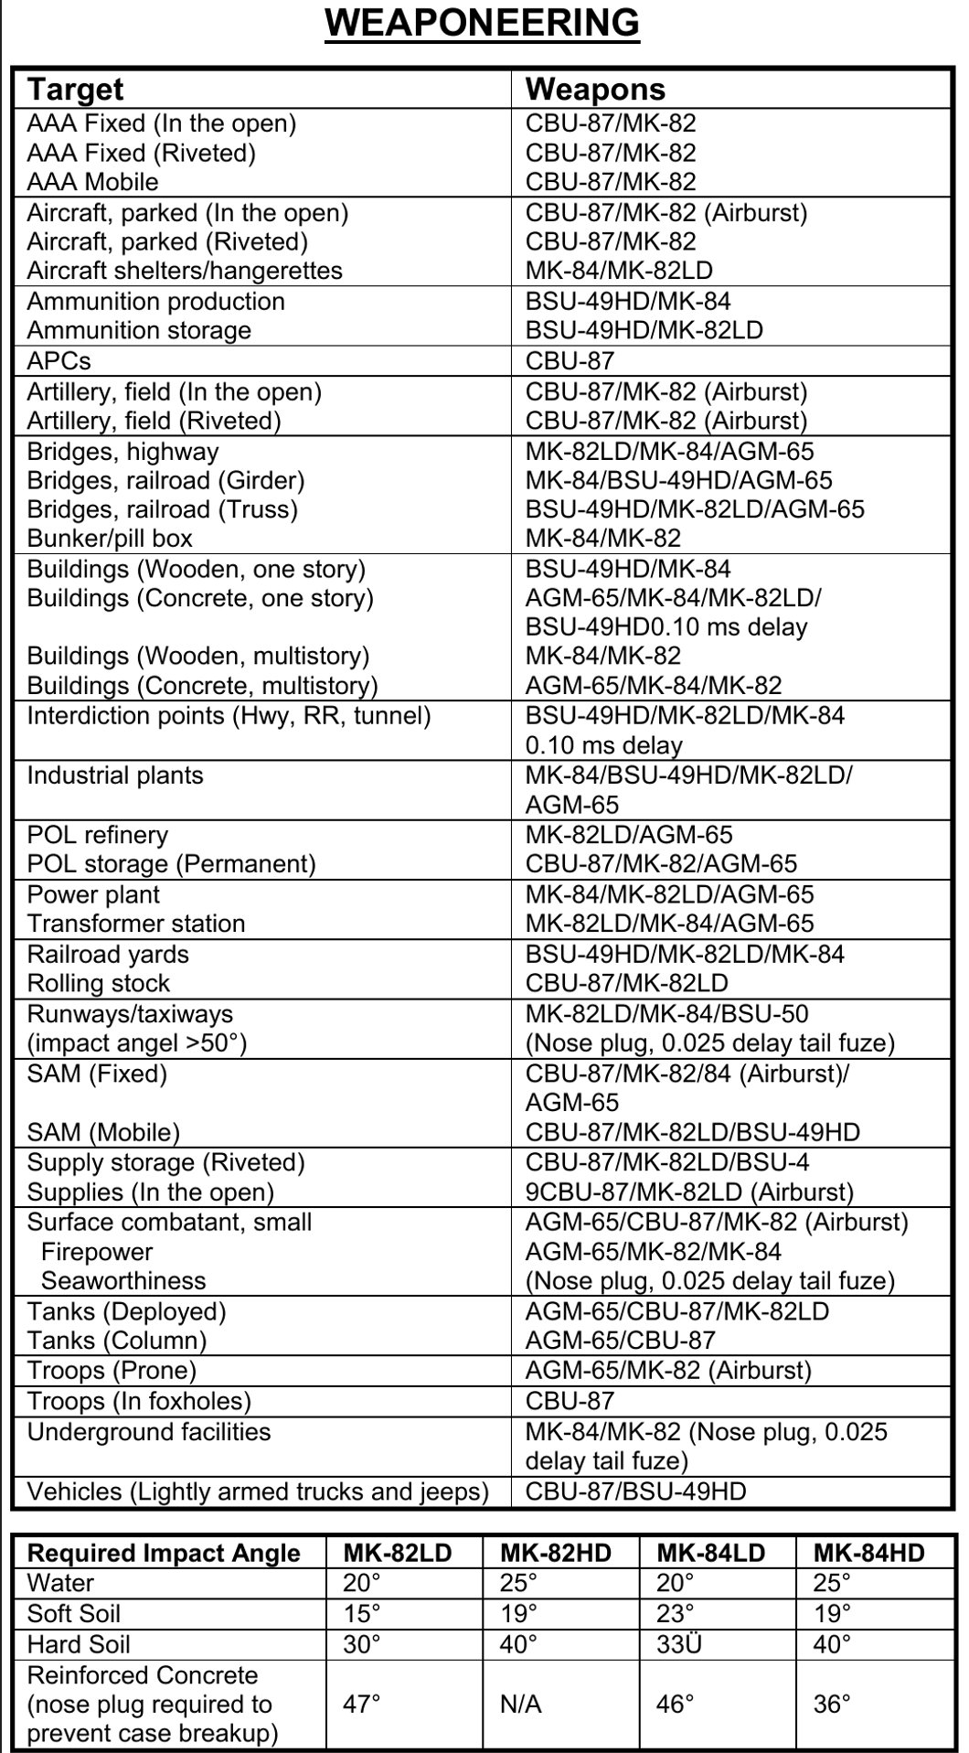

## Annex 6: Aircraft to tasking

A table with suggested tasking for the various aircrafts

Plus and minus with each aircraft per tasking?

## Effects

Terms that are used to describe the desired effects include:

● **Deceive.** Military leaders attempt to mislead threat decision makers by manipulating their

understanding of reality.

● **Defeat.** *Defeat* is a tactical mission task that occurs when an enemy force has temporarily or

permanently lost the physical means or the will to fight. The defeated force’s commander is

unwilling or unable to pursue that individual’s adopted course of action, thereby yielding to the

friendly commander’s will and can no longer interfere to a significant degree with the actions of

friendly forces. Defeat can result from the use of force or the threat of its use (FM 3-90-1).

Defeat manifests itself in some sort of physical action, such as mass surrenders, abandonment of

positions, equipment and supplies, or retrograde operations. A commander can create different

effects against an enemy to defeat that force. For example a commander’s employment of field

artillery fires to attack an enemy force may result in the enemy no longer having sufficient

**1-2 ATP 3-60 7 May 2015**

**Target Guidelines and Philosophy**

personnel, weapons systems, equipment, or supplies to carry out its mission. Likewise the

delivery of massed, synchronized and intense fires can cause enemy personnel to lose the will to

continue to fight.

● **Degrade*.*** To degrade is to reduce the effectiveness or efficiency of a threat.

● **Delay.** To *delay* is to slow the time of arrival of enemy forces or capabilities or alter

the ability of the enemy or adversary to project forces or capabilities. (FM 3-09)

When enemy forces are delayed, friendly forces gain time. For delay to have a major impact the

enemy must face urgent movement requirements or the delay must enhance the effect(s) of

friendly operations. When delayed enemy forces mass behind a damaged route segment a more

concentrated set of targets and a longer period of exposure to friendly fires results.

● **Deny.** An example of deny is to destroy the threats communications equipment as a means of

denying his use of the electromagnetic spectrum; however, the duration of denial will depend on

the enemy’s ability to reconstitute. *Denial operations* are actions to hinder or deny the enemy

the use of space, personnel, supplies, or facilities (FM 3-90-1).

● **Destroy.** *Destroy* is a tactical mission task that physically renders an enemy force combatineffective

until it is reconstituted. Alternatively, to destroy a combat system is to damage it so

badly that it cannot perform any function or be restored to a usable condition without being

entirely rebuilt. (FM 3-90-1).

● **Destruction**. *Destruction* is 1. In the context of the computed effects of field artillery fires,

destruction renders a target out of action permanently, or ineffective for a long period of time,

producing 30-percent casualties or materiel damage. 2. A type of adjustment for destroying a

given target (FM 3-09).

● **Disrupt*.*** *Disrupt* is 1. A tactical mission task in which a commander integrates direct and

indirect fires, terrain, and obstacles to upset an enemy’s formation or tempo, interrupt the

enemy’s timetable, or cause enemy forces to commit prematurely or attack in a piecemeal

fashion (FM 3-90-1). 2. An obstacle effect that focuses fire planning and obstacle effort to cause

the enemy force to break up its formation and tempo, interrupt its timetable, commit breaching

assets prematurely, and attack in a piecemeal effort (FM 3-90-1).

● **Divert.** To divert is to turn aside or from a path or course of action. A *diversion* is the act of

drawing the attention and forces of an enemy from the point of the principal operation; an attack,

alarm, or feint that diverts attention (JP 3-03). Diversion causes enemy forces to consume

resources or capabilities critical to enemy operations in a way that is advantageous to friendly

operations. Diversions draw the attention of enemy forces away from critical friendly operations

and prevent enemy forces and their support resources from being employed for their intended

purpose. Diversions can also cause more circuitous routing along lines of communication,

resulting in delays for enemy forces. An option for field artillery employment in support of a

commander’s diversion is to use high explosive fires to encourage an enemy to adopt a different

route.

● **Exploitation.** *Exploitation* is an offensive task that usually follows a successful attack and is

designed to disorganize the enemy in depth (ADRP 3-90).

● **Interdict.** *Interdict* is a tactical mission task where the commander prevents, disrupts, or delays

the enemy’s use of an area or route (FM 3-90-1).

● **Neutralize*.*** *Neutralize* is a tactical mission task that results in rendering enemy personnel or

materiel incapable of interfering with a particular operation (FM 3-90-1).

● **Neutralization.** *Neutralization* in the context of the computed effects of field artillery fires,

neutralization renders a target ineffective for a short period of time, producing 10-percent casualties or

materiel damage (FM 3-09).

● **Suppress.** *Suppress* is a tactical mission task that results in temporary degradation of the

performance of a force or weapons system below the level needed to accomplish the mission

(FM 3-90-1). Also see suppressive fire and suppression. (FM 3-09)

## ANNEX X: Intelligence production – Ground

## ANNEX X: Intelligence production - Air

## ANNEX X: Intelligence production – Targeting

## ANNEX X: Intelligence production – Big picture